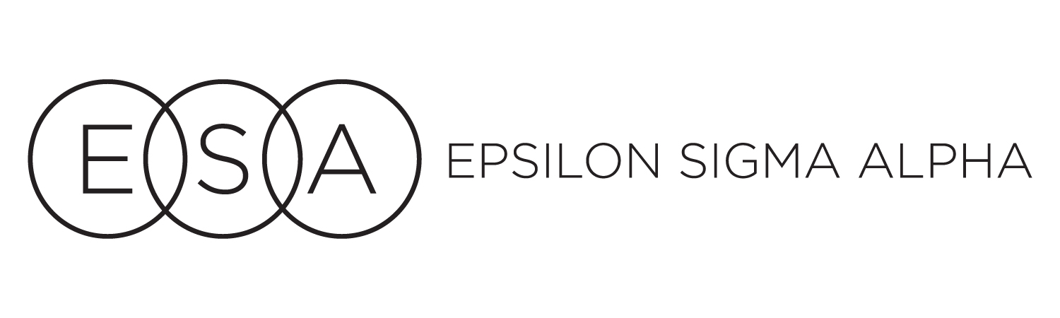

**COLORADO STATE COUNCIL**

**LEADERSHIP AND EDUCATIONAL FUND GUIDELINES**

The Leadership and Educational Fund of the Colorado State Council (CSC) of Epsilon Sigma Alpha (ESA) was established in 1984. Monies previously collected by the International Council to establish an ESA Home (which was abandoned in 1983-84) were returned to donor members, chapters, councils, etc. The CSC elected to use the interest from these monies for educational purposes.

I. Refer to CSC Bylaws, and Standing Rules for all duties; **please read the complete document.**

II. Fund Trustees:

1. The fund is administered by two (2) appointed trustees for three (3)-year terms.
2. The fund shall be invested in interest bearing accounts to fund speakers or other educational tools for the CSC.
3. Monetary distribution shall be made with the approval of the CSC Executive Board.

III. State Reporting:

1. Keep the membership informed of the Leadership and Educational Fund at the annual CSC Convention.
2. Prepare four (4) copies of the report for the annual CSC Convention. Copies are distributed to the Secretary, both Trustees, and Treasurer/Disaster Fund Chairman.
3. Prepare tax facts report for the CSC Treasurer/Disaster Fund Chairman by August 15 for inclusion in the CSC tax facts report.

IV. State Convention Officers’ meeting:

A. Attend meeting called by newly installed CSC President.

B. Every three (3) years, pass all files to your successors.

1. Follow the Records Retention Guidelines.