
ESA Colorado  Golden Lamp |  | June 2026| Volume 80 | Issue 11
Nancy Cameron

Colorado State President
2026-2027

Editor’s Corner  Last night, I was at a friends’ house to play bunco. We were sitting out on the deck enjoying the beautiful scenery as her house is in the countryside bordering Black Forest. She has a few hummingbird feeders on the deck, and we were entertained by several hummingbirds flying around all of us. It was magical.  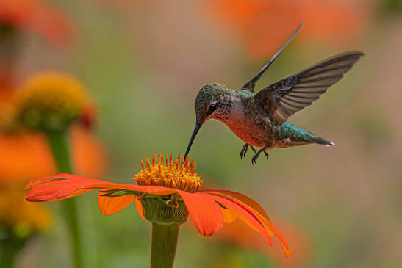  We are really lucky here in Colorado that we can sit outside in the evening and enjoy nature. It has gotten so hot lately, so it’s nice to retreat to the outside in the evenings. We have gotten some decent rainstorms this past week, I hope that it continues. There are so many fires around Colorado. I pray everyone is safe and that we can successfully extinguish them all.  Enjoy the rest of your summer! Safe travels! |  | WHAT’S INSIDE
PAGE 2-3
President’s Message

PAGES 4-8
Officer’s Pages

PAGES 9-10
Adi’s Update

PAGES 11
Chapter News

Pages 16-17
NEW! Birdie’s Bazaar

PAGES 17-18
Fun Pages

Message from The President – Nancy Cameron

My wings are flappin’ but the faster I go, the behinder I git!!
Just returned from the ESA IC Convention in Norfolk, VA! A beautiful place, so different from here! That’s what I love about IC Conventions -
I get to go places I would never have visited without ESA!!

Convention was great with the eastern sea as the background and President Celeste Webb’s theme of “Anchored in ESA” tying everything together. It was fast paced, as three days were cut from the former format! Kept us on the run but we did manage to get everything done. Only found one mermaid this time, ‘cause we didn’t take trips outside of the hotel - she was dockside at the hotel!

Awards will be announced at Fall Fest.
COLORADO has lots to be proud of!!

The new IC President, Angie Butenschoen from Missouri has chosen her theme for the coming year - “If not You, than Who?” All the states’ presidents are a part of her team. We choose a name to identify ourselves - forever after!! The logo has a circle with the theme in the middle and lines radiating out like rays. So we are the WHO RAYS!

-2-

So, to Business:
Yearbook information - Ginger has sent out a CSC Communications notice that we need all officer changes - or if there are no changes, we need that info too! Please let us hear from your chapter - ASAP!!

Fall Fest - I’m sure most of you have heard the date has changed to September 26 (Saturday). It will be a one-day meeting BUT I’ve just found out the Akron Ladies have a special event for us on Fri. Evening. Details will be in the flyer which will be out soon. The ladies are excited about having us visit them!

Colorado Facebook page - Dixie Daly will update our page so more info will get out about what we are doing! Please send her photos and info on projects you and your chapter are doing so we can let CSC be known!! You all do a lot! Even if you post on Facebook - send it to Dixie too! You can access her email from the website.

Spring Fling - I am looking for a location for March. Are there any chapters who would like to volunteer to host? We can have a one-day meeting then also!

Here are some photos I took on my phone from IC Convention- I will have others from the photographer later.
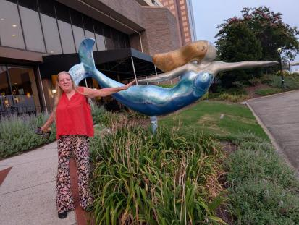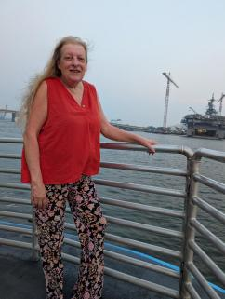
Outside our hotel Ferry Ride $2 - cool breeze
Across the Elizabeth River
Please let me know if there is any way I can be of help to you and your chapter and HAVE A WONDERFUL ESA YEAR!
Agape’, Nancy

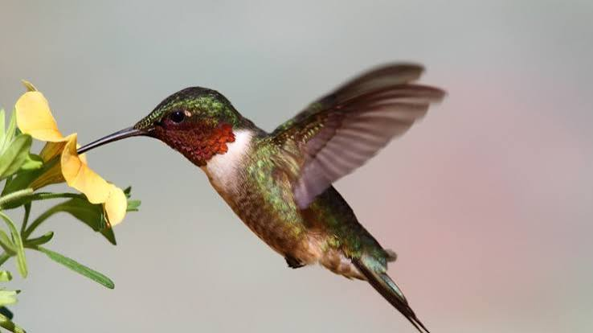

ESA FOUNDATION 2026-2027

Greetings from Sandy Alexander, your 2026-2027 ESA Foundation Coordinator.

ESA Foundation Membership:

The ESA Foundation is a public foundation for anyone who shares our goals. The annual membership fee is $40. You may also opt to support the Career Enhancement Grant through a $500 one-time Life Active membership. All dues are tax deductible. In order to vote at the annual meeting, the active member must have their annual dues paid before December 31. As the number of individuals seeking grants to improve their education is increasing, your participation in joining the Foundation as a Life Active Member is a key step in our ability to continue to support these individuals. In addition, donations can be made directly to the Grant fund, which is similar to making a donation to an endowment.

News from the Annual Foundation Meeting

* There are 3 Director positions available, for a commitment of three years, beginning January 2027. All applications must be sent to Tammy Akins by October 1.
* There are currently 538 Life Active Members.
* There will be 291 scholarships awarded this fall. Over $405,000 will be distributed to the winners.
* A more efficient process has been developed for a faster return of your charitable donations to the Turnaround Fund. Tracking has determined this process has established a minimum of two weeks.

ESAF Turnaround Fund

Is your chapter, state, or region preparing to make charitable donations for the year?
Please consider using the ESAF Turnaround Fund. This helps ESAF maintain our 501(c) 3 status.
A few things to remember when using the Turnaround Fund:
1. Your check must be made out to the ESA Foundation, and a minimum of $25.
2. Your donation must be to a 501 (c) 3 Non-Profit Charitable Organization and include their EIN. If you aren’t sure if your organization meets the requirement, you can ask a Foundation Director or search www.guidestar.com.
3. Please complete the Turn Around Fund Request Form at https://www.epsilonsigmaalpha.org/contribute#turn. You can add up to 10 different charities to a single form. If you have more than 10, please complete another form. This helps expedite the processing of the request.
4. The checks to the specific charity will be mailed back to the requestor for distribution to the organization.
5. There is no charge to you for this service.

Please feel free to contact me with any questions.
Sandy Alexander, ESAF Coordinator 2026-2027

-4-

ESA for St Jude – Jennifer and Adi 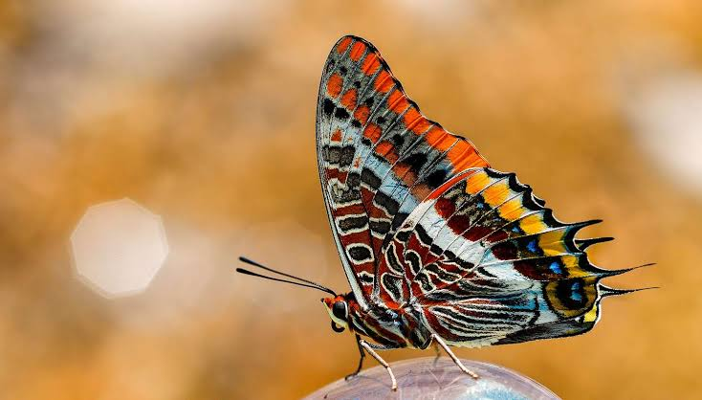

Hello!!!!

Adi has a few fundraisers coming up in different locations. I was hoping you would please share her calendar in case we are close to anyone who would like to stop by and say hi!!!

ADI'S 2026 CALENDAR

08.15.2026 Cookie Stand 09.12.2026
Spencer's Lawn and Garden Fundraising event at
Saturday 10am - 2pm Chaffee County Fairgrounds
1430 S. Tejon St. More details to come
Colorado Springs, CO

Pampered Chef Online Party 09.19.2026
August 21st - September 4th St. Jude 5K Walk
More details to come Denver, CO

09.06.2026 Cookie Stand 09.20.2026 Bake Sale
Harvest Festival Knights of Columbus Breakfast
Sunday 9am - 5pm Sunday 8am - 1pm
Windsor Main Park St. Joseph's Gym - 320 E. 5th St
Windsor, CO Salida, CO

09.07.2026 Cookie Stand 10.11.2026 Golf Tournament
Harvest Festival Salida Golf Course
Monday 9am - 5pm Sunday Check in 12pm
Windsor Main Park
Windsor, CO
.

Check out Adi's website for all the details

As more fundraising is finalized. We will update it on Adi's website!!!

https://adiscookiestand.wixsite.com/cookies

Thank you
Jenniffer and Adi

Communications Coordinator Update

I’m very excited to be serving as the Colorado State Communications Coordinator with our state council this year - especially under President Nancy Cameron's beautiful theme: "You've Already Earned Your Wings in E.S.A. Now, Just Fly!"
Right now, I'm hard at work with this year's State Yearbook, getting the format and content pulled together so it's ready for you at Fall Boards. We're exploring a few updates to the look this year, so stay tuned! If you're a chapter or committee contact who submits updates for the Yearbook, our goal is to have everything by August 15th.
I'm also starting to prepare for our Fall meeting. So grateful for the chance to serve and looking forward to a great year together as we spread our wings and fly!
Wings up, Colorado!
Ginger Dodge
CSC Communications Coordinator 2026-2027
Sigma Rho #5014, Loveland

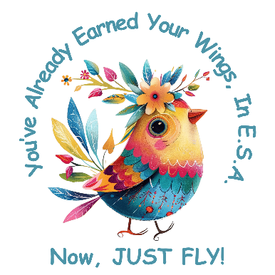

-6-
Hope for Heroes
OH MY GOSH HAS IT BEEN HOT!!!! Hopefully everyone has survived the heat and fires with no problems.
Hope for Heroes this year will focus on funding for the Operation/Maintenance of our Colorado Honor Bells. As most of you know, Colorado is the only state in the country with Honor Bells. These Bells can provide Honors for deceased veterans from any branch of the military regardless of their rank while serving.
I am planning to send each chapter a packet about the Honor Bells (one is based at Fort Logan National Cemetery and one at Pikes Peak National Cemetery) with information on how to request Honor Tolling for a veteran, how to spread the news about the option of this Bell Tolling AND how to financially support the operations of the Bells.
Stay tuned for more information in the Golden Lamp or on the Communications Email.
Then, unrelated to Hope for Heroes, there were 7 of us from Colorado at the IC Convention in Norfolk, Virginia. It was a great time! Check the Golden Lamp for the recognitions our state received.
Hope to see everyone at the Fall Meeting.
Susan Bloss - Hope for Heroes Chair

International Convention Awards

I am just back from the 2026 IC Convention in Norfolk, VA.

Joining together in Norfolk were Nancy Cameron, Colorado President 2026-2027, Leslie Stevens, Sandy & David Alexander, Alice Robinson, Dana Bell and me, Susan Bloss, (I stood in for Lori Anderson Havelick Colorado President 2025-2026 as she was unable to attend).

The following Recognition Awards were received:
Hope for Heroes: Legacy of Hope ---Phyllis Minch, Colorado
Top 3 Overall "From My Birthday to Yours" Campaign Fundraiser ---- Adi Mazza, Elan Colorado
Top 3 Overall Fundraiser --- Adi Mazza, Elan Colorado
Colorado was recognized for:
Dollars donated: $119,019.51 ($97,323.51 to St. Jude)
Hours Volunteered: 5,724 (1,060 in support of St. Jude)
Goods Donated: $86,251.20
Miles Traveled: 20,656

In addition the following members were recognized for their Years of Service:
30 Years of Service: Dana Bell
35 Years of Service: Susan Bloss and Vickie Chavers-Bruso
50 Years of Service: Alice Robinson

Be watching for some information on how ESA can continue to support the Honor Bell program with funding for maintenance and other expenses as needed. I am SO PROUD of ESA and each member who helped support the funding drive for the Pikes Peak Honor Bell.

Susan Bloss

ESA for St. Jude Chair

Adi and I are so excited to be the St. Jude Chairman for 2026!!
ST. JUDE CHILDREN’S RESEARCH HOSPITAL

Nancy Cameron’s Chosen Presidential Project for this year
Adi and I are so excited to work next to Nancy this year supporting all the kids at St. Jude.
Colorado had great representation this year at the IC Convention.
Nancy Cameron, Leslie Stevens, Sandy & David Alexander, Alice Robinson,
Dana Bell, and Susan Bloss.
Colorado was recognized at the IC Convention for a few St. Jude things this year:
- Top 3 Overall "From My Birthday to Yours" Campaign Fundraiser ---- Adi Mazza
- Top 3 Overall Fundraiser --- Adi Mazza
- Dollars donated: $119,019.51 ($97,323.51 to St. Jude)
- Hours Volunteered: 5,724 (1,060 in support of St. Jude)
If your chapter does anything for St. Jude this year, please send us all the details so we can share it with everyone!!! If you have any questions or comments, please reach out. We would love to hear from you!
We are putting together a great St. Jude Gift Basket for the drawing at Fall Board. We look forward to seeing everyone there.
Our contact info is available on the website.
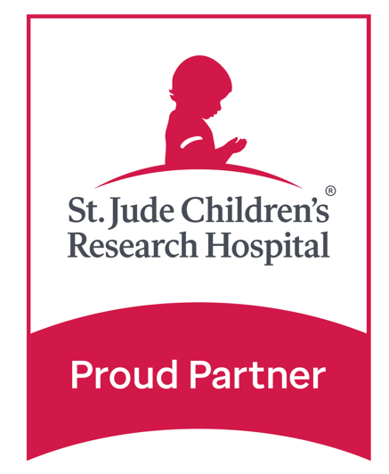
Jenniffer and Adi Mazza

-8-
Adi News Update

We received a text from Susan Bloss on July 18th letting us know that Adi received 2 awards at the IC Convention. She is so excited and so thankful to have won.

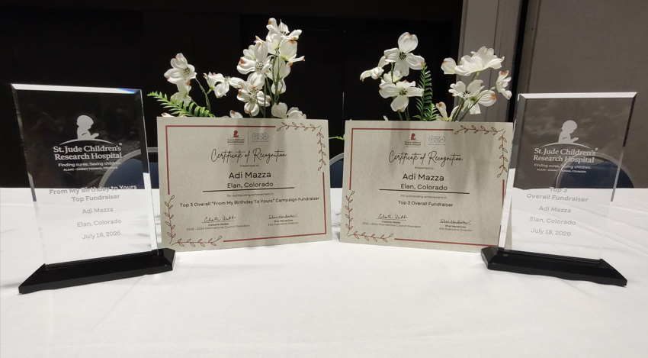
In June, Lillian, an editor with Time Magazine for kids, reached out because they heard about Adi’s fundraising. They chose Adi as their Power Star Kid, and she was interviewed by one of their kid reporters.

Adi was also invited by Empire Homes to set up a cookie stand at the Grand Opening of the Colorado Springs Dream Home. We got to spend the day with the Colorado Springs ESA ladies, Grace, Ron and Bayli, and St. Jude’s Anne and Brenda. We had the best day.
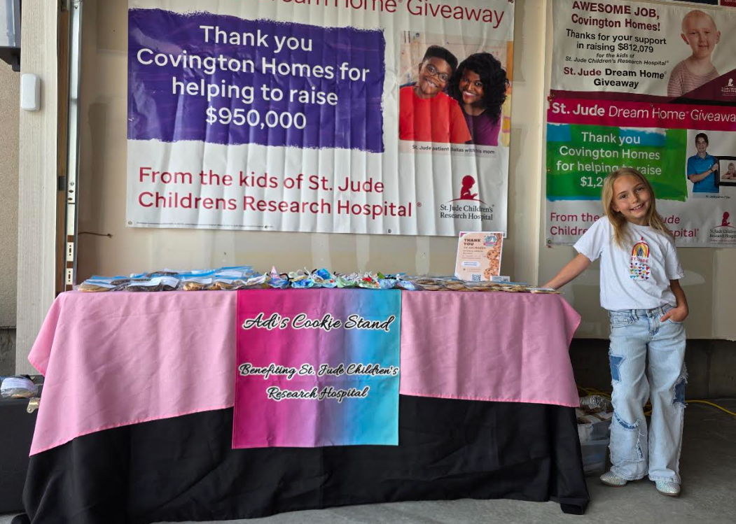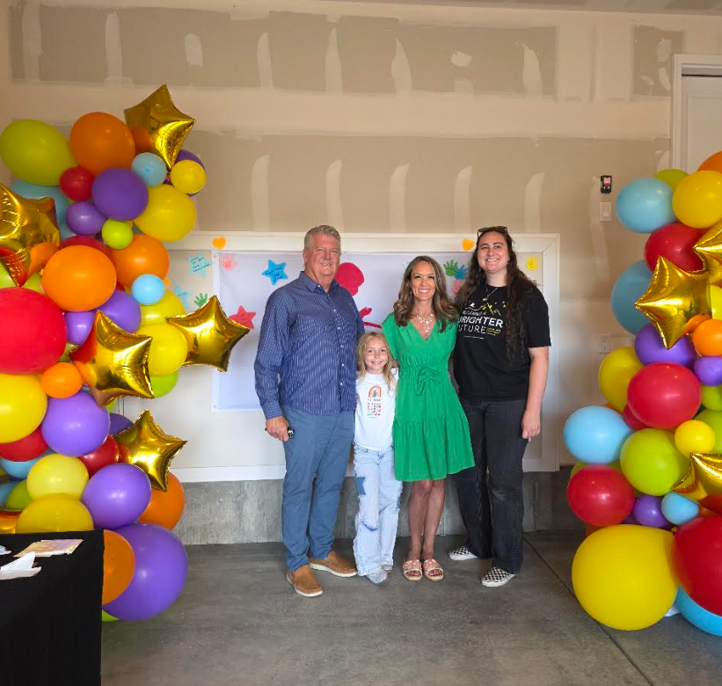

Here are a few ways to check our Adi’s fundraising

Adi’s website:
https://adiscookiestand.wixsite.com/cookies

News segment from KKTV11 recorded in May 2026:
https://www.kktv/2026/05/11/8-year-old-colorado-child-trying-raise-75000-st-jude-/

St. Jude fundraising website: (where the money gets uploaded)
http://fundraising.stjude.org/goto/Adi-9thbirthday

Facebook page:
https://www/facebook.com/share/1AFpwwX7vL/

I just want to say a big THANK YOU to everyone who supports Adi. She couldn’t do all of this without people like you in her corner!! Thank you do much for all your love and support!! If we are in your area, please come by and say hi! We would love to see you.

Love in ESA
Jenniffer and Adi Mazza



-10-
Chapter News  Sigma Rho #5014

Sigma Rho in Loveland, CO: What We've Been Up To!
Sigma Rho has been making the most of the spring and early summer seasons with some wonderful get-togethers and memorable moments.
In May, we enjoyed a fun social evening starting at the unique Loveland Localist Shop, browsing and supporting local makers, artisans, and small businesses. From there we headed over to Pinspiration Loveland Craft Studio for a creative night working on art projects. The shop's pup was a good project manager and kept a close eye on us (as you can see from the photo).
Good company + great creativity = a perfect combination!
June brought our end-of-year gathering at the beautiful Sweetheart Winery. What a lovely setting to relax, reconnect, and celebrate another great chapter year together! We are also bursting with chapter pride as we head into the 2026-2027 ESA year! Sigma Rho is thrilled to have four members stepping up to serve on the Colorado State Council: Emily Westphal as President Elect, Chris Dostal as Secretary/Disaster Fund, Deanna Sloat as Treasurer, and Ginger Dodge as Communications Coordinator. What an incredible representation of our chapter! Sigma Rho is so proud of each of them and can't wait to see all they accomplish this coming year.
Looking ahead, Sigma Rho will gather in August for our big chapter planning meeting. We are excited to map out the year ahead and hit the ground running this fall.

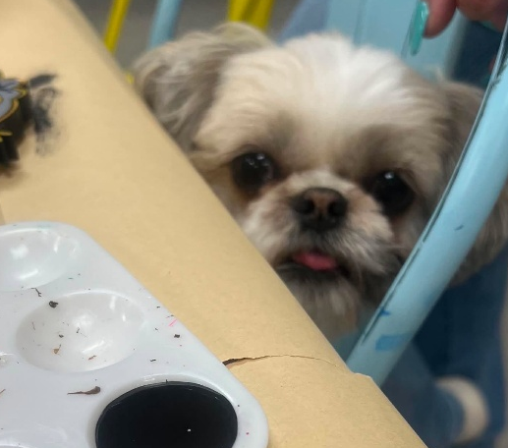
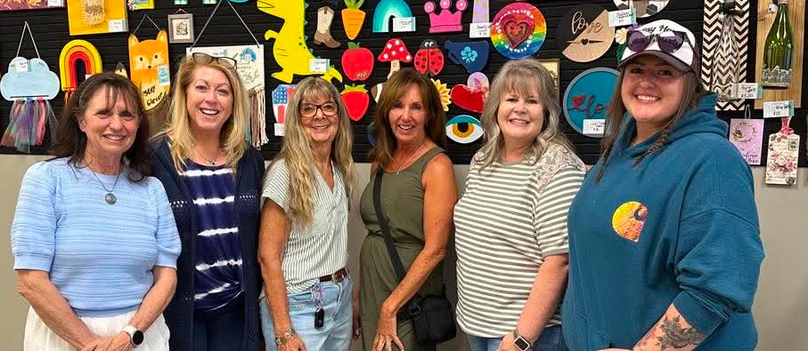

Chapter News Gamma Chi # 3668

I hope everyone is surviving the heat. It certainly isn’t letting up. We have been busy with a few different projects.
June started out with the annual Envision 5K in Evans. This event is in support of People with Developmental Disabilities. RuthMary and Deena helped at the registration table. There were approximately 100 people that entered the race and numerous vendors.
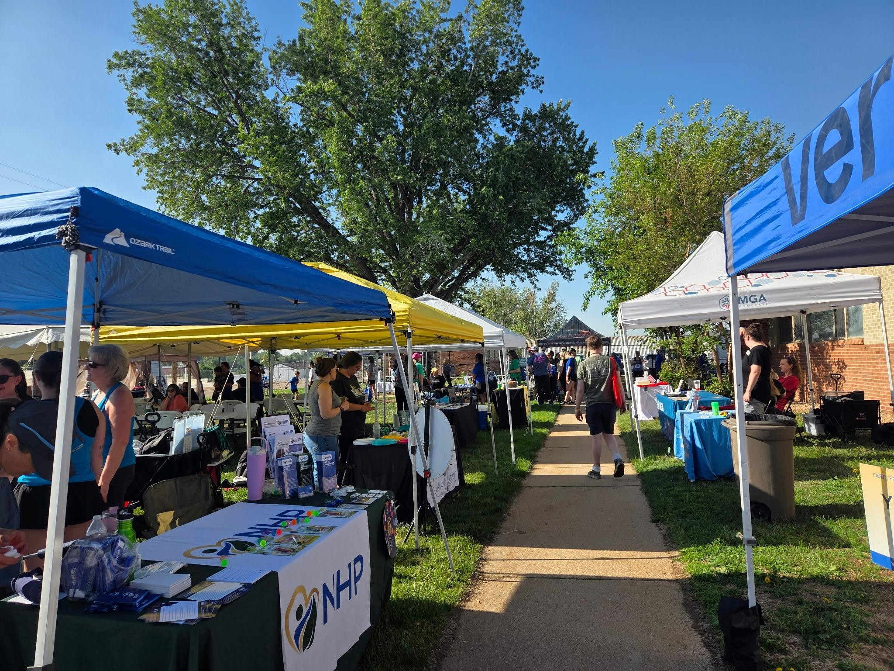
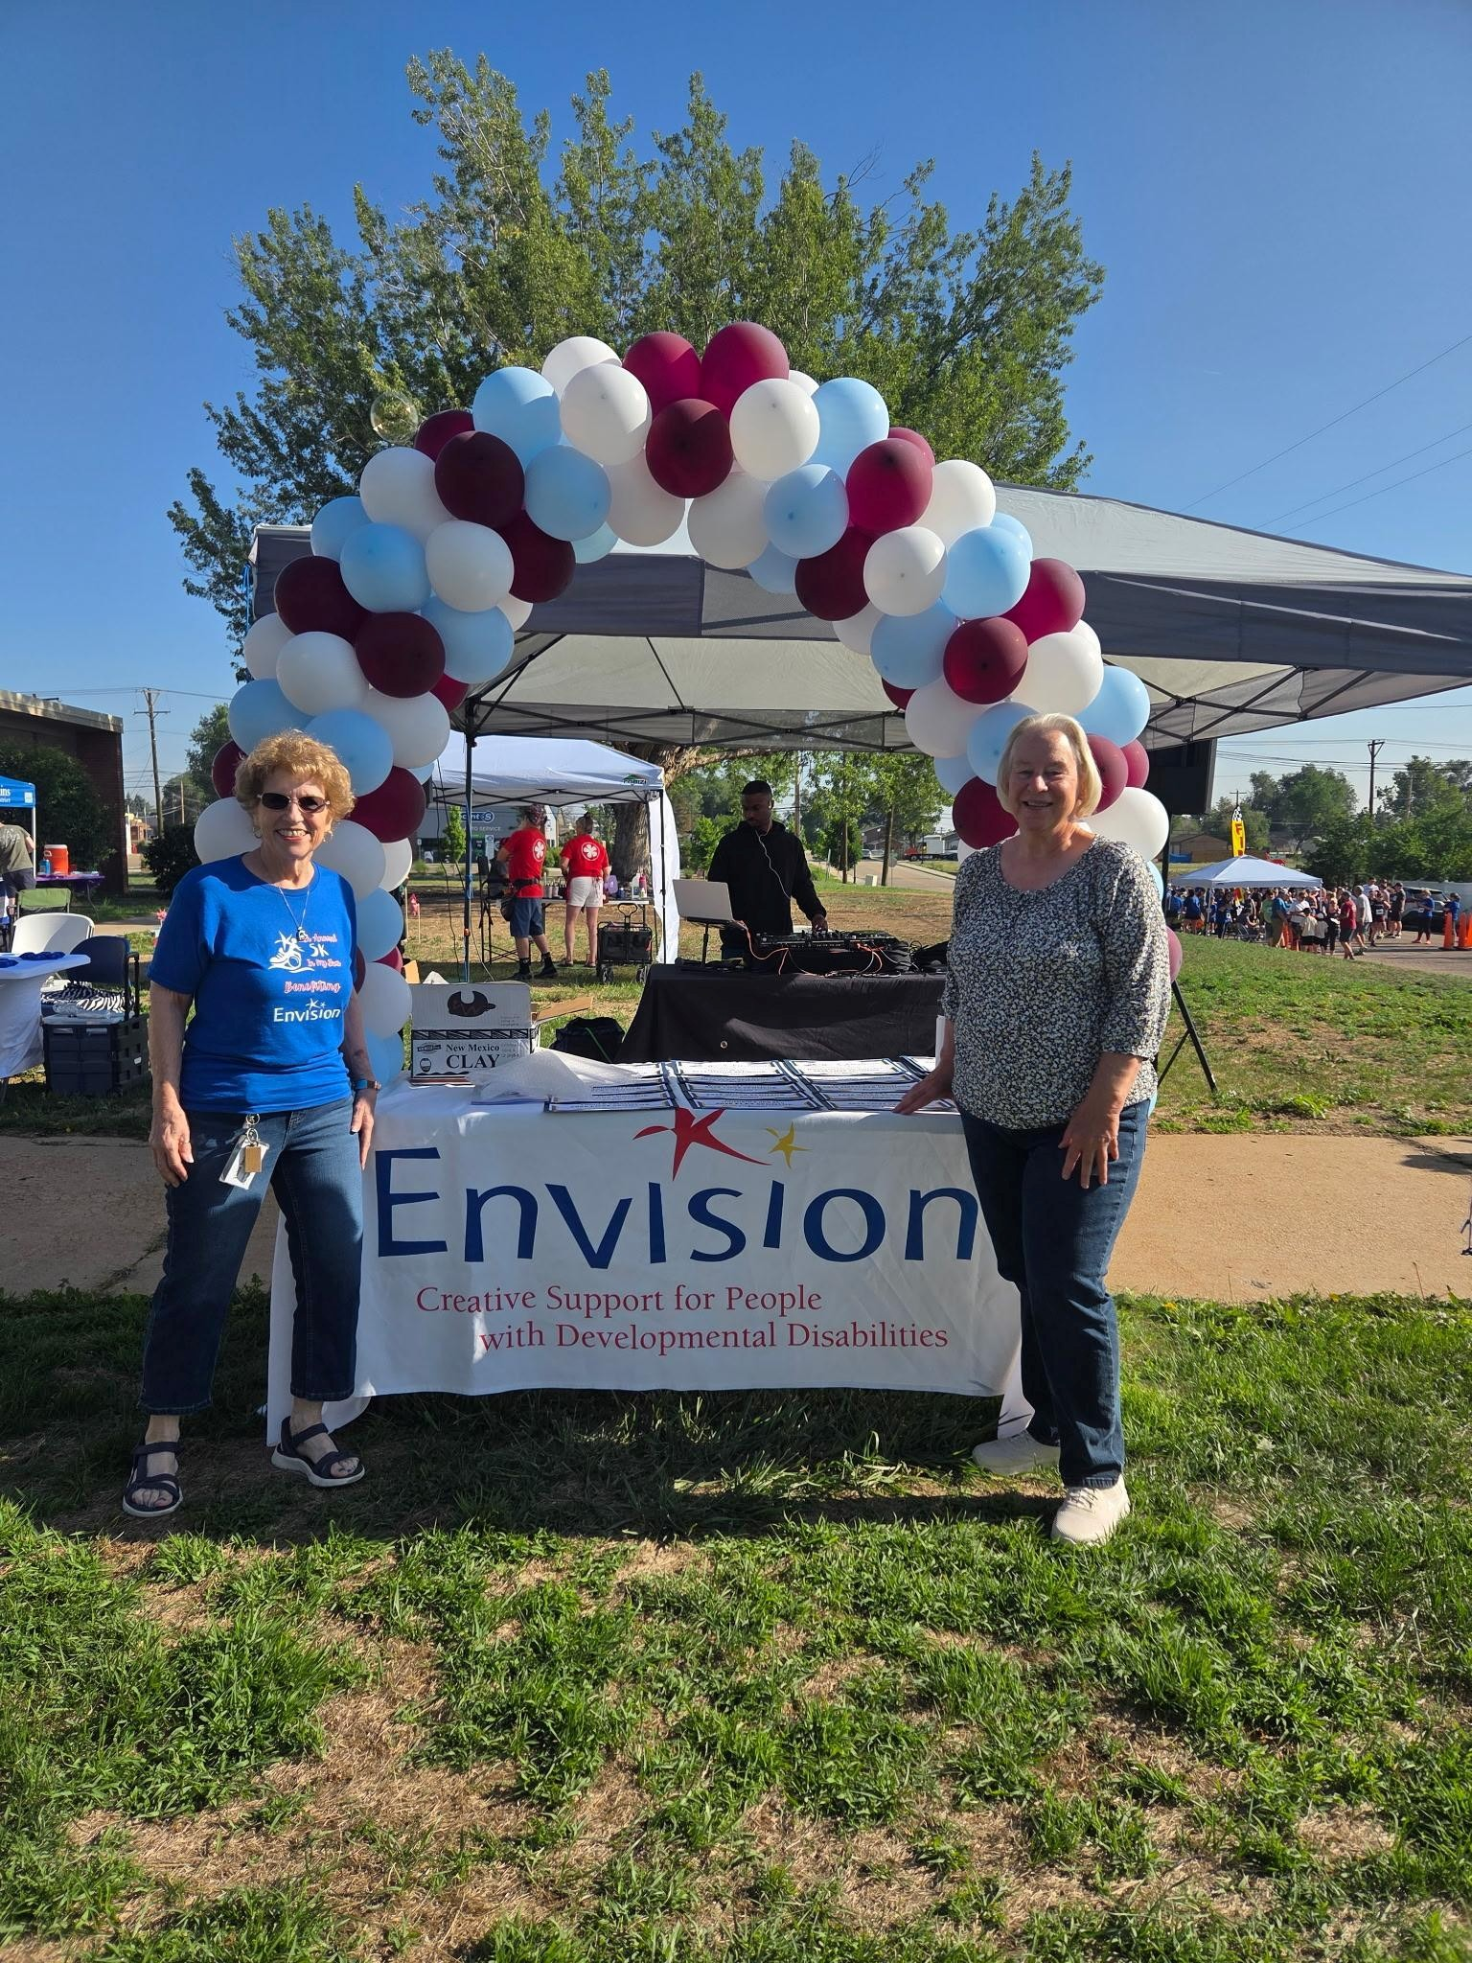

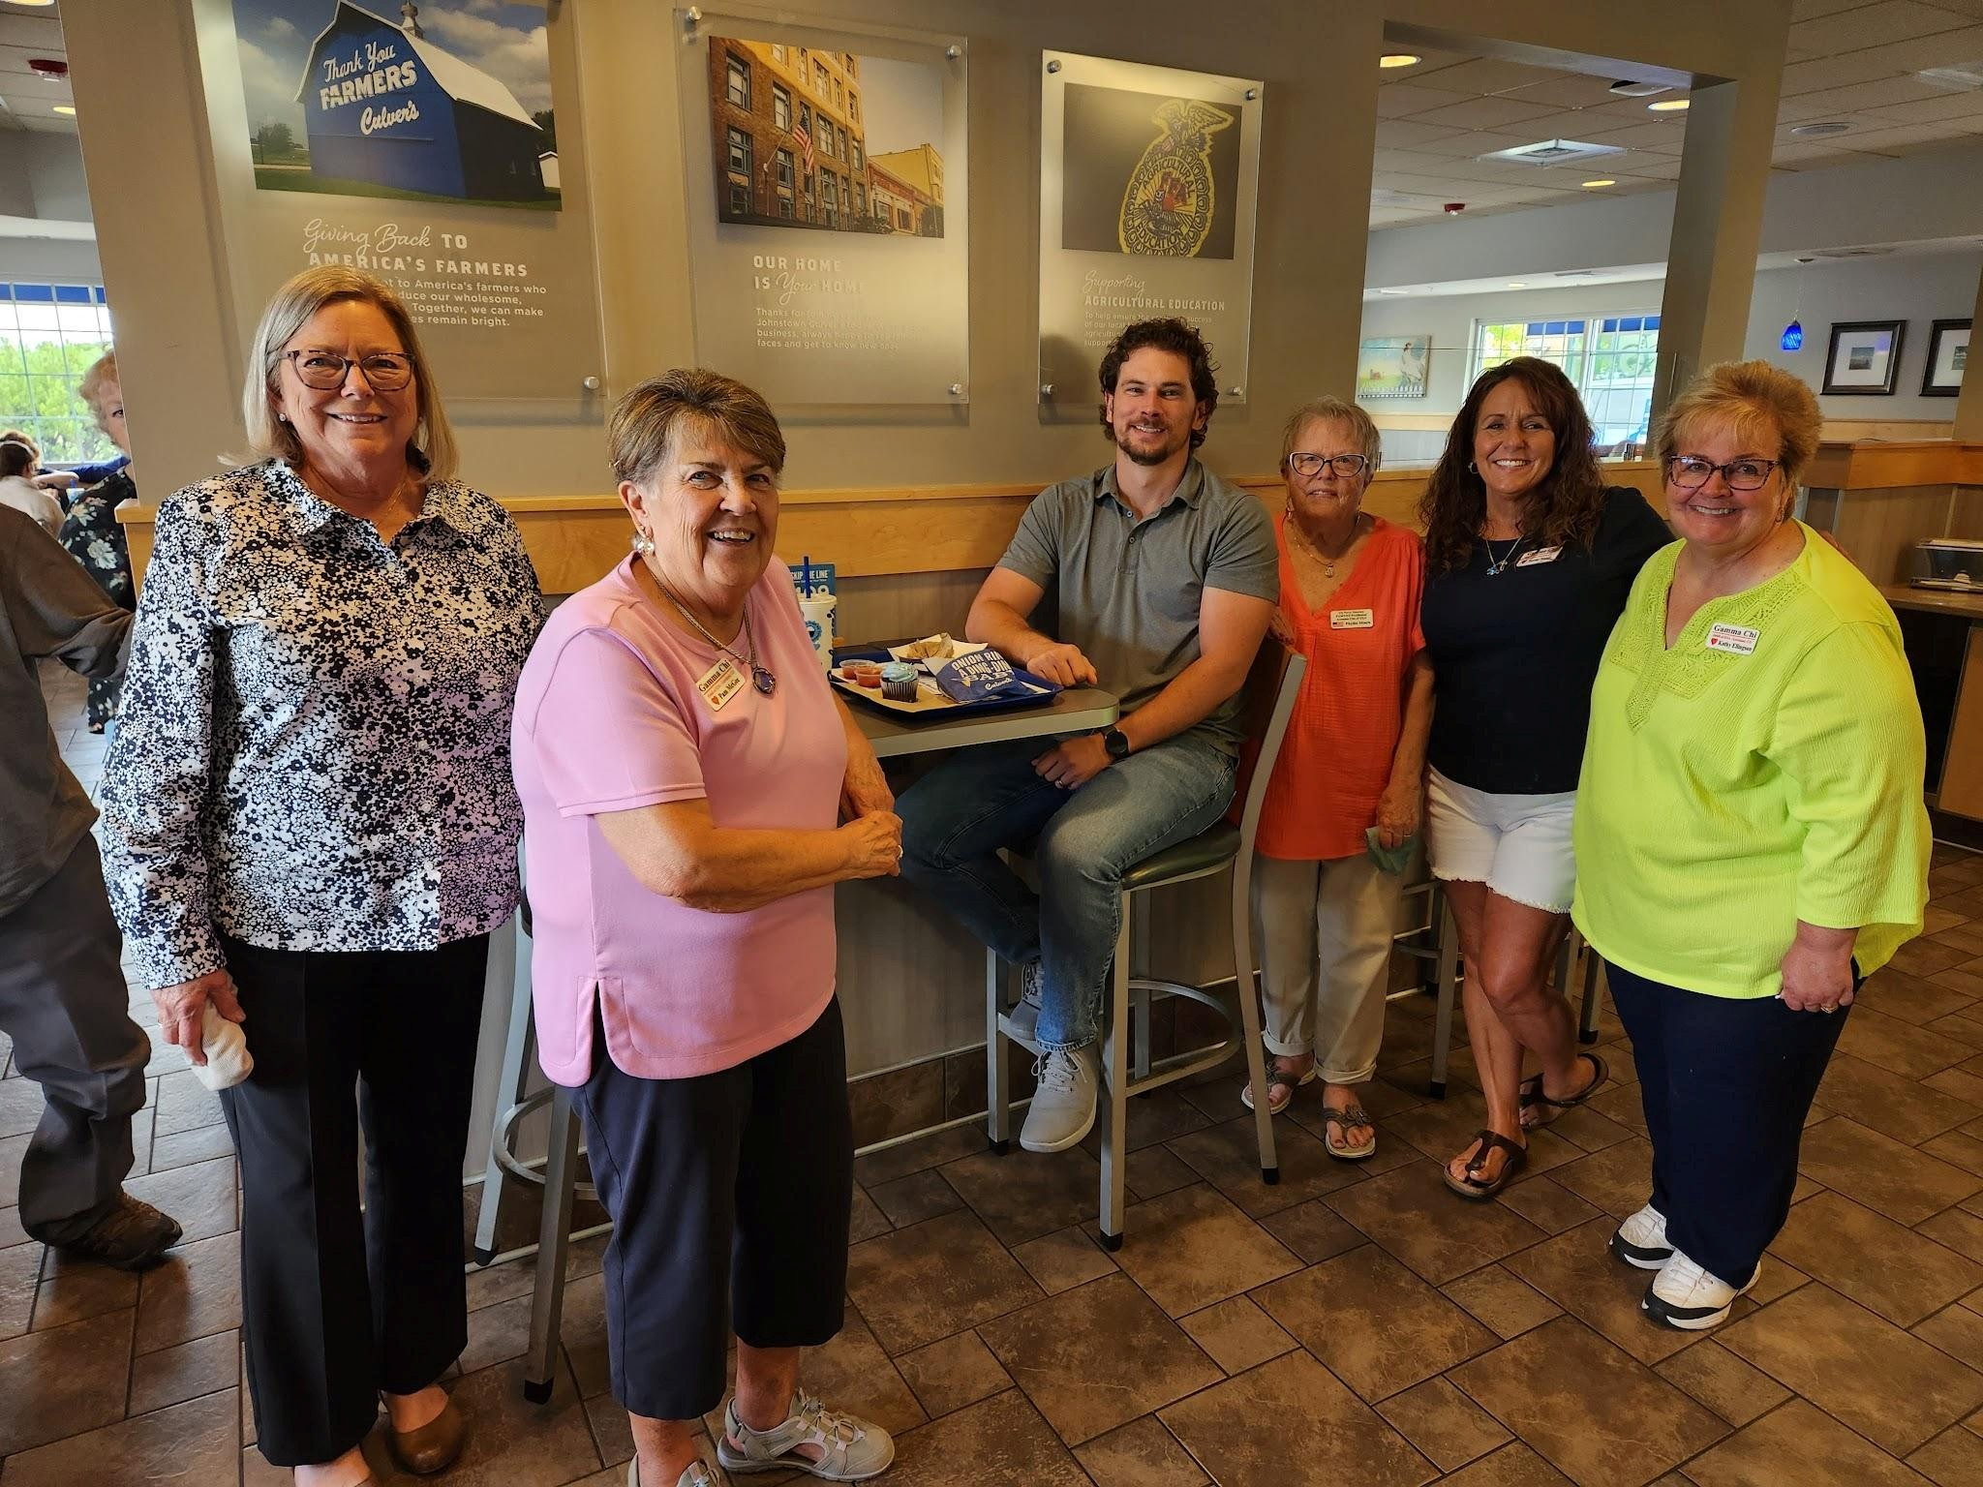
Later in the month most of Gamma Chi volunteered at Culver’s in Johnstown to help celebrate 19 years in this location. They were donating 19% of the profits to Gamma Chi that day. We had the privilege of chatting with customers, sharing information about Gamma Chi and handing out cupcakes. There were also some drawings. The young man in the picture made the mistake of telling one of us it was his birthday when we gave him a cupcake.

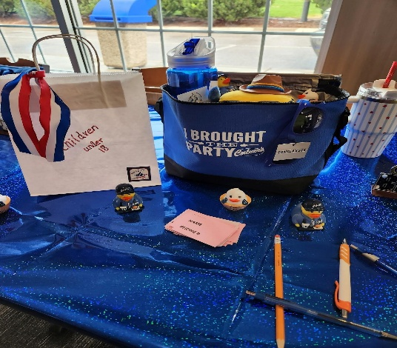
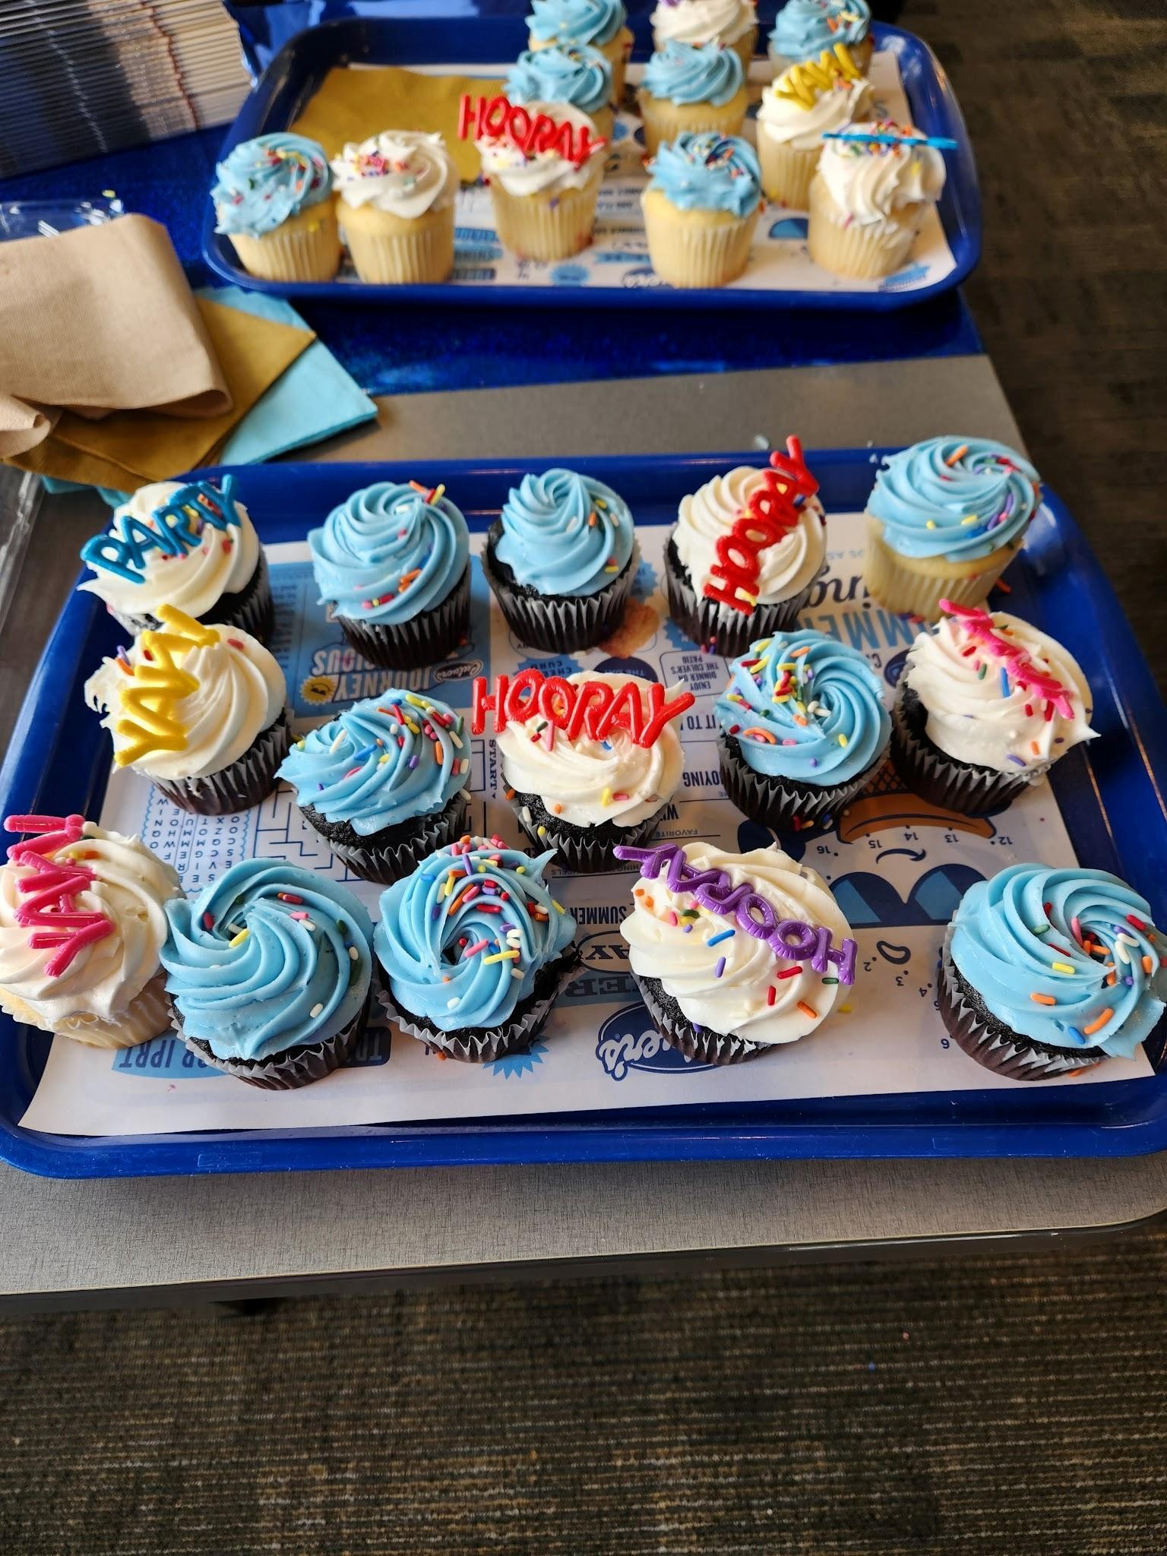

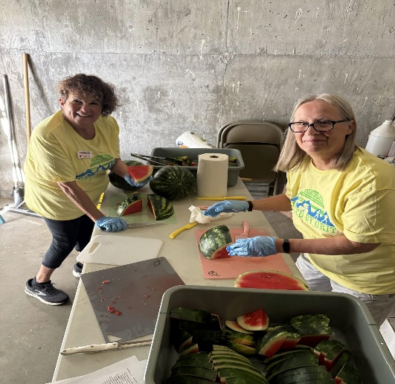
Two days later eight of us helped set up food and serve to 100 plus participants that took part in the Loveland Lake to Lake Triathlon. We’ve been involved with this for 20 years.
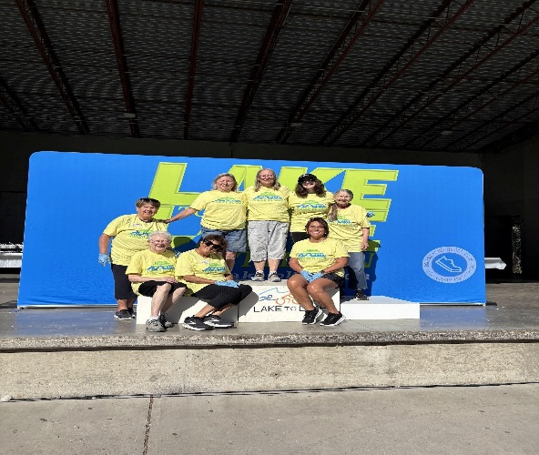

We serve weekly at the Community Kitchen and once a month at the Food Bank. It’s summer time so we also take care of the flowers around one of the sculptures in the Benson Sculpture Park.
The last day of July three of us woke up early and set up for the #3 Exchange of the Wild West Relay at the Wellington/Waverly Fire Station. Thirty-six teams were entered and they ran from North Fort Collins to Steamboat Springs. You can tell we don’t take selfies very often.
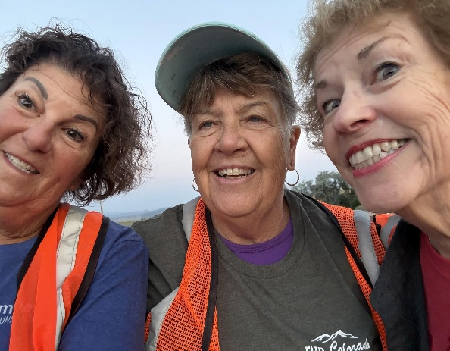

Gamma Chi hopes all of you continue to have a good summer and still get to do some fun activities and trips.

Chapter News Beta Zeta #3149
Beta Zeta is such a busy chapter! They are hosting their Soup, Salad and Shopping Event for the 10th year! And according to Carol Dunn, “With such a great group of friends, we make everything fun!”

Local charities that Beta Zeta supports are: Cañon Literacy Center; Christmas gifts for teens in foster care; Court Appointed Special Advocates (CASA); Dolly Parton’s Imagination Library; Senior Services Solutions, Fremont Regional Hospice; Green Thumb Initiative; Meals on Wheels; Orchard of Hope Foundation; Sangre de Cristo Community Care, and scholarships for seniors at Cañon City High School.

National charities it supports are St. Jude’s Children’s Hospital, Easterseals, ESA Foundation, and ESA Disaster Fund.
Beta Zeta also prepares and serves a meal of biscuits and gravy and fresh fruit at the free annual Senior Breakfast at the Fremont County Fair.



-14-

Chapter News Zeta Nu #5608
Zeta Nu is busy getting ready for the annual craft show event hosted by the Banning Lewis Retirees Neighborhood. We first did it last year and had a wonderful day selling our wares. We were able to raise enough money to pay for the Ronald McDonald house meals that we provide. So, we are replenishing our ways and means fund again for this coming year. It’s such a nice time to spend with our chapter members.
We strive to make unique items and offer for sale. The event is being held on September 12.

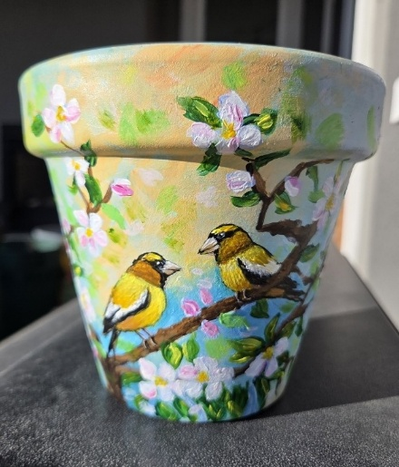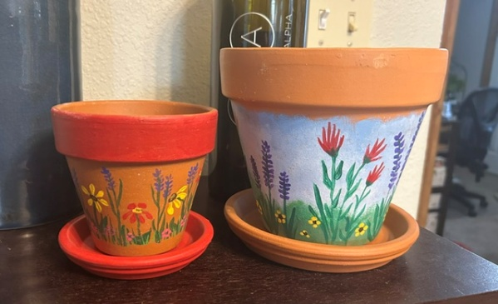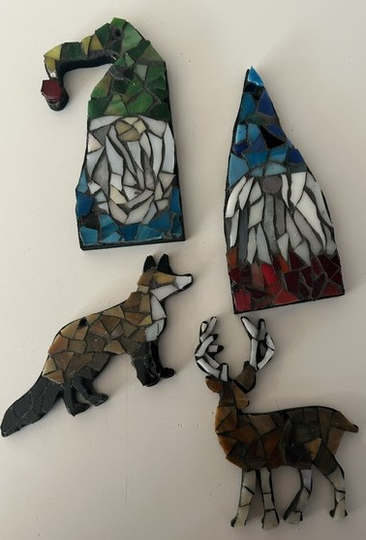
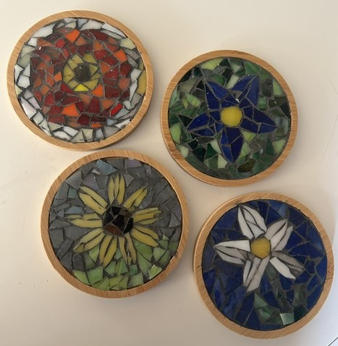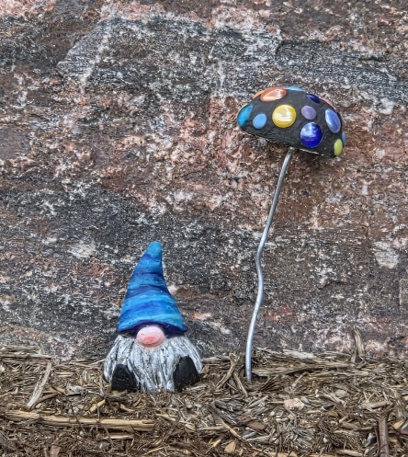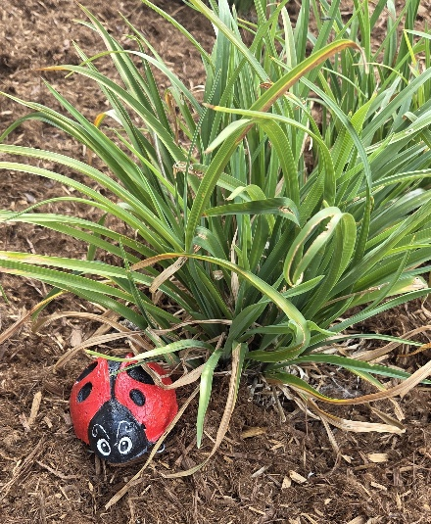

Birdie’s Bazaar 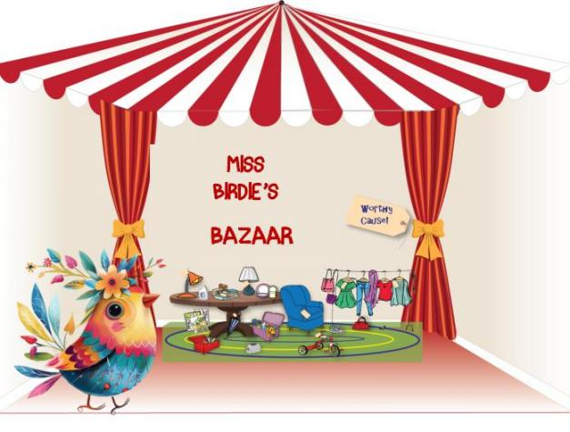

Birdie’s Bazaar is a way to raise $$ for the ESA/St Jude $5 Million in 4 Years event –
The Colorado State President’s philanthropic project.

ESA members can collect (buy) posted items or post (donate) items listed in the Golden
Lamp issues on a DONATION BASIS.

Items go to the first person to contact the donor by phone, text or email.
Delivery of items is arranged between the buyer and donor.

Donation payment for the item is to be sent to the “Birdie’s Bazaar for St. Jude” project. This
will be a donation to St Jude’s by the buyer.

Please send checks to Nancy Cameron to forward to Birdie’s Account until further notice.
(Portal for sending payment to this project is still under construction. Notice will be
published as soon as completed.)

Listing items - Send photo, brief description and your contact info to Karen Addison -

Thank you from Birdie & Nancy for supporting the St Jude Kids!!

Here are some items that can be purchased. Contact Nancy to purchase items.

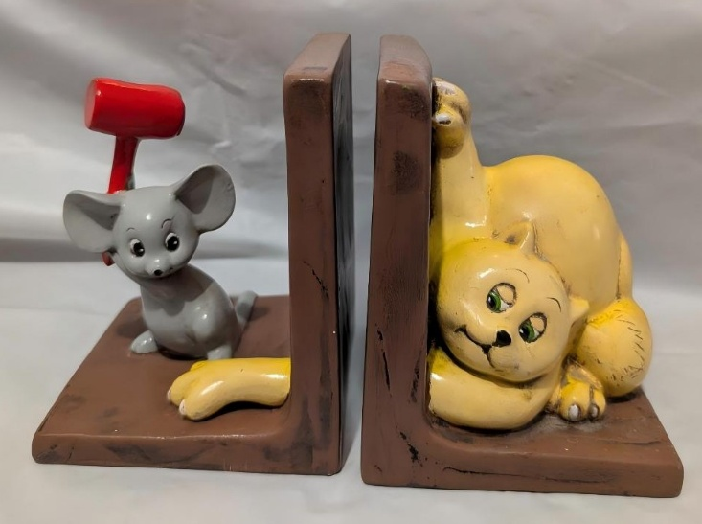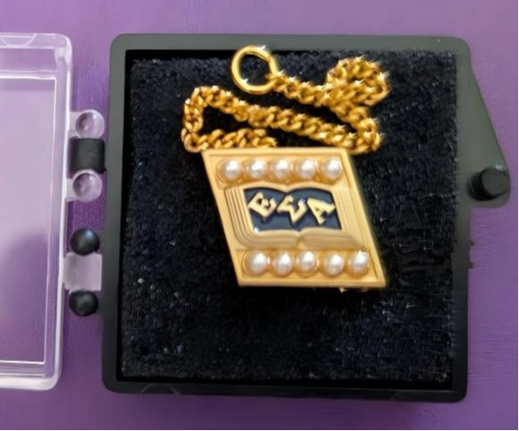
Cat and Mouse Bookends ESA Pin

-16-
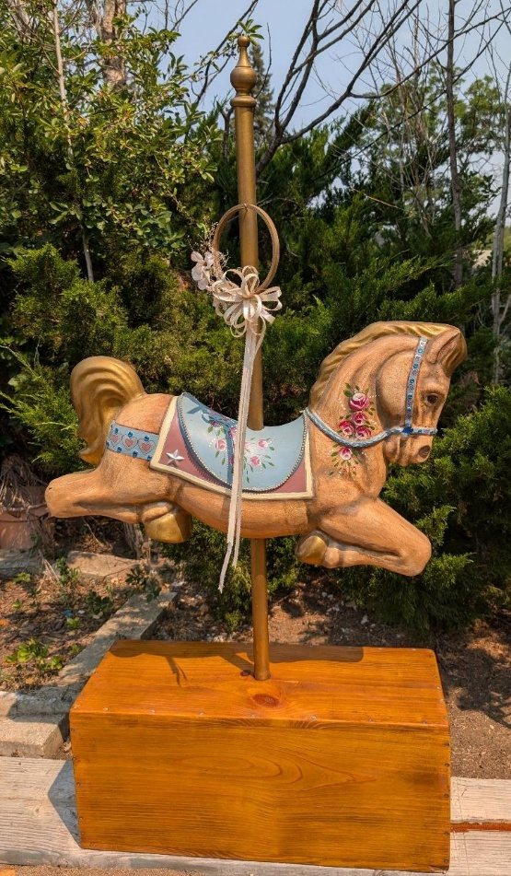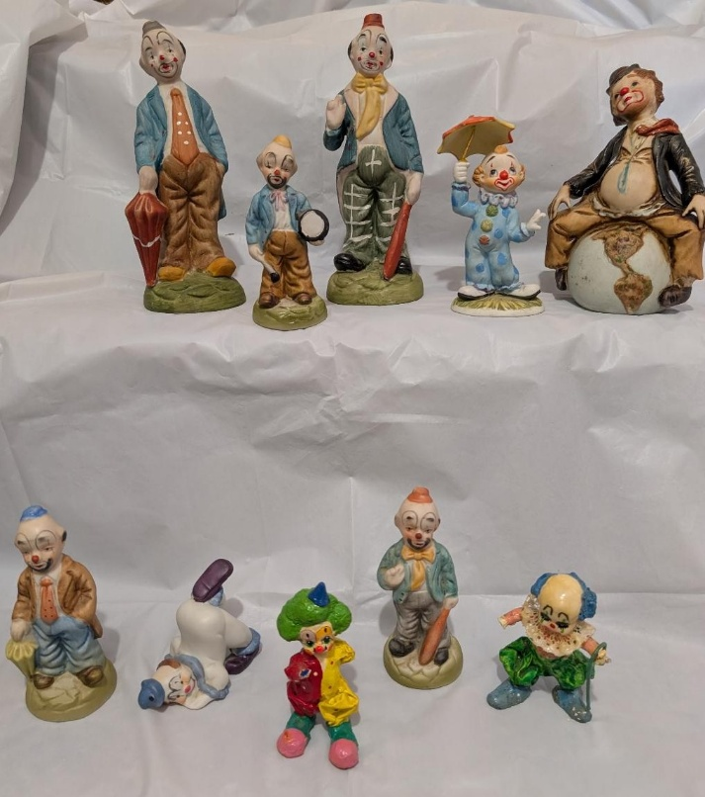
Carousel Horse Clowns

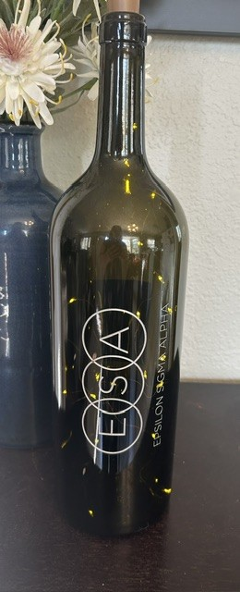
Ceramic Plate ESA Lighted Wine Bottle Flower Vase

The New Mexico State Council of Epsilon Sigma Alpha International invites you to attend….
2026 Rocky Mountain Regional Roundup
August 28-30, 2026
NRA WHITTINGTON CENTER
Raton, New Mexico
DIRECTIONS
Located just off Interstate Highway 25, north out of Albuquerque and south out of Raton. At New Mexico Exit 446 turn west onto State Highway 64. The NRA Whittington Center is 4 miles down the road on the right side. Everyone entering the facilities must sign in at the gate.
The building we will be using has a central lobby with three separate wings. Each wing contains five bedrooms, each with two single beds, a kitchenette and two separate bathrooms with showers. There are no bunk beds, and all rooms are on the same floor. Bedding provided. Bring your own towels and toiletries
We have housing for 30 people. Husbands or Guests may stay in the building as long as we do not exceed 30 total. They should register the same as a member. If we exceed 30 we will check into other options.
Send Registration to: Bobbie Massey For information contact Bobbie PO Box 316 575-640-2370 (cell) Las Animas, NM 88020 bjmassey@vtc.net
RESGISTRATION FORM
Registration Deadline: August 7, 2026
Registration: $125.00 per person, $130.00 late. Includes 5 meals and 2 nights lodging.
Name: State:
Address:
Phone Number: Email:
Special Dietary Needs:

News of the Weird

Nature Gone Wild
-- In Douglas County, Colorado, sheriff's deputies responded to a call about a break-in, only to discover the culprits weren't of the human variety: Two cubs had found their way into the home through an open window, UPI reported on July 27. After exploring the home, the bears settled on a dinner of cat food. Colorado Parks and Wildlife responded and assisted deputies in directing the bears out of the home and into the woods. [UPI, 7/27/26]
-- Meanwhile, over in Gold Hill, Colorado, a bear broke into an unlocked car overnight and, unable to get out, laid on the horn. All night. KOSI reported on July 22 that when the owner came upon his car the next morning, he saw the driver's side airbag had been deployed and the interior ransacked. Afraid to get too close, he devised a plan, no doubt inspired by parents of children with loose teeth: He tied a rope around the car door handle, walked a safe distance away ... and yanked. The door flew open and the bear ambled out and into the woods. [KOSI, 7/22/26]
--The summer heat isn't only getting to the humans. Just ask Katie Cole. On July 16, KDVR reported that she found a black bear cooling off in her kiddie pool. While the pool is actually for her dogs, Cole said she was glad the bear had a chance to go for a dip and cool down since the weather in that area has been so hot and dry. Colorado Parks and Wildlife said that compared to last year, there have been 1,000 more bear sightings, which they attribute to drought. [KDVR, 7/17/2026]
-- Customers and employees at a shopping mall at Joint Base Elmendorf-Richardson in Anchorage, Alaska, were surprised when a black bear triggered the automatic doors and wandered in, stole a peach and defecated on the floor before leaving, KTUU reported on July 7. "My coworker, who is cutting hair in front of me, yelled, 'Bear!' And I looked up from my phone, and the bear was walking into the barber shop right in front of me," barber Kory Godbout said. "And we all ran into the break room and shut the door behind us." Conservation Law Enforcement officers were able to herd the bear into the woods, away from the mall. [KTUU, 7/7/26]

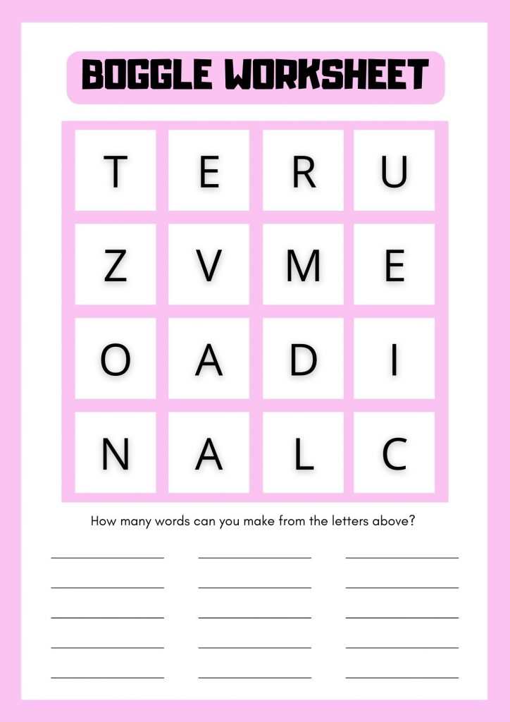

Sunday Funnies

