JUNE 2025 | VOLUME 79 | ISSUE 6
GOLDEN
LAMP
OF COLORADO
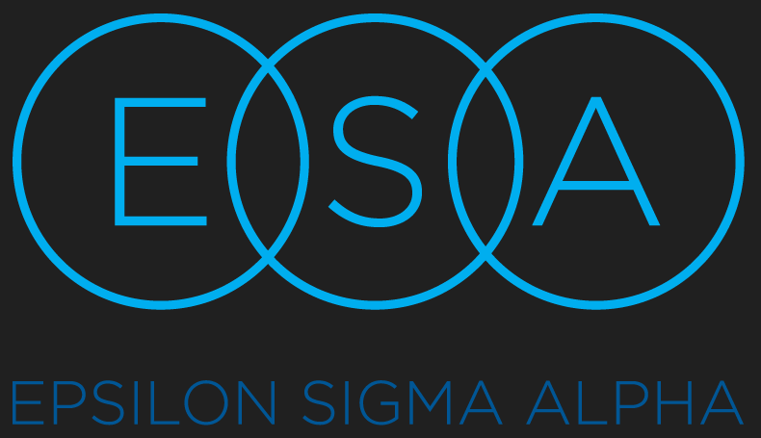
Page 14 Chapter Reports
Page 20 Adi’s Page
Page 23 Fall Fest
Page 24 State Convention
Page 28 Word Search
Page 2 Council Officers
Page 5 President’s Message
Page 7 Golden Lamp Editor
Page 8 State Reports

2024-2025

colorado state
council officers

PRESIDENT
SUSAN BLOSS

President-Elect/
Membership Coordinator
Lori Anderson-Havelick

Secretary
Susan Wint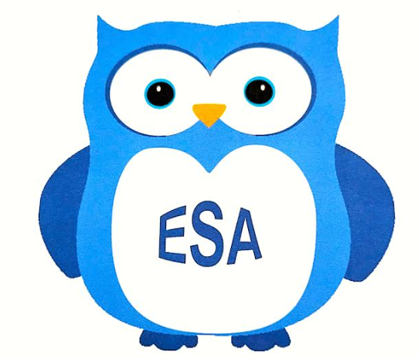n

Treasurer/Disaster Fund Chairman
Jenniffer Carlson-Mazza

Parliamentarian
Debbie Spear

Appointed Officers/Chairmen

COMMUNICATION COORDINATOR
Dana Bell

ESA FOUNDATION COUNSELOR
Susie Morris

GOLDEN LAMP EDITOR
Jenniffer Carlson-Mazza

WEBMASTER
Candie Patino

LAMPLIGHTER PRESIDENT
Rita Martin

LEADERSHIP & EDUCATIONAL FUND TRUSTEES
Nancy Camern
Debbie Spear

CONVENTION CHAIRS
Leslie Stevens
Chloe McClantoc

DISASTER FUND
Jenniffer Carlson-Mazza

PAST PRESIDENT/AWARDS
Karen Addison & Chloe McClantoc

CHAPLAIN
Phyllis Minch

EDUCATIONAL DIRECTOR
Rita Martin

PHILANTHROPIC CHAIRMAN
Mary Humphrey

ESA FOR ST. JUDE COORDINATOR
Chris Dostal

EASTERSEALS COORDINATOR
Deena Gregory

HOPE FOR HEROES CHAIRMAN
Kerry Date

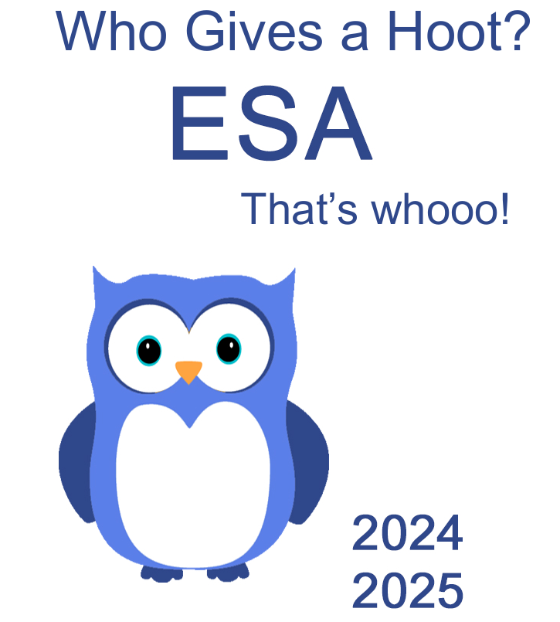

*** There are 6 owls throughout the newsletter! See if you can find them***

President’s Message

HOOT! HOOT! HOOT!
This year has been a HOOT! Thank you to everyone who has played a part in making this past year one of FUN, FRIENDSHIP, & SERVICE—Ya’ll are the best!
I hope you’ve enjoyed our meetings; we really tried to bring some FUN into everyone’s life.
As to communication, we all know life is better when we communicate. This year we started the Communications Email (esacoloradocommunications@gmail.com) and hope to see it continue as an easy way to share information quickly with our Colorado ESA family. Keep using it and keep everyone updated on any events, projects, fundraisers, etc.
The Communication Coordinator is now Eric Havelick at eric.havelick@gmail.com . This position will manage emails for Colorado ESA members’ communications. If you want to change your email, please contact Eric and he will do so. The Communication Coordinator will then update your email with the Chaplain and the Golden Lamp.
CONGRATULATIONS COLORADO ESA for supporting the Pikes Peak Honor Bell. I am so proud to say that we donated a grand total of $4318.00 to this campaign. For those of you who have not been able to attend our meetings this year, I chose the Pikes Peak Honor Bell as my CSC State President Project. The first Honor Bell is based at Fort Logan National Cemetery in Denver, CO. This Honor Bell is tolled at services for veterans at the request of family/friends. There is currently a campaign for the creation of a second Honor Bell for Pikes Peak National Cemetery. At this time, the service member artifacts chosen to be cast into the Bell have been transferred to the Netherlands to be included in the casting and it is hoped the Pikes Peak Honor Bell will be functional sometime this year. I’ll keep you all updated when the Bell will be placed in service. If you are still interested in donating, please go to HonorBell.org and choose Pikes Peak and note that it is from ESA Colorado.
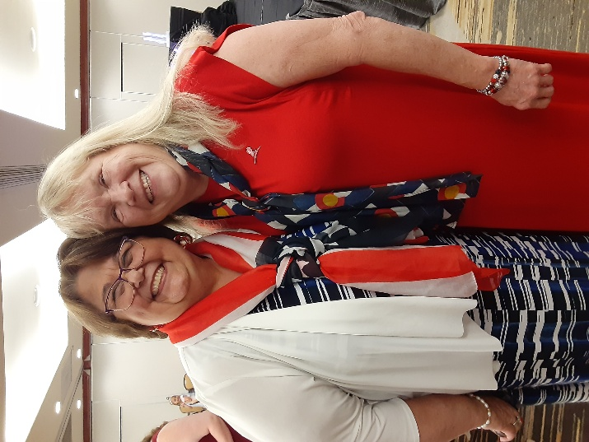

Thank you again for all you do in the name of ESA and our many projects.
Keep on Hootin’!
Susan Bloss
CSC President 2024-2025

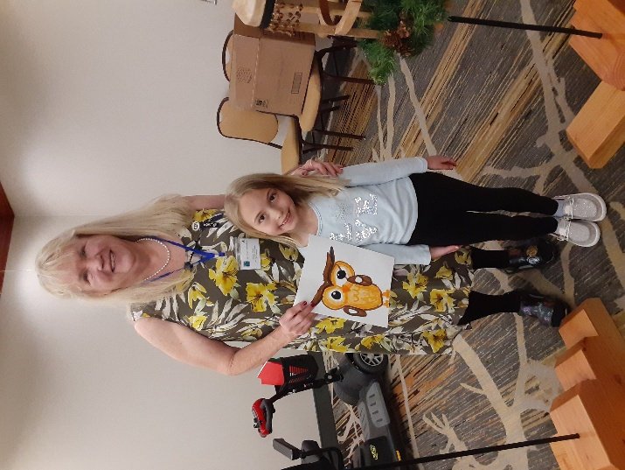
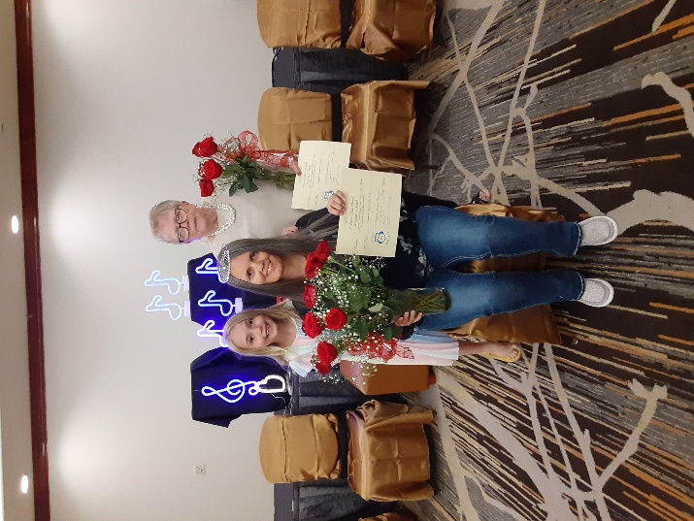
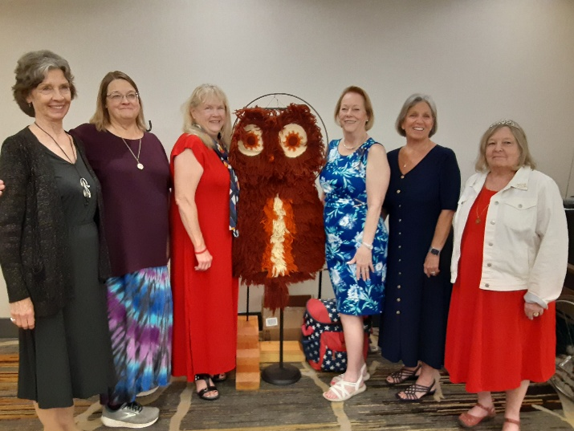
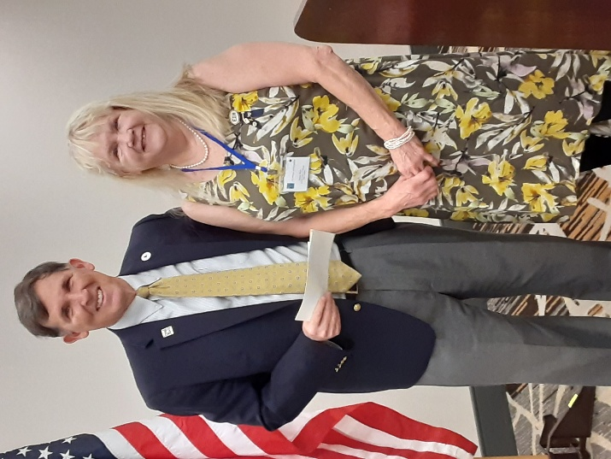
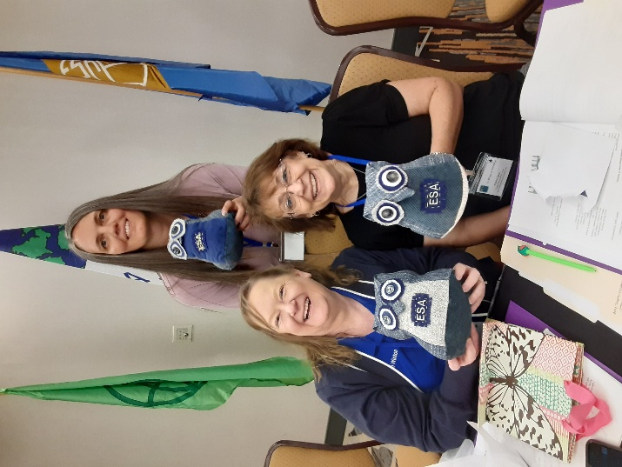
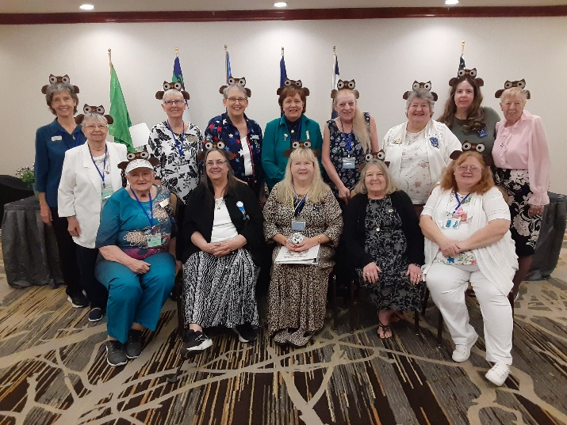
Golden Lamp

Hello for one last time from me as the Golden Lamp Newsletter Editor!!!!!
I can’t believe this is my last Golden Lamp. I also can’t believe it’s been 3 years since I started editing the Golden Lamp Newsletter.
I want to thank all who helped me make these issues great for the last 3 years. Thank you for turning in your articles, thank you for reading each newsletter, and thank you for all the amazing responses after you read each issue.
A huge thank you to Candie for being my eyes after I submitted to her each issue. Some nights were pretty late when I would finally email her a copy. I was so thankful that she would look over them. Candie it was an honor to work so closely with you. Thank you for everything.

I will meet up with Karen soon to hand over everything to her.

Her first newsletter will be in August. I can’t wait to see how great she does.

Thank you again

Love in ESA

Jenniffer Carlson-Mazza
2024-2025 Golden Lamp Editor

President Elect/Membership Coordinator

Theme: ESA Friends in Perfect Harmony

Colors: Red, White, and Blue (my favorite colors)

Flowers: Roses and Wildflowers

Symbol: Treble Clef

Just like in music. Where seemingly notes create a beautiful Melody. True Harmony in our lives emerge when we embrace our differences and work together with a shared purpose. It’s not about silencing dissenting voices, but about actively listening to them, understanding their perspectives, and finding common ground. Common ground is the Shared Key. In music, musicians must listen to each other to ensure their parts complement a whole. It is much like musicians in an ensemble. When we strive for Perfect Harmony, we unlock the potential for incredible creativity, innovation and collective progress in ESA.

My goal is to have better Communication within our group. To Utilize the Facebook Page and Media to get our name of ESA out into the public. My special projects are going to be centered around the Veterans. I have some ideas. Stay tuned for more information.

Please join me in a year of fun and education. I encourage all of you to try and make the Fall, Spring or State Convention mtg. When you miss these meetings, you are missing out on some Great information and Fun. These meetings are for everyone. We also have more activities on Friday afternoon/evening. We have had a Paint and Sip activity - 2 times at no cost to attend, Bunco - 2 times. This year at the Spring Fling mtg, we had a class on making your own cute bunny, had an excellent dinner and played Bunco. We had time to visit with each other. We had 7 to 8 tables, and it always grows. We will be working on activities for you to enjoy this year. We have a total of 265 members for the State of Colo. It would be great if we could get at least half of our membership to attend these meetings. At least try for 50 to 100 people. Bring friends and maybe more people can join ESA!!

Here are just a few short updates.

I collected a total of $400.00 for the Fun fest Night at IC. Thank you all for handing in your gift cards.

I forgot to mention please Update your Change of Officer Report form. The form is on our website. You can also find it on HQ Website and do it online. Just search on the HQ Website - Search Officer Change Form. Scroll down and you can see the Chapter form. You may also use snail mail and send it to me. My address is in the Yearbook. It is really important to get these changes into HQ as soon as possible. It also helps Eric (ESA Communications Coordinator) to get the Yearbook ready. You may contact me by email or call. loriandersonhavelick@gmail.com or 720 353 8839 for any changes.

Another reminder - For all Officers - please follow your Guidelines! They are there to help you.
I had a great time seeing everyone. It was a fun, fun, fun Convention!! Also, meeting our IC Rep - LeAnn Wray.

Thank you,
Lori Anderson Havelick
ESA CSC President
2025 2026

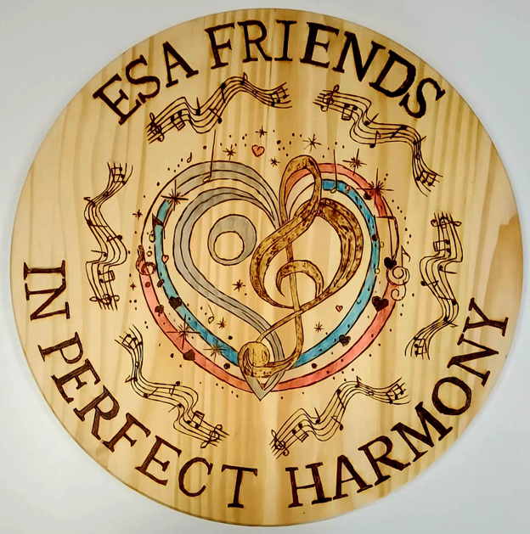

ESA Membership - Golden Lamp
A Brainstorming exercise

This is A Brainstorming Activity that was held at Leadership this year. We heard a speaker present these questions. We heard many Leadership presenters. This workshop is tied into a Membership Report and the workshop was well received at our ESA Colo Convention. It got the Members up and out of their chair, and they placed sticky notes on the podium for their answers. The Members talked about what they did to the whole group. The answers will be at the bottom of this report.

- What Fundraising efforts do you do Well?

- What did you learn from your last campaign/event that you can apply to make your event more successful?

- What is an activity or event you can do that you haven’t tried before?

- If money were no object, what’s the wildest fundraising idea you could do?

- What can you use to make the success of your campaigns and events beyond just dollars raised or attendance?

These are the answers from the Members in no particular order of the questions. Just the answers that were mentioned.

Cut out more coupons, a cruise, More Bunco events, Easter Seals - Queen Palmer School, Garage Sales, Wreaths Across America, CSC Email and Publicize more, Blingo Jewelry, Book Fair at Barnes and Nobles, Adi does cookie stands, St Jude Events, St. Jude drawings for the Farmers Marker, VFW and Bingo, Meals on Wheels, Donation Dinner, TV Ad Campaign, Coupons for Hope for Heroes, Mahjong Tournament, Tea and Bunco, Tea Parties, Yard Sales, Bake Sales, Make a Theme for our Bunco fundraiser, Honor Veterans, Bunco Fundraisers, Sell candy, We lip synch shows for St Jude, Selling nuts as a Fundraiser, Butter Braids Sales, Online popcorn, Dream Homes, Sell spiced nuts, Sell Rocky Roundup Cracker Mix at Christmas, Farmer’s Market in Ridgway - drawings for wooden lazy susans and/or plaques and Promote ESA - talking to people from around the United States, people come from all over - Every Friday thru the summer.

Invite more people outside ESA!

These are all great ideas, and these ideas could be used more than once a year. We could have several throughout the months and raise even more money.

Thank you for letting me go to Leadership and represent Colo for two years and one more year to go. It is always fun, meeting new people around the U.S. and you always learn something new. A learning experience.

CSC Membership Coordinator
Lori Aderson Havelick

Treasurer / Disaster Fund

Here is my report from State Convention

Treasurer’s Report

Beginning balance as of 03.22.2025 was $9,646.37

I wrote 2 checks
1st check to Lori Anderson-Havelick for Leadership meeting
2nd check to Beta Alpha for Susan and LeAnn's registration to State Convention
We had one Deposit of $157.00

Ending balance as of May 18, 2025 is $9,180.53

We had $10.00 in fines for no pins at convention.

Disaster Fund

We had raised a total of $3,138.50
We had three checks for $500.00 each.
Donations from:
Colorado Lamplighters
Denver Epsilon Council
Ten other chapters
and one individual member

We raised $140.00 for ticket sales on the quilt. I’m excited to say that Vickie Chavers-Bruso was the winner of the quit. I want to say a huge thank you to Mary Grannell from Alpha Omicron for donating the quilt to the Disaster Fund for the drawing.

Jenniffer Carlson-Mazza
2024-2025 Treasurer/Disaster Fund Chairman

Easterseals
Coordinator

I see that our I am pleased to announce that we earned $100 at Spring Fling and $166 at the State Convention from the basket auctions. Thank you to everyone for your generous support! By the time you read this Rocky Mountain Village Camp should be in full swing serving its first group of campers.
I spoke with the camp director on May 19th and he is so appreciative of our donations and hours of service throughout the year. His assistant mentioned that they can always use prom dresses, accessories and especially outfits for young men such as suit jackets for the weekly dances at camp.
Easter Seals has many programs throughout Colorado - I encourage you to visit their website https://www.easterseals.com/co/ to discover the many ways to donate and serve this worthwhile organization. I have enjoyed my tenure as Easter Seals coordinator this past year and learned a lot. Please welcome Ginger from Sigma rho as ESA's new coordinator in the coming year.

Deena Gregory
Easterseals Coordinator

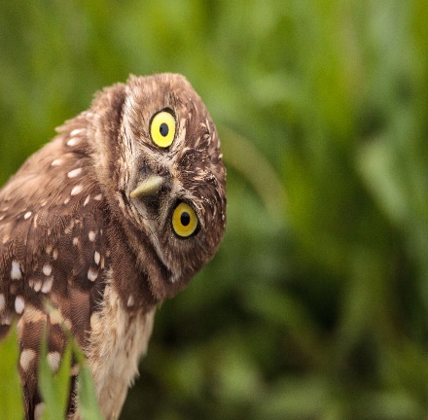
Webmaster

Colorado Web Team
esacolorado.org

So great to see so many of our members and I.C. Representative, LeAnn Wray from Michigan, at our “On Wings of Friendship” convention in Lakewood.
Our CSC Website continues to be updated. The annual update for the 2025-2026 presidential year will begin in August and should be completed by the Fall meeting.
The “PROJECTS” page contains a few projects that CSC supports including pictures of related Colorado activities.
Pikes Peak Honor Bell Fund
- Information regarding the Bell fund as well as pictures from Spring Fling Bell activities have been provided.

St. Jude Events
- 2025 Dream Home information has been added for both the Denver and Colorado Springs homes.
- Adi has been a very busy young lady. View her section to see some of the projects she has been undertaking and the funds she has been able to raise. She also has TV coverage – three news spots!

Easterseals
- New pictures from Easterseals Coordinator, Deena Greogory, have been added.

Hope for Heroes
- Gamma Chi shares several pictures of their H4H projects.

“OFFICERS/CHAIRMEN” page
Be sure to check the “Notices” section for the following:
- CSC Convention Winners
- Minutes from Spring Fling
- Minutes from CSC Convention (as soon as they are received)

The “CALENDAR” page continues to list lots of exciting dates. Be sure to check it out for more upcoming events. To post your event to the Calendar, contact the web team.
WHO has made our website a success? YOU have, that’s WH!
Mahalo!
The Colorado ESA Web Team
Bonnie & Candie
Alpha Omicron
Salida, CO

I can’t believe we are already in May and the 2024-2025 year is coming to an end.
Last week we met at Velma McCormick house for our end of the year party.

We installed our new member Jo Ross, we also installed our new officers for next year. Each member brought an appetizer to share, and Diana Wood made a beautiful birthday cake which we celebrated everyone’s birthday.

Adi and I were able to go to State Convention this year. We had so much fun, we met new friends, hung out with amazing ladies, enjoyed good food, and had the best weekend. Thank you to everyone who made it a great convention.

I want to say a huge thank you to everyone who was behind naming me “Outstanding Member of the year” I was not expecting it, and it is truly an honor. I will always treasure this award. Thank you all so much. I means the world to me.

We do have an exciting announcement ALPHA OMICRON WILL BE HOSTING FALL FEST AGAIN THIS SEPTEMBER. Please see the flyer below. We are going to make it a great weekend!!!! Keep an eye out for details.

For the last 3 years I have been the President of Alpha Omicron, this is my last year as president. I want to thank our whole chapter for making it a fun 3 years and I want to say a huge thank you for everything. You all have made it memorable. I am truly lucky to be part of this chapter. We have the best members and the best chapter. Thank you all again for everything!!

Love in ESA
Jenniffer Carlson-Mazza
2024-2025 Alpha Omicron #770
Chapter President

Alpha Phi
Golden, CO

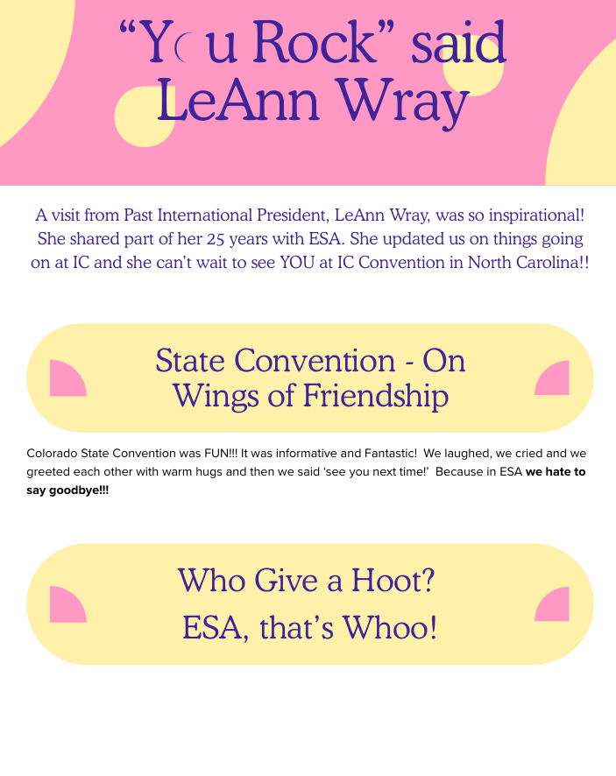

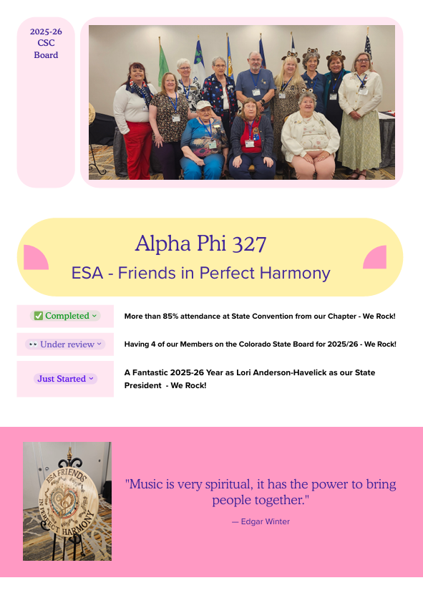
Beta Zeta
Canon City, CO

Beta Zeta hosted the 2025 Founder’s Day celebration at the Steeple Events Center in Cañon City on May 14th. A wonderful evening was spent with our sisters from Omega Chi chapter in Florence. The installation of officers for the coming year was conducted as well as service awards for several members. B. J. Schmidt was honored for 50 years of service in ESA.
Jewel Pin ceremonies were celebrated for new members Debra Beaumont and Sue Mcmillen of Beta Zeta, Paula Walker and Carrie Elliott of Omega Chi. These gals have already proved to be valuable additions, participating in many chapter activities this year.

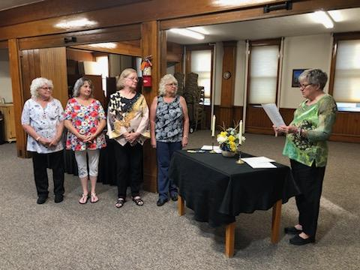

Gamma Chi
Loveland, CO

Summer is here and it is enjoyable to see all the beautiful flowers already in bloom. It is time for some of our activities to slow down.

On April 11th Gamma Chi hosted a blood drive in the parking lot of the Golden Corral. The drive netted 18 units, 18 whole blood, and power blood for a total of 46 units. There will be another one in October. Later in the month seven of us attended the Alternatives to Violence Purple Ribbon breakfast. We also helped with the Project Prom Dresses on two different days. It is always fun to see the young girls come in and try on the dresses.

At the May meeting we presented a $1,000 check to Ron Albers and his co-sponsor of the Veterans Honor Monument to the Vietnam Veterans. Gamma Chi will be recognized on the monument. The day after convention RuthMary, Deena, and Kathy Fischer drove to the Easter Seals Camp to take part in the camp work day. Susan Bloss also met them there. Our chapter purchased a sink for the laundry area. They completed various jobs and had a good time. Next week we will have our Installation dinner. We are also celebrating our new member, Tammy Muzzio. We will have some other guests that are also interested in joining.
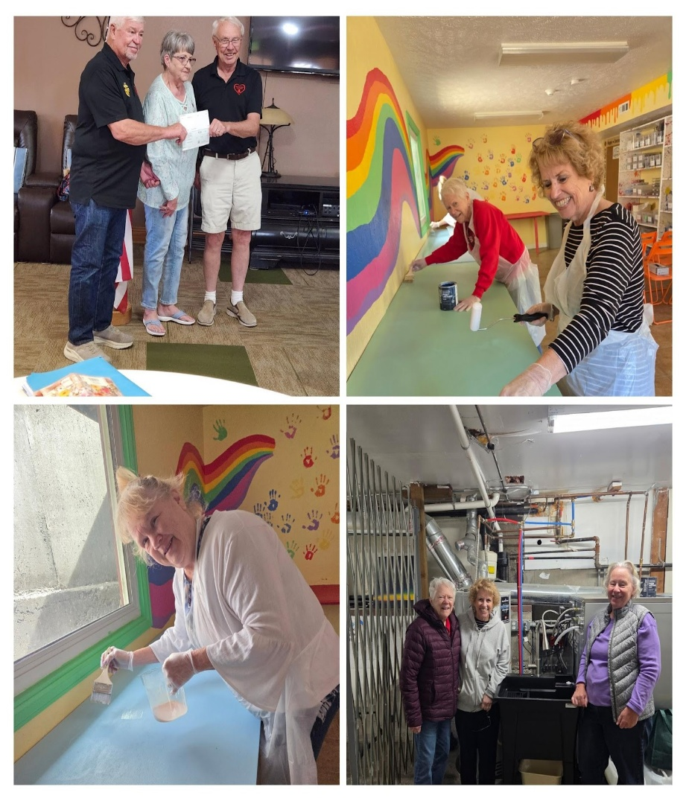
During the summer we will continue to maintain the flowers at the sculpture we adopted years ago. Throughout the summer we will be volunteering at Loveland Lake to Lake Triathlon, Envision Walk/Run in Evans, Wild West Relay, Exchange 3 in August, and throughout the summer hand out bread and vegetables at the Veterans Clinic. We will continue to also help at the Food Bank and the Community Kitchen.

Kerry, Phyllis, Deena, and Lisa had a good time at the Convention. To all of our sisters, have a great and relaxing summer.

Pam McGee

Zeta Nu
Colorado Springs, CO

I was unable to attend Spring Board last weekend, but I hear it was a lot of fun! It has been a struggle the last few years to get our conventions scheduled in a timely manner. We used to take bids three years out, but now we are struggling to book the upcoming year. We all know that since COVID, prices have gone up, many places either closed or revised their accommodations and some prices have raised significantly. Fortunately, we are ESA, and we are very good at coming up with new ideas and adjusting accordingly. We are looking for smaller hotels that are still reasonably affordable. We sometimes must find unconventional places to meet, and that has proven both interesting and fun!

I am happy to hear that Sigma Rho has offered to host the State Convention in Loveland. So far, we do not have specifics, but we will pass on that information as soon as we hear. I encourage everyone to come. If you haven’t attended conventions in the last few years, we strive to make them more fun and interesting. It is wonderful coming together with lifelong friends from all over the state.

I am also excited that we will be returning to Salida for our Fall Board. Cheers to Alpha Omicron for hosting once again! We always have a great time there. The date is set for Sept 26 and 27. Put it in your calendar now!

Tell me it’s not so!! Lori just told me that Leadership in February may be held via zoom instead of in person. I know most of us don’t attend Leadership each year, but it is disheartening to hear about change. When one goes in person, we usually share a room with someone from another state and often we gain a new friend. We get to meet the incoming IC board and socialize with others from all over the country. It is a wonderful experience! We lose all of that when we do a zoom meeting.

Whether for Leadership or conventions, when we meet through a zoom meeting, we don’t get to visit with friends, or to meet new people. We lose out on the conversations where we learn about what other chapters are doing in their fundraising, service projects and recruiting. And we miss out on hugs. Hugs are essential in my book. I don’t want to give them up. Let’s keep the in-person conventions alive. Step up and host an event. If you need help, it is always available.

Please talk within your chapters. Plan on attending some of the conventions. Meet friends, young and old!

Let’s toast to an exciting coming year!

Karen Addison
ESA Zeta Nu
Colorado Springs

PS I am excited to be taking over as Editor of the Golden Lamp as well as the Educational Director. My email address is karenadd.esa@gmail.com . Please put “ESA article” in the header so I don’t miss any articles. I will reply back to you when I do get it. My phone number is 719.482.5820. Thanks.

Adi’s Page

Adi has so much going on this summer, I don’t know if I will be able to keep up.
We do have some really exciting news.
We received an email in April from Ike Anand with St. Jude letting us know that Adi was named the 2025 Jerry Nicholson Award Winner!!
St. Jude gives out 40 volunteer awards and they only give out one youth award, this award is making Adi the most recognized youth fundraiser throughout the country this year.
The Jerry Nicholson Award is given in memory of a St. Jude patient from Riverside, CA who led campaigns to obtain funding for the hospital in the early 1960’s. Nominees must be 19 years old or younger. St. Jude gets nominees from all 50 states. Phyllis found out that Adi is the youngest in years who has won this award.
We take Adi to the St. Jude campus this summer where they will present her with the award. I can’t wait for Adi to see the campus in person.
Her goal for 2025 is $20,000.00, and to help her reach her goal she has quite a few fundraisers coming up. Two big fundraisers are her spaghetti dinner (flyer attached) AND…..
Gamma Chi is helping Adi with a BUNCO fundraiser. (flyer attached) We will also send out more information as we get more!!! We are so excited for this fundraiser.
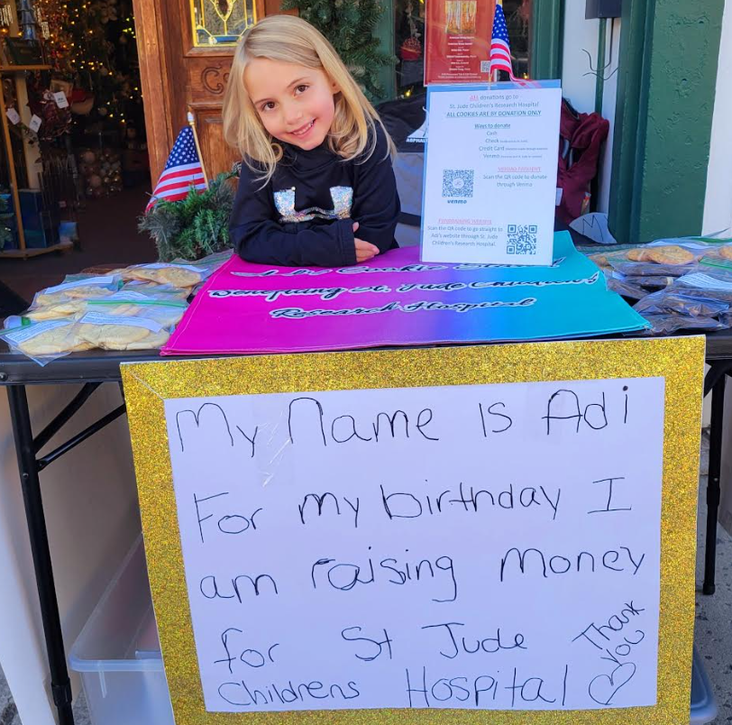
She is still setting up cookie stands through the summer, she will have a Pampered Chef Party in August (where 30% of sales will go towards her fundraising.) She also walks in the St. Jude 5K walk in Denver, CO. The walk is on September 20th. We would love to have ESA members, friends, and/or family walk with us. Last year we were the only ones from ESA. If you would like to join Adi’s team and walk with us, please let me know. We would love for you to be there!!!
Adi has a Facebook and Instagram Page that follows all her fundraising. If you would like to follow her pages just search “ADI’S COOKIE STAND” on either Facebook or Instagram.

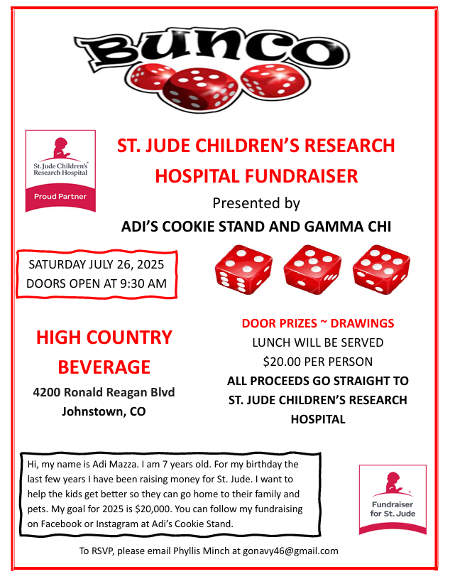
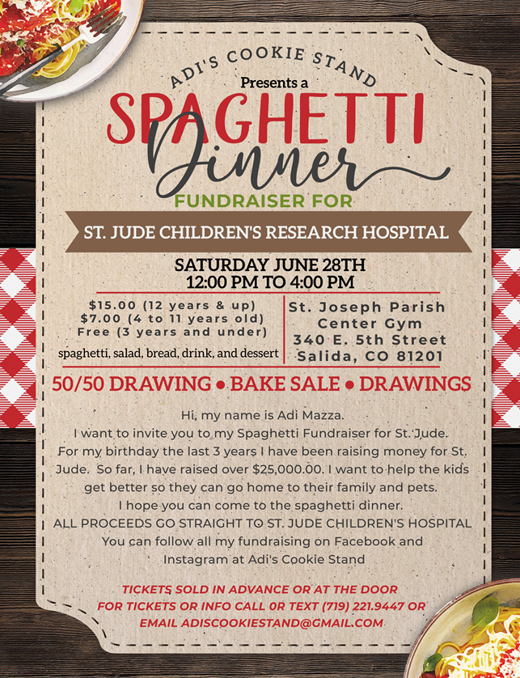
FALL FEST

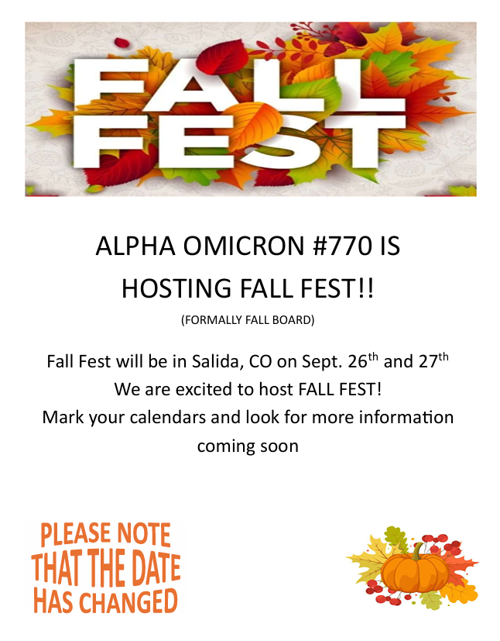
State Convention

Hello all!!

The Motley Crew would like to thank everyone who came to Convention!

We think it went pretty smoothly, outside a few things beyond our control!! It's ALWAYS something, isn't it???

We certainly HOPE our attendance numbers ARE NOT a portend of future Conventions, Ladies! We don't put on a Convention for OUR health! We do it for YOU! To make a welcoming place to celebrate all YOU do!

It's not a Secret about when it's gonna be! About the same time every year! But maybe we need to change that? Maybe we need to look at changing A LOT of things around our Convention. Something to consider!!??

We had fun doing this year's, and we hope you enjoyed it, too!

I do need to acknowledge our Crew! Couldn't have done it, without them!

Chloe McClantoc - Co -Chair - Contracts
Joan Snyder - Communications/Programs
Susie Hitchcock - Registrations
Yvonne Ferrell - Registrations/ Drawings
Mary Humphrey - Treasurer
Nancy Cameron - Contracts - Fri. Mixer
Rita Martin - Sat. Luncheon - Drawings
Joyce Fuller - Sat. Banquet - Pic. Corner
Vickie Chavers - Bruso - Sun. Brunch
Bettie Maxwell - Drawings Sales - All around help.
Leslie Stevens - Co -Chair - Facility - Drawings

Congratulations to Lori and her new Board!

Until next year, we'll see ya all at Fall Board in Salida! YAY!!
A MOTLEY CREW.

2024-2025 Colorado State Council Awards

Friday May 16, 2025

Membership Awards
Chapters with Growth
1st Place: Alpha Omicron #770 - Salida

Individuals Sponsoring New Members
1st Place: Vicki Butts, Beta Zeta #3149 - Canon City
2nd Place: Megan Reid, Delta Chi #5052 - Akron
Jan Hagen, Epsilon Epsilon #1896 - Denver
Peggy Kelly, Omega Chi #4842 - Florence
Cheryl Cahill, Zeta Nu #5608 - Colorado Springs

Golden Lamp
1st Place: Alpha Omicron #770 - Salida
Gamma Chi #3668 - Loveland
Pi Sigma #5621 - Johnstown
2nd Place: Beta Zeta #3149 - Canon City
Alpha Phi #327 - Golden

ESA Foundation
New Members
Carol Graham, Gamma Omega #4306 - Akron
Jessica L. Filla, Gamma Omega #4306 - Akron

Educationals
Chapters
1st Place: Zeta Tau #2064 - Colorado Springs
Zeta Nu #5608 - Colorado Springs
2nd Place: Alpha Phi #327 - Golden

Golden Link Awards
Mary Chamberlain and Jane Schuh, Beta Zeta #3149 - Canon City
Julie Zehner, Zeta Nu #5608 - Colorado Springs
Eric and Lori Anderson-Havelick, Alpha Phi #327 - Golden
Kevin Richards, Zeta Tau #2064 - Colorado Springs
Distinguished Athenian
Julie Zehner, Zeta Nu #5608 - Colorado Springs

Disaster Fund
Individual
1st Place: Vickie Chavers-Bruso, Epsilon Epsilon #1896 – Denver

Chapter
1st Place: Theta Eta #2830 - Denver
Gamma Chi #3668 - Loveland
Sigma Rho #5014 - Loveland
2nd Place: Alpha Nu #535 - Akron
3rd Place: Epsilon Epsilon #1896 - Denver

Council
1st Place: Colorado Lamplighters

Saturday May 17, 2025

Philanthropic
Hours Per Member
1st Place: Alpha Phi #327 - Golden
2nd Place: Beta Alpha #5416 - Aurora
3rd Place: Pi Sigma #5621 - Johnstown

Combined Monies Per Member
1st Place: Epsilon Epsilon #1896 - Denver
2nd Place: Beta Alpha #5416 - Aurora
3rd Place: Alpha Phi #327 - Golden

Hours Per Member Reporting Troopons
1st Place: Gamma Chi #3668 - Loveland
2nd Place: Zeta Nu #5608 - Colorado Springs
3rd Place: Alpha Gamma #174 - Denver

Combined Monies Per Member Reporting Troopons
1st Place: Zeta Nu #5608 - Colorado Springs
2nd Place: Alpha Gamma #174 - Denver
3rd Place: Theta Eta #2830 - Denver

Easterseals
Hours Per Member
1st Place: Zeta Tau #2064 - Colorado Springs
2nd Place: Gamma Chi #3668 - Loveland
3rd Place: Alpha Phi #327 - Golden

Combined Monies Per Member
1st Place: Zeta Tau #2064 - Colorado Springs
2nd Place: Epsilon Epsilon #1896 - Denver
3rd Place: Alpha Phi #327 – Golden

ESA For St. Jude
Hours Per Member
1st Place: Alpha Phi #327 - Golden
2nd Place: Alpha Omicron #770 - Salida
3rd Place: Zeta Nu #5608 - Colorado Springs

Combined Monies Per Member
1st Place: Alpha Nu #535 - Akron
2nd Place: Pi Sigma #5621 - Johnstown
3rd Place: Alpha Phi #327 - Golden

Dream Home
Hours Per Member
1st Place: Beta Alpha #5416 - Aurora
2nd Place: Kappa Iota #5442 - Golden
3rd Place: Zeta Tau #2064 - Colorado Springs

Miles Per Member
1st Place: Beta Alpha #5416 - Aurora
2nd Place: Kappa Iota #5442 - Golden
3rd Place: Alpha Phi #327 - Golden

Travel Award
1st Place: Kappa Iota #5442 - Golden

Service Awards
15 Years Bettie Maxwell, Chi Kappa #5129 - Denver
20 Years Emily Westphal, Sigma Rho #5014 - Loveland
40 Years Patty Ehrlick, Pi Sigma #5621 - Johnstown
40 Years Lori Anderson-Havelick, Alpha Phi #327 - Golden
40 Years Joyce Fuller, Theta Eta #2830 - Denver

80 YEARS Alpha Nu #535 - Akron

Outstanding Chapter of the Year
1st Place: Gamma Chi #3668 - Loveland
2nd Place: Alpha Phi #327 - Golden
3rd Place: Alpha Omicron #770 - Salida

Pioneer Member
Yvonne Farrell, Delta Theta #1898 - Denver

Outstanding Member of the Year
1st Place: Jenniffer Carlson-Mazza, Alpha Omicron #770 - Salida
2nd Place: Phyllis Minch, Gamma Chi #3668 - Loveland

