**FEBRUARY 2025 | VOLUME 79 | ISSUE 4**

GOLDEN

LAMP

OF COLORADO

**Page 12 Chapter Reports**

**Page 18 Spring Board**

**Page 20 State Convention**

**Page 22 Word Search**

**Page 2 Council Officers**

**Page 5 President’s Message**

**Golden Lamp Editor**

**Page 7 State Reports**

**2024-2025**

**colorado state**

**council officers**

**PRESIDENT**

**SUSAN BLOSS**

**President-Elect/**

**Membership Coordinator**

Lori Anderson-Havelick

**Secretary**

Susan Winton

**Treasurer/Disaster Fund Chairman**

Jenniffer Carlson-Mazza

**Parliamentarian**

Debbie Spear

**Appointed Officers/Chairmen**

**COMMUNICATION COORDINATOR**

Dana Bell

**ESA FOUNDATION COUNSELOR**

Susie Morris

**GOLDEN LAMP EDITOR**

Jenniffer Carlson-Mazza

**WEBMASTER**

Candie Patino

**LAMPLIGHTER PRESIDENT**

Rita Martin

**LEADERSHIP & EDUCATIONAL** **FUND TRUSTEES**

Nancy Cameron

Debbie Spear

**NVENTION CHAIRS**

Leslie Stevens

Chloe McClantoc

**DISASTER FUND**

Jenniffer Carlson-Mazza

**PAST PRESIDENT/AWARDS**

Karen Addison & Chloe McClantoc

**CHAPLAIN**

Phyllis Minch

**EDUCATIONAL DIRECTOR**

Rita Martin

**PHILANTHROPIC CHAIRMAN**

Mary Humphrey

**ESA FOR ST. JUDE COORDINATOR**

Chris Dostal

**EASTERSEALS COORDINATOR**

Deena Gregory

**HOPE FOR HEROES CHAIRMAN**

Kerry Date

**owls throughout the newsletter! See if you can find them\*\*\***

**President’s Message**

What a FRIGID winter we are having; hope everyone is staying warm and keeping safe.

Plans are moving along with a couple of ESA State Meetings coming up.

March 21 & 22 will bring our “ESA Colorado Spring Fling” in Colorado Springs. We are dropping the name “Spring Board” as some members felt they weren’t welcome as it was a meeting only for our Board members. Let’s try this new idea of calling the Fall & Spring meetings what they are—ESA Colorado Meetings for ALL the membership. It’s a great time to gather and share some fun activities & social time along with taking care of any business we may have. Remember ESA Colorado should serve all our ESA members. The Fall & Spring meetings tend to be more informal and social than State Convention, so please consider joining us. We will have the actual meeting at the Cliff House in Manitou Springs. This is where the first ESA chapter in Colorado was chartered so kind of a cool connection. The information and registration form are on our Website Calendar and easy to find; go to esacolorado.org, click on the calendar on the left toolbar and there you are. We will also send out the registration form through our communications email again.

ESA Colorado State Convention, “On Wings of Friendship” is also coming up May 16,17 & 18 in Lakewood, Colorado courtesy of the Motley Crew. Registration is open; this registration form will also be available through the Website Calendar for your convenience. This is a great time to meet ESA people from across the state. There are opportunities to connect with old friends, make new friends, take care of business so ESA stays strong and relevant AND most motivating of all is the chance to recognize the achievements of our members and chapters. Think about attending—it’ll be fun! **A blue and white owl
**

I will again be attending the ESA Leadership Conference in Denver in February; also attending will be Lori Anderson -Havelick who as President Elect is our “official” representative for Colorado. We will be gathering information on all things ESA. There are tips on how to market ESA, how to publicize your events and how to grow our membership. Lori will have a report for you at Spring Fling.

If you have any feedback on our new communications email, Dana & I would love to hear from you. Communication is SO important, so we are really trying to make it useful and informative. You can reach us at [esacoloradocommunications@gmail.com](mailto:esacoloradocommunications@gmail.com) with any feedback.

So---keep on HOOTIN!!!

Susan

**Golden Lamp**

Hello everyone,

Just a reminder!

All articles are due on the 1st of the month and the newsletter will be uploaded on the website on the 10th of the month. I will be sending out 2 emails, one will be a reminder, and the 2nd will be to let you know the newsletter is ready to be viewed on the website.

Please reach out to me at any time with any questions or comments about the Golden Lamp.

My email is goldenlampnewsletter@gmail.com or call / text me at (719) 221.9447

Please send all articles to: [goldenlampnewsletter@gmail.com](mailto:goldenlampnewsletter@gmail.com) Please submit your articles by the 1st of the month. The Newsletter is published in August – October – December – February – April - June

In the subject line put **Golden Lamp Article**

**Please make sure I respond to your email. If I don’t respond, then I didn’t receive it.**

The Golden Lamp newsletter will be uploaded on the 10th of the on [www.esacolorado.org](http://www.esacolorado.org)

Jenniffer Carlson-Mazza

2024-2025 Golden Lamp Editor

**Easter Seals**

Easter Seals Colorado is excited to share their programs and services for individuals with disabilities, older adults, and caregivers through a new video.

From inclusive camps to employment support and day programs, this video highlights the incredible stories of resilience, growth, and community that define their mission.

Watch it HERE <https://aesbid.org/ELP/ESCANPP25> and see how they are creating a more inclusive and accessible Colorado every day. The next available fundraiser for Colorado is titled "The Perfect Pairing" and will be held at Rocky Mountain Village Camp on April 26, 2025. Information can be found here:  A Perfect Pairing, 12th Annual.

Please continue to support Easter Seals with your donations and service!

Deena Gregory

Easter Seals Coordinator

**Educational**

Just a Reminder that all Educationals are due by April 1st.

Remember If you want your book to be sent on to I.C. It MUST be in a 3-ring notebook to meet Their requirements.

I will accept any or all of them at Spring Board, and am looking forward to seeing what everyone has been doing this year.

Rita Martin

Educational Director

**Past President / Awards**

Greetings!

As I glance out the window at yet another fresh layer of snow, I can’t help but look forward to the arrival of spring. This winter has certainly brought an abundance of snow and frigid temperatures to our area!

I am thrilled that our **Spring Board Meeting** will be held right here in **Colorado Springs**—it will be a wonderful opportunity to come together. Saturday, we will be meeting at the Historic Cliff House in Manitou Springs!

With spring approaching, I want to remind everyone that **Philanthropic Reports**—including **St. Jude, Hope for Heroes, and Easterseals reports**, as well as **Award Nominations**—are due by **April 1**. You can find all the necessary forms on our website at [ESAColorado.org](http://ESAColorado.org).

As Past Presidents, **Chloe McClantoc** and I are honored to co-chair this year’s **Awards Program**. We kindly ask that all **award nominations** be submitted to Chloe at **chloe_mar@msn.com** no later than **April 1**. Nomination forms are available online for the following categories:

* **Pioneer Member**
* **Outstanding Member of the Year**
* **Outstanding Pledge**
* **Outstanding Chapter of the Year**

We appreciate your participation and look forward to recognizing the incredible contributions of our members. Please don’t hesitate to reach out if you have any questions.

Looking forward to seeing you all soon!

Karen Addison

**25 Past President

**Philanthropic**

Reminder: Philanthropic Reports are due **by** April 1; they may be emailed or mailed. The current form is on our Colorado website under Yearbook; be sure to complete both pages of the form.

The current IRS mileage rate is **$.67**, as posted on the current IC Philanthropic Report form on the HQ website.

Report the following:

|  |  |  |  |
| --- | --- | --- | --- |
|  |  |  |  |
| Hours | Monies | Donated Goods | Miles |

After you complete the Philanthropic Report, please complete and forward the Colorado forms for Easterseals, St. Jude, and Hope for Heroes to the appropriate Coordinators or Chairman. All forms were reviewed and revised by the Guideline Committee in September 2024; they are posted on our Colorado website.

Please contact me if you have any questions, my information is in the Yearbook.

Mary Humphrey

Philanthropic Chairman

**Webmaster**

**Colorado Web Team**

esacolorado.org

February, the month of hearts, flowers, and thoughts of LOVE, LOVE, LOVE!

Speaking of LOVE, we love all the items we have received for posting to our Colorado ESA website as we head toward our 100th anniversary in 2029. Thank you, thank you, thank YOU! Our website continues to be a source of information as well as the latest/greatest instructions and forms.

In addition, we would LOVE to receive MORE. More items for our ***Projects*** page would be fabulous! We know you are having great fund raisers for your many great projects and would like to share them with all our members. Don’t be shy. We can’t wait to see them.

Considering the Bylaw and Guidelines updates, a new page has been created – **“Communications Corner”**. Colorado ESA has lots of news/information to share and several options in which to relay this to the membership. This page explains these options which include Communications Coordinator, Chaplain, Golden Lamp, and the CSC Website.

Running for Colorado State Council? You can find the Nomination form, due February 15, on the ***FORMS*** page.

Having problems finding what you need on the CSC web? The ***Site Map*** (on the upper left margin of home page) lists all the pages and their contents. The Web Team is always available to help.

Looking forward to seeing you at the March Spring Board!

The Colorado ESA Web Team

Bonnie & Candie

**Alpha Omicron**

**Salida, CO**

HAPPY VALENTINE’S DAY!!!

We had a fun social last month. We did a Jewelry Auction. Each member brought jewelry they didn’t want anymore and each of us received $4,000.00 in funny money to spend on the jewelry. We had a lot of fun spending our fake money and getting some new jewelry.

Adi and I went to Pi Sigma’s “Valentine Tea with a Flair. We had a lot of fun. A huge shout out to Patty and Pi Sigma they did an amazing job down to every detail, it was absolutely a beautiful tea. Patty shared all her teacups and the meaning behind them, you can tell hard work went into their fundraiser. Well done!!!!!

We are looking for warmer weather, it has been so cold and windy here. I can not wait for spring to get here.

In a few weeks I will be going to Gamma Chi’s fundraiser and then spring board. I love when chapters have fundraisers, it gives me an excuse to travel, support our ESA members, see familiar faces, and meet new faces.

Love in ESA

Jenniffer Carlson-Mazza

2024-2025 Alpha Omicron #770

Chapter President

**Alpha Phi**

**Golden, CO**

# Alpha Phi has been cold…. Even in AZ!

With winter temperatures in CO staying near 0 degrees, the chapter is keeping busy and helping where we can! It has been cold…. Even our chapter members in AZ got into the 30’s!

In December we had a ways and means fundraiser that made over $600. With several individuals donating to our cause, we had a total of over $700. This was a great fundraiser, and we really thank those of you who helped our chapter! THANK YOU!!

Volunteering is a regular for our AZ chapter members who usually have great weather! Sandy and David regularly volunteer at Help My Starving Children and St. Mary’s Food Bank. They are also regularly seen at State Farm Stadium volunteering in the booths there. A surprise request for January 13th came as the California fires had the NFL moving their game to AZ. Sandy and David were asked to help cover hours.

A couple members of Alpha Phi were able to attend the WSRC Spring Fling in Tucson. Sandy Alexander and Susan Winton joined more than 35 women who enjoyed the offerings of Tucson and spent a wonderful time getting to know or spending time with great friends!

Sandy, Cleoria & Susan


**

A group of ESA members with and without our hairnets! We are volunteering at Help My Starving Children.

In Colorado, one of our members, Bill Winton, continues to help weekly at a local non-profit that uses mini horses to give comfort to those in need. He helps to keep the stable clean by mucking stalls and replacing hay for the comfort of the therapy horses.

February will find us doing an Educational on many of the parks in CO!

May you stay warm in this unusually cold winter!

Susan Winton

President, Alpha Phi

**Gamma Chi**

**Loveland, CO**

We are well into the new year and are keeping busy.

As a chapter Gamma Chi kept very busy through December. We started off handing out 72 coffee mugs filled with goodies and lap robes to many Veterans at the Veterans Clinic in Loveland. This has become an annual event. We also continued to collect 500 pounds of nonperishable food items, toys and monetary donations for the Kayla Foundation. Eric and Lisa Adsit came by Phyllis’s house a couple of times to collect the items. As the month went on, we stuffed 150 Christmas stockings and handed them out to the Veterans breakfast on Saturday December 21st. During the month some members also sent Christmas cards to some of the veteran’s that are alone.

Phyllis finally finished making candy and was extremely happy to put her cooking supplies away for another year. I think Chuck was happy, too. Other members after boxing and wrapping many boxes of candy were also relieved that the fundraiser was over. We also put platters of homemade cookies together for the staff at Culver’s in Johnstown as a thank you for their support of many of our activities.  Before Christmas some of us attended the grand opening of the Landing which is supported by the Matthews House which is our President Kerry’s philanthropic project. It is a beautiful facility for your people that are experiencing homelessness or just out of the foster system and need support.

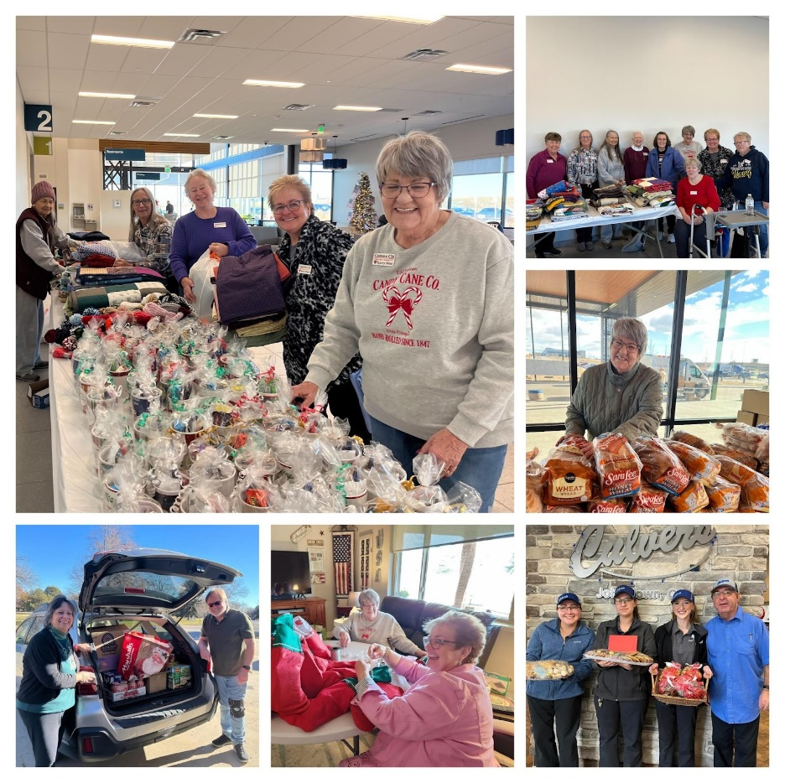

At our December meeting we had Kathy Baumgardner come and speak about Child Safe which now has a facility in Loveland. They provide individual, family, group therapy, and play therapy to victims of abuse. In January Lorriane Snow from The Arc came and spoke at our meeting. This organization helps and supports people with Intellectual and Developmental Disabilities. It is always an eye opener as to the many needs of people in our community. Both organizations have been in the community for many years, but we weren’t familiar with either group.

We continue to volunteer at the Food Bank and Community Kitchen. 

As a chapter we also want to congratulate Phyllis being named in December Hero of the Month by Fox 31 News. This honor was for all her involvement with the Veterans.

To all our sisters in Colorado we wish you a Happy Valentine's Day from Sweetheart City.

That’s our news. See you in March at Spring Board.

Pam McGee

**

**Pi Sigma**

**Johnstown, CO**

Hello ESA Colorado Friends and happy LOVE month,

February 8, 2025 plans to be our 2nd Annual Chapter Fundraiser Tea -themed “Valentines”. Our catering gifted Chapter member Patty has been planning this 2nd one since our 1st fundraising tea last April 2024. This year, she was able to add even more seating, so we’re hoping everyone is well and the weather cooperates for the possibility of having another 100% RSVP attendance like last year. The menu she has planned is “Valentines” yummy. Any questions, please contact Patty @ (970) 673-2175.

Our Chapter continuously appreciates the gifted “Love Dollars” and the donations of not being able to attend this upcoming fundraiser, as well. If you or your Chapter mailed those last year, please don’t think you’ve been forgotten, as I am not yet up to date sending THANK YOU cards. ♥

Appreciate you all, Love in ESA,

Susie Morris

ESA Int’l Chapter Pi Sigma #5621

President

Johnstown, CO

**Spring Board**

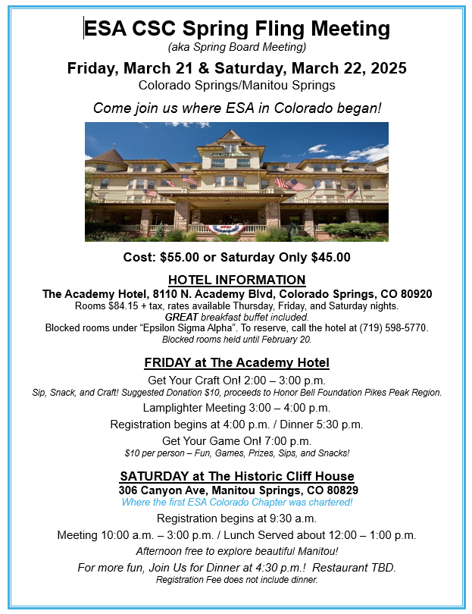

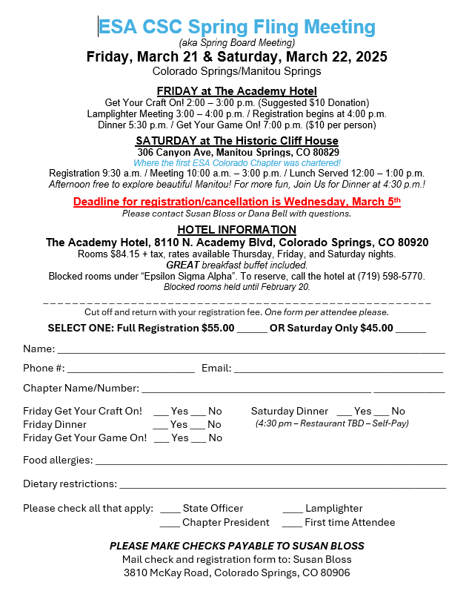

**State Convention**

**“On Wings of Friendship”**

79Th Colorado State Convention

May 16, 17, 18, 2025

Holiday Inn – Lakewood

7390 W. Hampden Ave.

Lakewood, CO 80227

303-980-9200

Hosted by Our Motley Crew

**Registration for Convention**

$165.00 until May 1st

$175.00 after May 1st

NO PARTIAL REGISTRATIONS

**Deadline for room reservations**

**April 17, 2025**

Room rate is $129.00 + tax ($142.55)

per night. ADA rooms are available.

Room block is under ESA Convention

Help celebrate our members, chapters and councils’ achievements last year.

Honor the members we lost during the year at the Memorial Service on Sunday morning.

Registration forms can be found in the Golden Lamp and on the Colorado web page.

