

|  |  |  |
| --- | --- | --- |
| **ESA Colorado Golden Lamp** |  | August 2025  Volume 79 Issue 7 |
| **ESA Friends**  **in**  **Perfect Harmony**  **Lori Anderson Havelick**  **Colorado State President 2025-2026**   |  |  |
| Welcome By Karen Addison, Golden Lamp Editor  Welcome to the new ESA Colorado State Council!  This is my first issue as the new Golden Lamp Editor. I have big shoes to fill, following Jenniffer Carlson Mazza! A big thank you to Jenniffer, for she has been so helpful in turning over the position.  Going forward, we want to hear from you. We want to know what your chapter is doing. What projects are you working on? What recruiting events are you doing? What did you do as a chapter social? Fundraisers?  Do you have a flier for an upcoming event? Post it in the newsletter!  Pictures! I want your pictures! Events, socials, fundraisers, it doesn’t have to be ESA related! Did you see a beautiful sunset? Something funny? Is your flower garden particularly beautiful this year? Send me pictures!  I’m so excited about the coming year! Let’s make it amazing! |  | Welcome |
| PAGE 2 Philanthropic Project  PAGE 3 Presidents Message  PAGE 4 New State Council  PAGE 7 IC President Message  PAGE 8 State Reports  PAGE 18 St Jude Dream Homes  PAGE 20 St Jude Dollars Report  PAGE 20 Chapter Reports  PAGE 25 Fall Fest Registration  PAGE 29 Fun Page |

|  |  |  |  |
| --- | --- | --- | --- |
| Veteran Programs for Rigging & Crane Training | Baytown, TXPresident’s Philanthropic Project By Lori Anderson Havelick  My Philanthropic Project this year Is centered around serving the Veterans and active Military. This will include the Wreaths Across America program. Chapters are encouraged to contact their local VA Hospitals to explore possible programs such as providing ice cream bars/sandwiches or Sudoku, Word search and Crossword activity books.  MEMBERSHIP  My goal is to have better communication and team work within our membership. There are some new people on the ESA Colorado Board and there are bound to be questions. Any member with questions should feel free to contact any board member or Lamplighter. They are always willing and happy to help.  Please use our State, chapter and individual member Facebook pages get the name of ESA out there. As you go to events, please bring a friend. We just might get more people into ESA. | |  | Presidents’ Acceptance Speech   A group of women sitting in chairs  AI-generated content may be incorrect.  Just like in Music, where seemingly desperate notes create a beautiful melody, True Harmony in our lives emerges when we embrace our differences and work together with a shared purpose. It’s not about silencing dissenting voices, but about actively listening to them, understanding their perspectives, and finding common ground. Common ground is the Shared Key. In Music, musicians must listen to each other to ensure their parts complement a whole. It is much like musicians in an ensemble. When we strive for perfect Harmony, we unlock the potential for incredible creativity, innovation and collective progress in ESA.  My Theme: ESA Friends in Perfect Harmony  Colors: Red, White and Blue  Flowers: Red Roses and Wildflowers  Symbol: The Treble Clef |
| Mark your Calendar Upcoming Events on the Website | Denver Dream Home Open House September 20 – October 21  Giveaway October 23  CSC Fall Fest Salida CO Sept 26 – 27  Tax Facts due online to ESA office by September 15 | | |

Page 2

Message from the President

Hi All,

Summer is going by quickly. I am glad I didn’t do any gardening this year. Out here where we are, it takes a lot of watering, and it has been very hot and dry. The Black Canyon fire is at 52%. More down in the Canyon now. We have had some huge helicopters helping with the fire. The fire personnel have been stationed at the Montrose Fairgrounds.

My project will be centered on the Veterans and Active Military.

● Wreaths Across America - is actively operating in 2025. Wreaths Across America is

scheduled for Saturday Dec. 13, 2025. The organization continues its mission

“Remember, Honor and Teach” through the placement of wreaths on veteran’s graves at

cemeteries and other locations nationwide. The 2025 Theme for the event is “Keep

Moving Forward.” Please consider participating in this project. You can volunteer and

lay the wreaths at the Cemeteries on the designated date and if unable to volunteer you

can sponsor a wreath with a donation of $17.00. Here is the Link:

https://www.wreathsacrossamerica.org.

● Other projects for the Veterans can include setting up a table at the VA Hospitals,

getting the name ESA out there, serving lunch. Ice cream bars/sandwiches or a menu of

your choice. Get activity books for the veterans and books for them to read. Care

packages and write cards. We will be writing Thank You cards at the Fall Fest but this

project can be ongoing throughout the year. Especially for the Holidays. And don’t forget

to keep on cutting coupons. Any questions please feel free to email or call me.

● I would also like to ask that all chapters report the activities that they are doing

for the Veterans and Active Military in the Golden Lamp. Send in pictures and use

your Facebook.

● Fall Fest will be Sept. 26th and 27th 2025 in Salida, Colo. Looking forward to seeing

everyone. Look for the flyer for registration and schedule. It should be a lot of fun.

● This year’s IC Convention was a lot of fun. Total raised for St Jude Hospital for 2024 -

$27,541,607. Colorado raised $2,977.177. Lifetime total - $410,908,553. IC President

Celeste Webb Installation was just beautiful. Celeste’s Theme - Anchored in ESA. Mark

your Calendar - July 12 - 19th 2026. Next year’s IC Convention will be in Norfolk, Virginia

and will be shortened to four days. Theme - “Sweet Virginia Breeze.” They are asking

people to make it a family vacation trip and explore the area before or after the IC

Convention. I think this is an awesome idea.

● If your chapter has not turned in an Officer Change update and send it to me, please

contact me so we can get your info in the yearbook correctly. And just a reminder to get

the form filled out and sent to Headquarters. ESA Headquarters has a new name called

ESAMC.

I’ll be reaching out to chapters and maybe we can set a zoom meeting or when we are in

Denver, I can let you know. I am going to try and attend events if I can.

That is all for now.

Thanks so much,

Lori Anderson Havelick

ESA CSC State President

Email: loriandersonhavelick@gamil.com

Cell: 720 353 8839

Page 3

Introducing your Colorado State Council 2025-2026!

~

President

Lori Anderson-Havelick

Alpha Phi #327 – Golden

~

President Elect / Membership Coordinator

Nancy Cameron

Kappa Iota #5442 – Golden

~

Secretary

Lisa Weeks

Gamma Chi #3668 – Loveland

~

Treasurer / Disaster Fund Chairman

Susan Winton

Alpha Phi #327 - Golden

~

Parliamentarian

Rita Martin

Chi Kappa #5129 – Denver

Page 4

~

Past President / Awards Chair

Susan Bloss

Zeta Tau #2064 – Colorado Springs

~

Chaplain

Margaret Ames

Zeta Tau #2064 – Colorado Springs

~

Educational Director / Golden Lamp Editor

Karen Addison

Zeta Nu #5608 – Colorado Springs

~

Philanthropic Chairman

Mary Humphrey

Beta Alpha #5416 - Aurora

~

Easterseals Coordinator

Ginger Dodge

Sigma Rho #5014 – Loveland



~

ESA for St Jude Coordinator

Pam McGee

Gamma Chi #3668 – Loveland

~

Hope for Heroes Chair

Deanna Sloat

Sigma Rho #5014 - Loveland

~

ESA Foundation Counselor

Sandy Alexander

Alpha Phi #327 – Golden

~

Communication Coordinator

Eric Havelick

Alpha Phi #327 – Golden

~

Webmaster

Candie Patino

Beta Xi #4398 – Berthoud

~

Lamplighter President

Rita Martin

Chi Kappa #5129 – Denver



A note from your IC President

Hello, Captains.

For those of you who attended the IC Convention in Cary, I hope you have rested up. To those of you who missed the convention you were missed. It was a fun week with all of the things we love in ESA, the friends, the monies raised for St Jude, the workshops. Just a fun week.  I am going to try to send an e-mail to all of you every Sunday. Suzy Winters did this when I was one of her state presidents and it was interesting to get to know Suzy a little better plus she gave us some inside info.

It is hotter than ever here in central Illinois.  There is a heat advisory until 9 tonight and we have been under advisement for several days. It is calling for rain and the chance to cool off later this week.  That is good as the Mattoon to Peoria St Jude Run is Friday. I have coordinated this run for the past 15 years and this year will be my last. I will be at the kickoff Friday morning but will not be traveling to Peoria. The run is leapfrog style for 143 miles; we get into Peoria on Saturday.  I love this run and have put my heart and soul into it for 15 years, but it is time to pass the baton. We need to all be able to say no once in awhile and not feel guilty. Delegate some of the things on your list.

As I mentioned in my speech, next year's convention will be 4 days, starting on Thursday and ending Saturday night. Hopefully, this will make it more affordable. Also, folks will be willing to take the family as there will be time to sightsee and enjoy the area. Please encourage your members to try to attend as Virginia will still be putting in a lot of work.

Speaking of vacations, I will be traveling to Australia in April to attend the Australia convention on May 1st thru the 3rd in Redcliffe. I am inviting all of ESA to travel with me. I will be going to a travel agent this week to discuss the itinerary and cost so stay tuned for more info.  Start saving and spread the word.

We are all working on membership, I hope. The St Jude mom who spoke to us at the banquet sang the praises of ESA. Afterwards, it is my understanding, that Cindy Norman from Indiana asked if she was a member and she said no, no one had ever asked her to join. Cindy hooked her up with TN where she lives.  We have to ask, invite them to the fun things, the socials, the bingos. Show them how amazing we are! Wear your ESA shirts once a week, be prepared to give your "elevator speech" when asked what is ESA.  Sign up your grands as Elons, put them to work on your events. They will have fun and you will have added help.

Feel free to reach out to me with your ideas or concerns. Kate Sala asked for a zoom meeting as she needed a sounding board. That is what I am here for, to listen, to help if I can.  Deana Reen from Virginia has sent me an idea about Elons which I passed on to the staff. Share my e-mail with your state members, I'm open to suggestions and ideas and sometimes I need to reconsider a different viewpoint.

Have a great week, stay safe. Celeste

Celeste Webb

International Council President

[epsilonsigmaalpha.org](http://epsilonsigmaalpha.org/)

Page 7

**International Convention Awards**

Hello Colorado ESA

As your past president, I was honored and thrilled to be able to collect Colorado ESA Awards at IC. ESA Colorado you should be proud!

Our awards for 2025:

Educational Gold Seal Merit Awards:

     Zeta Tau 2064, Kevin Richards

     Alpha Phi 327, Eric Havelick

Easterseals: 2nd Place for State Hours, Deena Gregory (Gamma Chi 3668), CSC Easterseals Coordinator

St Jude Awards:

     Pinnacle Award: For raising $1 Million in one year

     DANNY'S DREAM AWARD: For reaching the $31 Million mark

ESA for St. Jude-Largest Individual Event, Second Place to Colorado State Council

Philanthropic

     2nd Place Philanthropic Donated Goods

     2nd Place Philanthropic State Monies

     2nd Place Philanthropic Grand Total

Also, at IC a new Mission Statement was presented. I’m proud to say I was part of the team who worked on this project--- and hope it will help ESA grow and thrive.

**ESA Mission Statement**

**Epsilon Sigma Alpha inspires a culture of authenticity, respect, and confidence, building strong community connections and empowering every member to flourish through purposeful service, bold leadership, meaningful networking and lifelong learning.**

As Past President, I will be your Awards Chair this year. Call me anytime if you have questions.

Enjoy a few pics from IC in Cary, North Carolina!

Susan Bloss

CSC Past President/Awards Chairman

Page 8

WHAT HAPPENED TO THE LAZY, CRAZY DAYS OF SUMMER?

Seems like we just had State Convention! I was lucky enough to attend the IC Convention in Cary, North Carolina! It was beautiful there and very hot - but isn’t it always hot at IC? Convention was inspiring and a lot of fun. I go mostly to see the sisters & brothers I’ve met and worked with for a long time. Another reason is - **The Trip!** I’ve visited so many places I would never have been able to if it wasn’t for the IC Trips!

Leslie & I visited the Cumberland Gap National Park on the way home. Daniel Boone opened the lands on the Tennessee-Virginia border west of the Appalachian Mountains for thousands of settlers.

A scene in the Park that is so simple but awesome to me

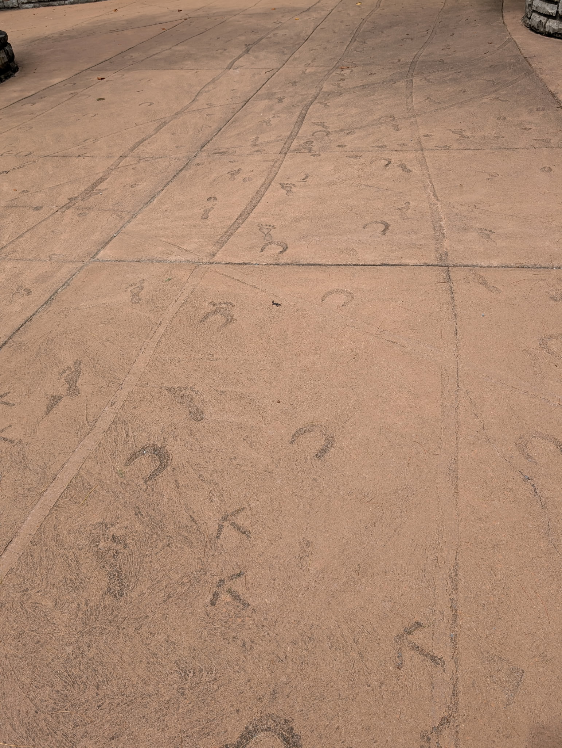

A path heads off into the forest signifying the starting place. The path has footprints, hoofprints, wagon wheel prints, dogs and even turkey or bird prints all heading off into the pass!

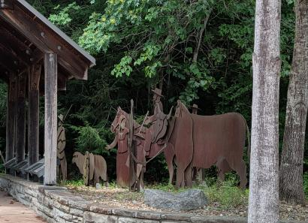 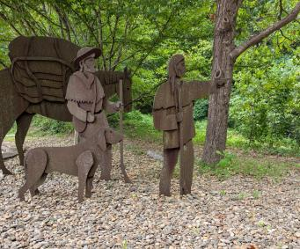

On the sides are silhouettes of families, trappers, Native Americans, and all kinds of animals going to challenge the unknown! I think of the courage and stamina and hard-headedness it took to leave everyone and everything behind to face the unknown with what you could carry and I’m blown away!

It is time to once again start thinking of what projects we want to accomplish in the coming months. My project for the year is - A SLATE OF OFFICERS FOR 2026-27!! Oh my gosh! That seems a long time away, but you know how quickly it arrives!

- SO, I’M ASKING FOR YOUR HELP-

Please think about an appointed or elected office you’d like to serve on **YOUR STATE COUNCIL**. I’m expecting lots of volunteers! We are great volunteers!! Serving with others from across the state is so rewarding and friendships are made that last forever.

I’LL BE ASKING AGAIN - AND AGAIN!

Looking forward to seeing you all in Salida in September.

The Alpha Omicron sisters always host a great event!!

Nancy Cameron

Treasurer



Your chapter can stay current! Who to contact if you need assistance:

Your Chapter’s In-Service Officer (reach out to state President Lori Anderson-Havelick if you don’t know who this person is!)  Susan Winton - State Treasurer - 505-670-4371 or [WintonColorado@gmail.com](mailto:WintonColorado@gmail.com)  CSC (Colorado State Council) Website - esacolorado.org has lots of information!!

Schedule of what is Due!

|  |  |  |  |
| --- | --- | --- | --- |
| **Due Date** | **What** | **Who/How/ What/When** | **Late after** |
| **Aug 1, 2025** | * **International Council Chapter Dues:** * Brenda Campbell Treasurer | $40 per chapter are paid to IC Treasurer. | **May 1st of 2026** |
| **Sept 1,2025** | * **Tax Facts** * Form is available on the IC Website. * Susan Winton, Treasurer can email it to you. Reach out if you need help! | **Each chapter** *MUST* file EVERY Year. This keeps ESA as a non-profit organization!! | **September 15, 2025** |
| **Dec 1, 2025** | * **State Council Dues** * the Form is on the CSC website under Forms, Dues Form | Your check made payable to *Colorado State Council* can be mailed to Susan Winton - Colorado State Council Treasurer | Late after December 1, 2025 |

*The road ahead has wonderful things in store for me.*



Educational Report

I am really looking forward to serving as Educational Director this year. In my chapter, we all really enjoy the educational reports during each meeting. The things we have learned has been very interesting.

It is very important to follow the guidelines when preparing your Educational Report. On the website, you will find the Chapter Educational Report Form. This is to be filled out for each report. Specifics needed for each report is outlined on the Judging form, also on the website.

Some requirements to take note of are as follows. You must use a 1-2” 3 ring binder for the years’ reports and use dividers to separate reports. Fill out the educational report form entirely for each report submitted. Be sure to include the author of the report and a brief summary of the report, including a list of information references.

To find the form, go to the website at ESAColorado.org. Under Officer Guidelines, you will find the reports needed.

Reports are to be turned in to me by April 1. You can turn them in to me at Spring Board, in March. If you need to mail them, my address is 3065 Haystack Dr. Colorado Springs, CO 80922

~Karen Addison

Educational Director

ESA FOUNDATION 2025

ESA Foundation Coordinator

Greetings from Sandy Alexander your 2025-2026 ESA Foundation Coordinator.

Let’s start off with some basic information about the foundation taken from their website.

Mission

Established in 1970, the ESA Foundation is dedicated to the promotion of continuing education and to altruistic activities that make a positive difference in the world community. Voluntary contributions of time and money from ESA members, ESA Foundation members, and friends of the Foundation are the ESA Foundation’s sole sources of support. As a nonprofit, tax exempt corporation, the ESA Foundation supports the service and leadership programs and the philanthropic projects of Epsilon Sigma Alpha International.

ESA Foundation Membership

The ESA Foundation is a public foundation for anyone who shares our goals. The annual membership fee is $40. You may also opt to support the Career Enhancement Grant through a $500 one-time Life Active membership. All dues are tax deductible. In order to vote at the annual meeting, the active member must have their annual dues paid before December 31.

Congratulations to these 2025 Scholarship winners

          Arlene & Dennis Schlosser Memorial Scholarship - $1,000 Cole Mills, Aurora

          Mary Louise Smith Memorial Scholarship - $1,000 Anderson Filla, Akron

Please contact me if you have any questions.  More “Did you know” articles to follow.

Sandy Alexander

ESAF Coordinator





**CHAPLAIN REPORT**

Hello Colorado ESA members!!

I am honored to serve as your State Chaplain for 2025-2026.

Please send me information you have for all your members’ joyful moments or

challenging ones.

My email address is mjesa8@gmail.com (The ‘j’ is my middle initial)

I’m excited to connect with each of you and work together as part of Lori’s team.

Let’s make our sisterhood stronger than ever!

Hope to see you all at Fall Fling.

Margaret Ames

mjesa8@gmail.com

907-250-3141

**When Robert Louis Stevenson was a young boy, he watched a lamplighter lighting streetlamps. When his nanny asked him what he was doing, he replied, “I’m watching a man punch holes in the darkness”.**

Where do you see darkness? Let’s punch holes in the darkness and make this a brighter world.



[This Photo](https://hochiminhcity.eregulations.org/procedure/83/91/step/866?l=en) by Unknown Author is licensed under [CC BY-SA](https://creativecommons.org/licenses/by-sa/3.0/)

**Colorado Web Team**

Greetings from your CSC Web Team!

We hope all are enjoying a fabulous summer.

We can’t wait to hear from those who attended IC Convention as well as the upcoming Rocky Mountain Regional Roundup. Such great times with such great people!

The Colorado State Council website has begun its annual update with new information. This process should be concluded by Fall Board. New information will include 2025-26 Officers/Chairmen, Committees, Due Dates, Calendar dates and more.

Chapters are invited to submit their upcoming events for posting on the Calendar page. Please be sure to send along a digital file with your event’s information.

To ensure that our Colorado forms are up to date, all officers/chairmen are asked to review their appropriate required forms.

**YOU** make our website great. We appreciate everyone’s input.

Mahalo!

The Colorado ESA Web Team

Bonnie & Candie

Easterseals Coordinator

Hello! I'm incredibly excited and honored to be your Easter Seals Coordinator this year! Easter Seals is an organization that's truly close to my heart. My son, Nick, attended their day program, and my family saw firsthand the incredible difference Easter Seals makes in the lives of families right here in our community.

Thanks to dedicated donors and partners like ESA, Easter Seals helps over 1.5 million people every year. Let’s keep making a difference in our communities and keep up the great work on your projects. I'm always here to help if you have any questions.

Much ESA love,

Ginger Dodge

Colorado Easter Seals Coordinator 2025-2026

St Jude for ESA Chair

Hi Everyone,

I am looking forward to being your St. Jude Chairman this year.

As most of you know Adi’s Cookie Stand has been raising money for St. Jude Children’s hospital for a couple of years. Gamma Chi had the pleasure of helping her and Jenniffer hold a Bunco Fundraiser in Loveland/Johnstown on July 26th.  Adi is still trying to reach her goal of $20,000. Between the money raised at the door, drawings, and some other donations the grand total Saturday $3,025.00. High Country Beverage where the bunco game was played shared they would match the day's total. With that she reached her goal of  $20,000 and their match put her over her goal. Steve and Lidia with High Country Beverage are very special to work with. Phil Prellwitz donated all the pizza and delivered it. Golden Corral donated the salad.

Earlier in the month Adi and her parents went to Memphis to have a tour of St. Jude Children’s Hospital, but the main reason they were there was for Adi to be awarded the Jerry Nicholson Award. This is given in memory of a St. Jude patient from Riverside, CA who led funding campaigns to obtain funding for the hospital in the early 1960’s.The award is presented for exemplary service to the hospital. Nominees must be 19 years or younger. Adi is one of the youngest to ever win the award. This is a national award there is only 1 youth award, making Adi the most recognized youth fundraiser throughout the country this year.

Congratulations Adi!

That’s my news for now. See you in September. My email is [pkmcgee1448@gmail.com](mailto:pkmcgee1448@gmail.com) if you have any questions or fundraisers to share.

Pam McGee

St Jude Dream Home – Colorado Springs

The Colorado Springs St Jude dream home sold out on July 7, over a week before the giveaway on July 16. We raised $1,250,000 for St Jude by selling 12,500 tickets.

All prize winners were thrilled when reached and prize packets have been mailed.  
Winner’s names can be seen on the KKTV web site.

We are grateful for all the sponsors who help make this another successful campaign,  and especially all the volunteers from ESA who contributed their time for this great cause.

ESA’s commitment to St Jude was well represented in Colorado Springs!

Jenny Liebowitz

Zeta Tau #2064 – Colorado Springs

Page 18

**Denver Dream Home**

The 15th Denver Campaign is getting ready to kick off. We have been working with the Colorado Secretary of State and ALSAC on our document approvals. We’re having to make a few changes for this campaign. Below is the timeline that starts August 21. We are selling 25,000 tickets!!

|  |  |
| --- | --- |
| **Timeline:**  • Tickets on Sale Deadline: August 21  • Early Bird Deadline: September 18  • Bonus Prize Deadline: October 2  • Last Chance Prize Deadline: October 9  • Floor signing/Grand Opening: September 19  • Giveaway: October 23  Open House Weekends:  • September 20 – October 12  Saturday: 10:00am – 5:00pm  Sunday: Noon – 5:00pm | 22202 E 38th Place Aurora, CO 80019 (back to East GVR) |

Nancy Cameron is our volunteer coordinator. You can reach her at: [ncnoremac@aol.com](mailto:ncnoremac@aol.com). Let her know your availability to help in the office, Tuesday or Thursday. The ALSAC office has moved and is in the Denver Tech Center by I-25 and I-225. Volunteers **are needed** for the Open Houses; especially the weekend of the Fall Colorado State Council Meeting, September 27 and 28.

Denver Dream Home Co-Chairs

Mary, Nancy, Vickie

St Jude Dollars 2024-2025 Report

**$$ St Jude Dollars $$**

|  |  |
| --- | --- |
|  | ESA St. Jude Dollars for 2024-2025: $27,541,607  ESA St. Jude Lifetime Total: $410,908,553  Colorado received the Danny’s Dream Award donating over $31M  Colorado donated in 2024-2025: $2,977,177 |

Chapter Report  Beta Alpha

It was a fun week at IC Convention in Cary NC seeing old friends, making new friends, attending workshops and the IC Challenge for St. Jude.

Friday at the Awards Luncheon, Susie Hitchcock received 3rd place for her fragile fused glass trees. Susie joined a class at her 55+ community a couple years ago and has found her niche making glass pieces. For Epsilon Council Valentine’s meeting, she made glass hearts for the attendees.

**Beta Alpha #5416**

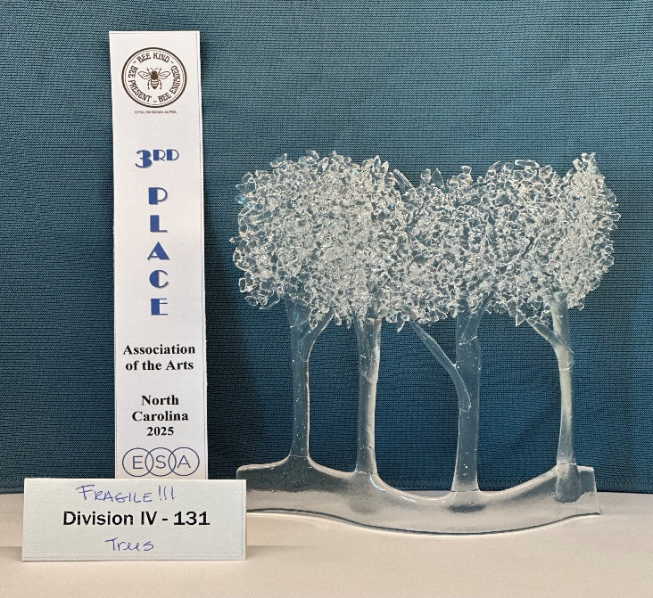

Page 20

Chapter Report  Gamma Chi

News from Gamma Chi,

It is hard to believe that teachers are going back to school this week. It seems to get earlier every year.

At the end of May we had our Installation dinner at Golden Corral. In May Tammy Muzzio and Judi Swartz joined our chapter. A couple of weeks later Ruth Walton and Tisha Vollum also joined. We met them through our volunteering at the Community Kitchen.

During the summer we rotate maintaining the flowers at the sculpture we adopted years ago which is located at Benson Park. In June Deena and Ruth Mary volunteered at the Envision Walk/Run in Evans. Later in the month a couple of members volunteered at Loveland Lake to Lake Triathlon. We usually help serve food. Also in June we found ourselves helping Dillon, who owns Culver’s in Loveland/Johnstown celebrating 18 years in business. He dedicated 18% of the sales that day to our chapter. We greeted people, told them about ESA, and served them cake.

On July 26th our chapter helped Jenniffer and Adi put on a bunco fundraiser for St. Jude at High Country Beverage in Loveland/Johnstown. It was very successful, and everyone had a lot of fun. Dominos in Loveland donated the pizza and Golden Corral salad for lunch.

Friday, August 1st, Deena, Lisa, and Ruth Mary volunteered at the annual Wild West Relay. They had 40 relay teams registered. We always help at Exchange 3 just west of Wellington at Waverly Fire Station.

Throughout the summer we continue to hand out bread and vegetables at the Veterans Loveland Clinic, help at the Food Bank monthly, and weekly at the Community Kitchen.

That’s the news. Enjoy the rest of the summer.

Pam and Gamma Chi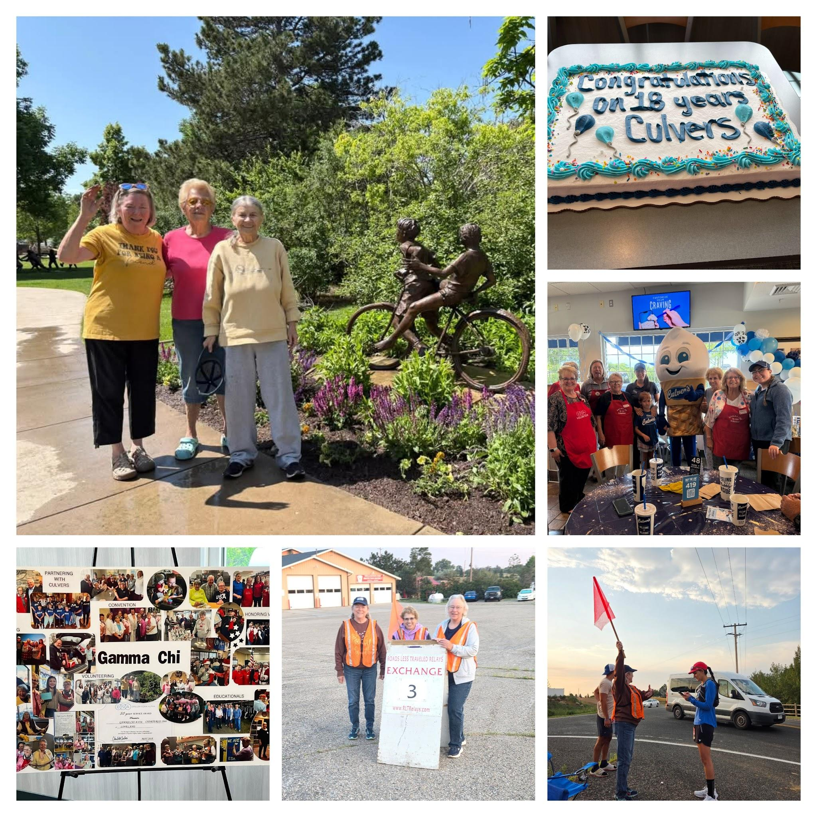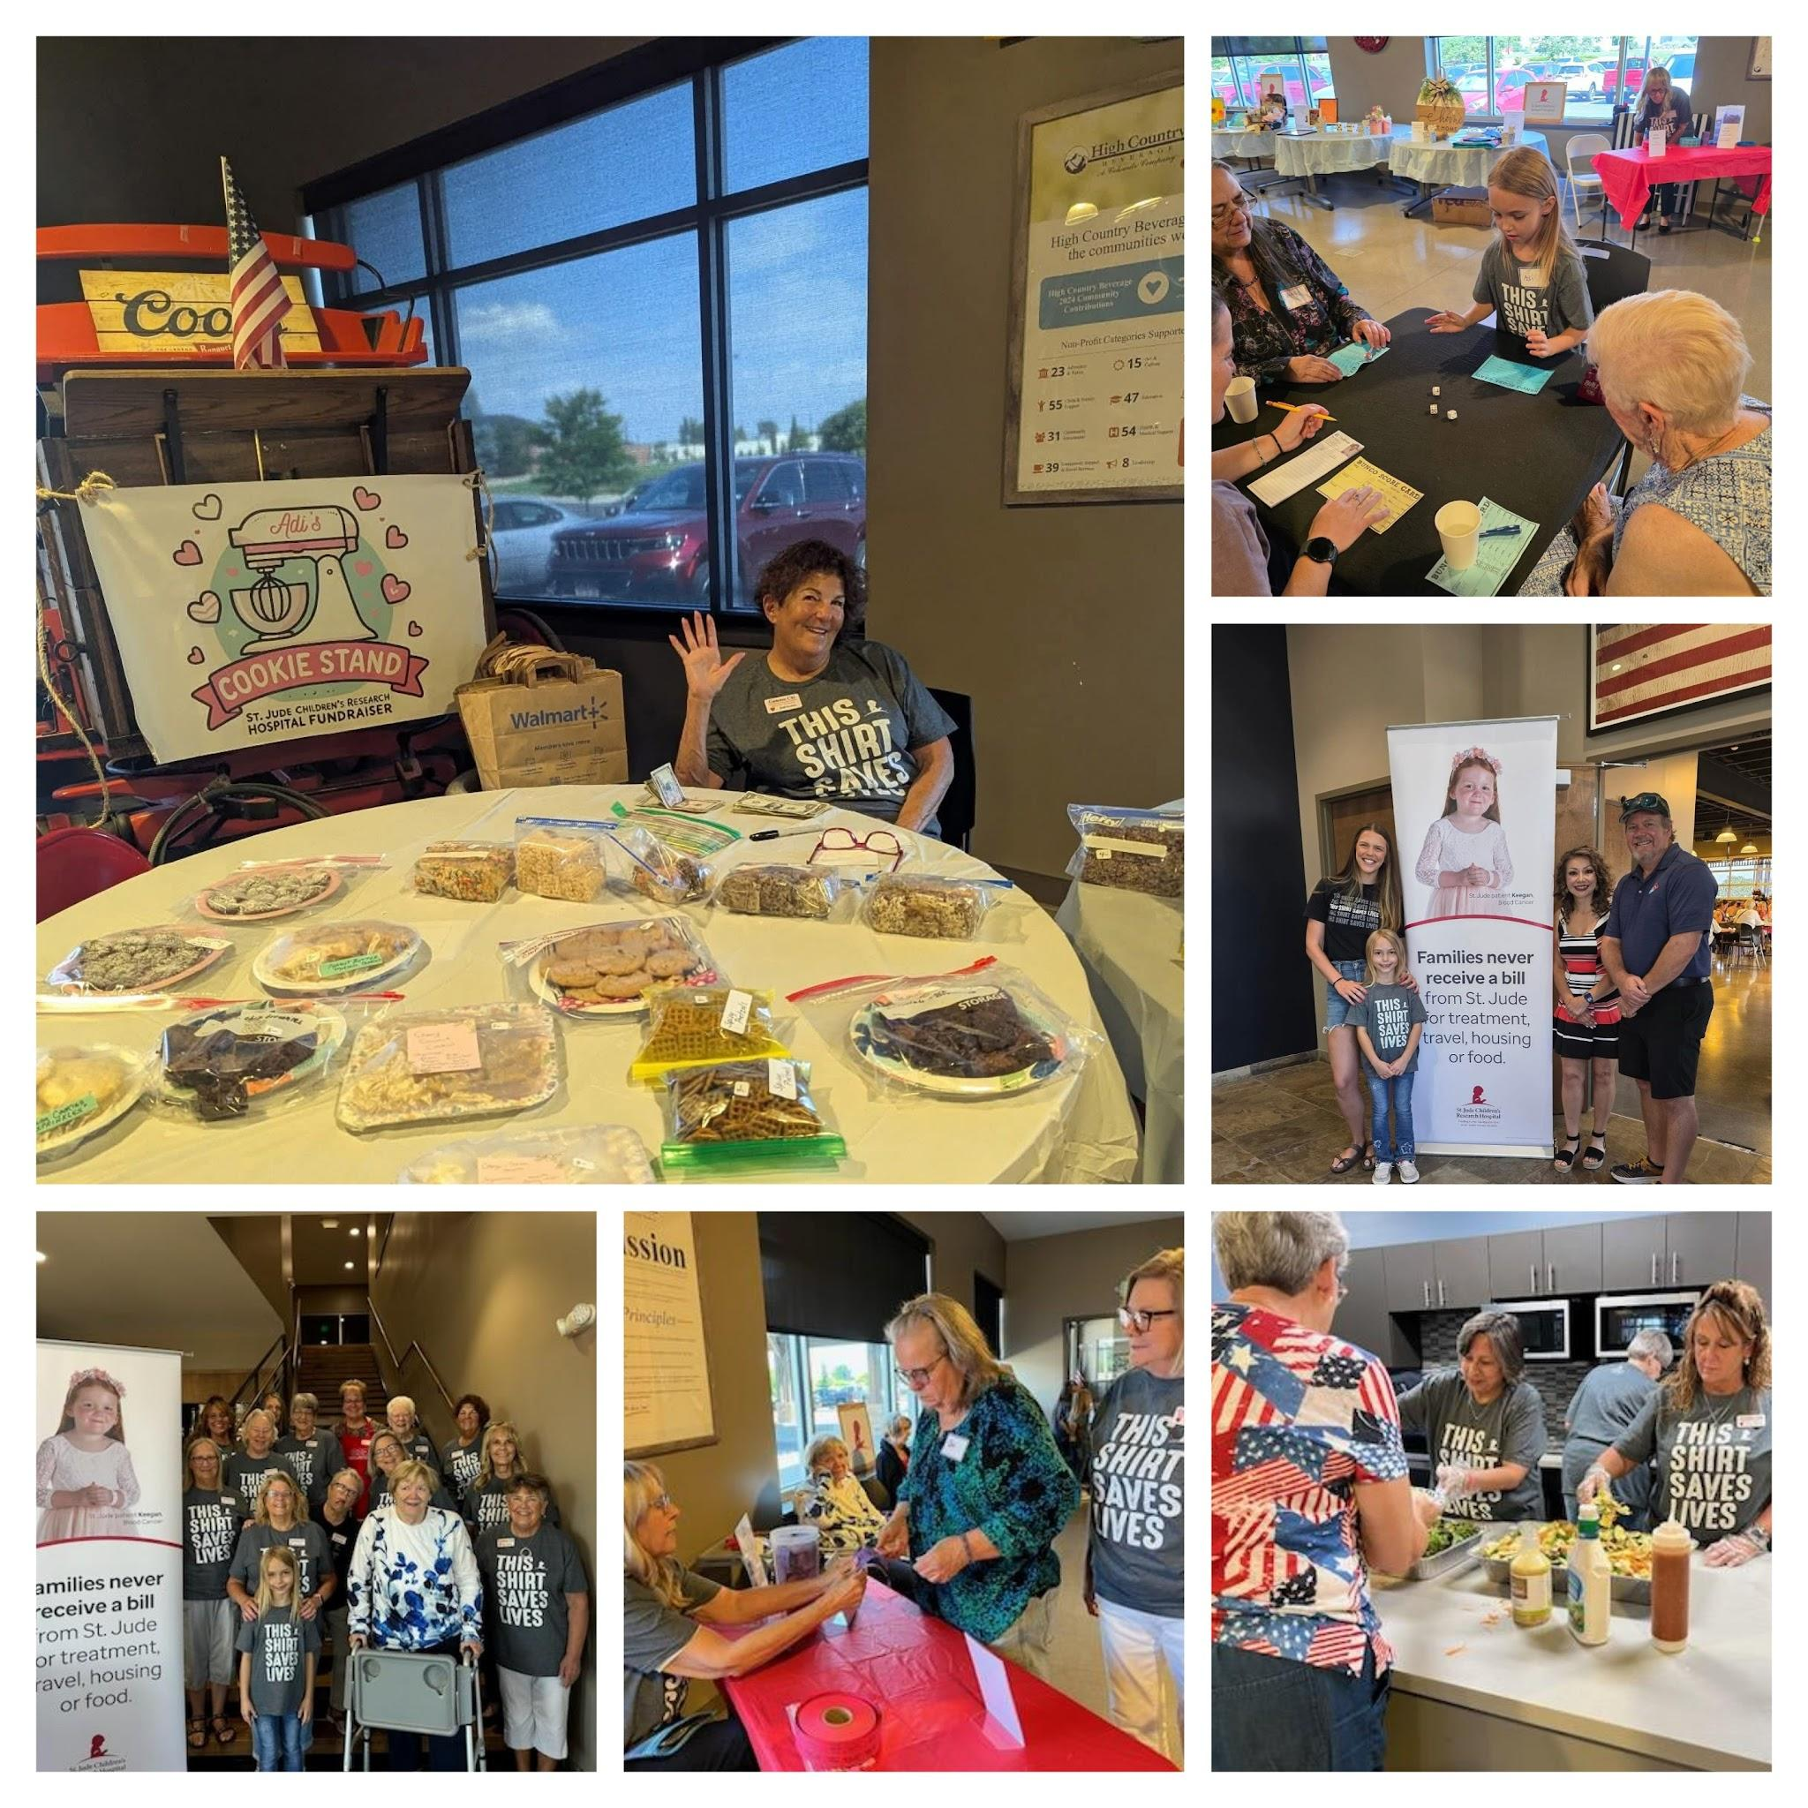

.

Chapter Report  Alpha Omicron

Happy August!!

We had our yearly summer picnic in July, it’s always nice to get together on our off months.

Our member Diana Wood and her husband Danny celebrated their 60 th wedding anniversary

this past month.

I can’t believe this summer has flown by. Our chapter is getting ready for our annual yard sale.

Everyone works hard every year to make it a great sale. Adi will also have her cookie stand set

up as she is still raising money for St. Jude Children’s Research Hospital.

As some of you may have heard………….. We are hosting 2025-2026 Fall Fest (formally Fall

Board) again this year. This will be 3 years in a row for us hosting, and we are so thankful you

all keep coming back.

I want to remind everyone. You do not have to be a board member to be a part of this

meeting. ALL MEMBERS ARE WELCOME!! We have the best time. Please see all the Fall Fest

info to see what is planned, and as always, our members put in so much love and planning in all

they do for this meeting from all the food that is prepared to all the crafts they make.

Alpha Omicron will be having 2 drawings at this Fall Fest. If you are a first timer to come to the

meeting in Salida, and the other one you just have to show up then you will be eligible for the

drawings. Our members are wonderful crafters, and they will be crafting to have items for

sale. (small secret they will have some items with our State Presidents theme)

We will also have a keepsake you can take home with you. I am excited about having dinner on

Saturday evening. I really hope you are able to stay and have dinner with us. We have a patio

reserved at a Mexican restaurant downtown Salida, CO.

We hope you all are having a great summer, and we look forward to seeing you in September.

LET’S MAKE THIS THE BEST FALL FEST!!

Love in ESA

Jenniffer Carlson-Mazza

Alpha Omicron #770

Salida, CO

Chapter Report  Beta Zeta

Golden Lamp August 2025

Is it August already??!! Beta Zeta enjoyed a wonderful Mid-summer Breakfast in July. It was great catching up with everyone, their summer plans, and various health issues.

The Fremont County 4-H Fair welcomes Seniors on Family Day, August 1, with a free biscuit and sausage gravy breakfast at Pathfinder Park in Florence. Beta Zeta has provided this yummy meal for 18 years, and this is one of our favorite projects. It is great to see all our friends from all over Fremont County. We love working together to make this a special day for fairgoers.

Our next upcoming project is the annual Soup, Salad and Shopping Auction Luncheon on October 4 at the Christ First Fellowship Hall, 931 Main in Canon City. Beta Zeta members are in high gear, making baked goods, small craft items, and lots of amazing auction offerings.

Colorado Beta Zeta members make plans to take a day trip to Canon City for this fun event, which enables our chapter to support our many philanthropic causes.

Hope the rest of your summer is great!

Carol Dunn

**COME JOIN US FOR OUR FALL FEST MEETING**

*** 

**IN BEAUTIFUL SALIDA, CO**

**HOSTED BY ALPHA OMICRON #770**

**SEPTEMBER 26th and 27th**

**(please see the registration form for all details)**

**Come spend time with your Colorado ESA Members, enjoy a craft, eat some amazing homemade food, roll some bunco, catch up on all the business, and go out to dinner in downtown Salida at the best Mexican place in town.**

**If you have any questions, please contact**

**Jenniffer Carlson-Mazza**

**Call or text**

**(719) 221.9447**

**or**

**email**

**jenniffercarlson@gmail.com**

**We are going to have 2 drawings.**

**1st drawing will be for the 1st timer.**

**If this is your first meeting in Salida, Co you will**

**be eligible for the drawing.**

**2nd drawing will be just because.**

**If you show up at the meeting, you are eligible for the drawing**

# 2026 ESA COLORADO STATE FALL FEST MEETING Friday, September 26 - Saturday, September 27, 2025

Hosted by 

Poncha Hall – 330 Burnett Ave, Poncha Springs, CO 81242

FRIDAY

Creative Craft for U.S. Veterans 1:30 - 3:00 p.m. / Lamplighter Meeting 3:00 - 4:00 p.m.

Registration starts at 4:00 p.m. / Dinner 5:00 p.m. / Bunco 7:00 p.m. (hosted by Kappa Iota)

SATURDAY

Registration 9:30 a.m. / Breakfast 9:30 – 10:00 am

Meeting 10:00 a.m. – 3:00 p.m. (Lunch 12:00 - 1:00 p.m.)

For more FUN, Spend the afternoon in beautiful downtown Salida and Join Us for Dinner at 4:30 p.m.!

Deadline for registration/cancellation is Monday September 15th

For info or questions please call or text Jenniffer Carlson-Mazza at (719) 221-9447

## HOTEL INFORMATION

Browns Canyon Inn – 407 Hwy US 50, Salida, CO 81201 Rooms $129.99 + tax. Take & Go Breakfast included.

To reserve, please call hotel at (719) 539-6651. Blocked rooms under ESA MEETING.

Blocked rooms will be held until September 15th – 15 rooms on hold

One form per attendee please.

FALL FEST REGISTRATION FORM – Cost: $55.00 or Saturday Only $40.00

Name: _______________________________________________________________________

Phone #: _______________________ Email: ______________________________________

Chapter Name/Number:_______________________________________ ___________

|  |  |  |
| --- | --- | --- |
| Friday Craft for Veterans __Yes __No  Friday Dinner __Yes __No  Friday Bunco __Yes __No | Saturday Breakfast Saturday Lunch Saturday Dinner | __Yes __No __Yes __No __Yes __No |

(4:30 pm – Las Camelinas – Self-Pay)

128 W. 1st Street, Salida, CO (room in back)

Food allergies: ________________________________________________________________

Dietary restrictions: ____________________________________________________________

Please check all that apply: ___State Officer ___Lamplighter

___Chapter President ___First time Attendee

PLEASE MAKE CHECKS PAYABLE TO ALPHA OMICRON

Mail check and registration form to: Alpha Omicron

P.O Box 177 Poncha Springs, CO 81242

Page 28

~ For a Laugh ~

A couple in their nineties are both having problems remembering things. During a checkup, the doctor tells them that they’re physically okay, but they might want to start writing things down to help them remember.  
Later that night, while watching TV, the old man gets up from his chair. ‘Want anything while I’m in the kitchen?’ he asks.  
‘Will you get me a bowl of ice cream?’  
‘Sure.’  
‘Don’t you think you should write it down so you can remember it?’ she asks.  
‘No, I can remember it.’  
‘Well, I’d like some strawberries on top, too. Maybe you should write it down, so’s not to forget it?’  
He says, ‘I can remember that. You want a bowl of ice cream with strawberries.’  
‘I’d also like whipped cream. I’m certain you’ll forget that, write it down?’ she asks.  
Irritated, he says, ‘I don’t need to write it down, I can remember it! Ice cream with strawberries and whipped cream – I got it, for goodness sake!’  
Then he toddles into the kitchen. After about 20 minutes,  
The old man returns from the kitchen and hands his wife a plate of bacon and eggs. She stares at the plate for a moment.  
‘Where’s my toast ?’

Sudoku by Reader’s Digest

