**APRIL 2025 | LUME 79 | ISSUE 5**

GOLDEN

LAMP

OF COLORADO

**Page 12 Chapter Reports**

**Page 20 Adi’s Page**

**Page 22 State Convention**

**Page 24 Word Search**

**Page 2 Council Officers**

**Page 5 President’s Message**

**Page 6 Golden Lamp Editor**

**Page 7 State Reports**

**2024-2025**

**colorado state**

**council officers**

**PRESIDENT**

**SUSAN BLOSS**

**President-Elect/**

**Membership Coordinator**

Lori Anderson-Havelick

**Secretary**

Susan Winton

**Treasurer/Disaster Fund Chairman**

Jenniffer Carlson-Mazza

**Parliamentarian**

Debbie Spear

**Appointed Officers/Chairmen**

**COMMUNICATION COORDINATOR**

Dana Bell

**ESA FOUNDATION COUNSELOR**

Susie Morris

**GOLDEN LAMP EDITOR**

Jenniffer Carlson-Mazza

**WEBMASTER**

Candie Patino

**LAMPLIGHTER PRESIDENT**

Rita Martin

**LEADERSHIP & EDUCATIONAL** **FUND TRUSTEES**

Nancy Cameron

Debbie Spear

**CONVENTION CHAIRS**

Leslie Stevens

Chloe McClantoc

**DISASTER FUND**

Jenniffer Carlson-Mazza

**PAST PRESIDENT/AWARDS**

Karen Addison & Chloe McClantoc

**CHAPLAIN**

Phyllis Minch

**EDUCATIONAL DIRECTOR**

Rita Martin

**PHILANTHROPIC CHAIRMAN**

Mary Humphrey

**ESA FOR ST. JUDE COORDINATOR**

Chris Dostal

**EASTERSEALS COORDINATOR**

Deena Gregory

**HOPE FOR HEROES CHAIRMAN**

Kerry Date

**owls throughout the newsletter! See if you can find them\*\*\***

**President’s Message**

Spring is here—a time for rebirth and rejuvenation after a long snowy winter. Let us all be thankful for the joy of warm sunny days and the glow of ESA Friendship. Please remember especially the ones of us who have lost loved ones; take a moment to remember not only the ones lost but those left behind who are hurting. See Phylis’s Chaplain emails for further information.

Our most pressing Colorado State Council (CSC) concern is the position of President Elect. As I am writing this, we have NO ONE for this position. Each member needs to be aware of this situation and consider seriously what part each member is willing to take in ESA. If we have no officers, in the near future there will be no Colorado State Council and ESA Colorado as we know it will change dramatically. We have recently streamlined offices as much as the guideline committee thought possible and Lori Anderson-Havelick is STILL ATTEMPTING to fill all offices. PLEASE consider the position of President Elect if you are able and willing. The qualifications for President Elect are a person who has served Two (2) years on the CSC Executive Board (meaning held an elected position for 2 years), is a member who is in good standing with the member’s chapter and whose chapter is in good standing with the CSC. Reach out to Lori if you think you might be our next President Elect!

Leadership was held in February in Denver, Colorado. My most valuable takeaway was learning to adapt to a modern ESA. I don’t know how many of you have looked at the new Ideals book on the ESA Website, but it has changed over the years!!! At Spring Fling, we all participated in an exercise about “Traditions: BIG Ts or Little ts???” We brainstormed on which Traditions are important to us and which we could do without. The times they are a changin‘ and what many think of as VERY IMPORTANT BIG T Traditions may not continue to be so important in the near future. I will share an outline of the Spring Fling presentation and a summary of which traditions were deemed BIG Ts and which not so much at our State Convention. There is no right answer here—just moving along to the future with a healthy ESA in mind.

**FUN TOPICS:**

We had a great Spring Fling in Colorado Springs March 21 & 22nd. FUN-FUN-FUN on Friday followed by friendship, patriotism and education along with some business on Saturday. If you haven’t received any information on my Philanthropic Project: The “Pikes Peak Honor Bell Capital Campaign” sponsored by the Honor Bell Foundation, please contact me or anyone who attended Spring Fling. We had a very emotional (yes—many tears were shed) and motivating presentation by representatives from the Honor Bell; please help us make the Pikes Peak Honor Bell a reality.

As we move along toward State Convention, be ready to fly “On Wings of Friendship”. Our very own “Motley Crew” has a great time planned for us and we all hope to see you there.

Reach out you have any concerns or questions.

Susan Bloss

**25

**Golden Lamp**

Hello everyone,

I have one more article left before I hand over the newsletter to Karen Addison.

Our newsletter has submitted to IC for the judging of the News Bulletin. I do need to get them all our newsletters by June 1st. For the June newsletter please submit everything to me by May 25th. If you have any questions, please feel free to reach out.

For my last newsletter PLEASE SUBMIT SUBMIT SUBMIT… Even if you have never submitted anything before let June’s newsletter be your first. Let’s make this the best newsletter to date!!

I will send out one reminder asking for articles by May 25th!

Please reach out to me at any time with any questions or comments about the Golden Lamp.

My email is goldenlampnewsletter@gmail.com or call / text me at (719) 221.9447

Please send all articles to: [goldenlampnewsletter@gmail.com](mailto:goldenlampnewsletter@gmail.com) Please submit your articles by the 1st of the month. The Newsletter is published in August – October – December – February – April - June

In the subject line put **Golden Lamp Article**

**Please make sure I respond to your email. If I don’t respond, then I didn’t receive it.**

The Golden Lamp newsletter will be uploaded on the 10th of the on [www.esacolorado.org](http://www.esacolorado.org)

Jenniffer Carlson-Mazza

2024-2025 Golden Lamp Editor

**President Elect/Membership Coordinator**

Hi All,

The Spring Fling March Weekend was great fun. Starting with Friday night with all the activities. If you weren't there you missed a good one. Doing our little Easter bunny project and Bunco was fun. Sat was a nice meeting. My favorite things on Saturday were meeting at the Cliff House and Candie’s presentation. It was a neat hotel. The Honor Bell presentation and the ringing of the bell and Susan’s workshop from Leadership in Denver. The Big T’s and Small t’s - pros and cons of what we can do without and what we want in ESA. Also driving to Manitou. I have never been there. I will be presenting a simple workshop in May at the Convention.

I asked for help at the Spring Fling Meeting. A huge thank you for the people that stepped up and said “Yes” for their positions. Thank you, Thank you!!!

To date: I have three positions left. President Elect, ESA Foundation Counselor and Philanthropic Chairman. I will be calling on a few more people. Or if you are interested in these positions give me a call.

Just as a reminder there are 4 meetings during the year. The June mtg is a Planning Meeting, Fall, Spring and then May Convention. Elected Officers should try to attend all the meetings. All you have to do is ask for help.

I am considering having the June Planning mtg, Fall and Spring meetings halfway for everybody. Not sure where the Convention is, yet.

Thanks so much,

CSC President Elect/Membership Coordinator

Lori Anderson Havelick

720 353 8839

ESA Colorado

Membership Coordinator Report

As of 3/22/2025

I am having trouble deciding what to put in the April Golden Lamp. So, I am going to open this up for a group discussion at our Spring Fling Meeting on what chapters do for activities to bring in New Members. This was done at Leadership. Our **GOAL** is to bring in New Members. We should have a Regular Meeting and a Social Meeting. We used to do this before instead of waiting for a meeting once a month.

I have brought up my ideas for activities and I am running out of ideas and have mentioned activities several times. If anyone has any ideas, please call me and we can put the ideas in the Golden Lamp.

I have talked with Susan Bloss about what they do in their Chapter. They have a picnic once a year, go on Field to Museums and they include food like going to restaurants too on their outings. Everybody likes food.

We used to do this when I was in Kappa Iota and that is the reason why I joined the chapter. We went and did a lot of things and had socials. We even just met at people's houses and visited with wine/beer and Appetizers for a Social Meeting. We got to know more about each other. At a meeting you only have a few minutes to visit each other.

Music Bingo was mentioned. Host a Trivia Party. That has become popular and working with teams. And have lots of Bunco parties.

To attract **New Members** = 1. Host a Wine and Cheese night. 2. Have an open House with friends that you know with food and drink. Or just go and have coffee or tea at coffee places with people. A Family Movie Night or Game night can always work and include potluck. Could have an Online Auction with chapters attending. Picnic or BBQ. Just a few ideas from **AI.** There is a whole list of things to do by asking **AI.** Do Community Outreach in your own town with the chapters. I am sure that most chapters are doing this, just a gentle reminder. ESA can partner with other clubs and fundraise together. Like the Elks Club or the Lions Club. And they also have meeting rooms that you can reserve. This latter part was mentioned at Leadership. BTW just a reminder: there is always a back way into buildings all you have to do is ask and it is easier.

We need to work outside of the box and do different ideas to get new people in.

From the meeting on Sat many of the attendees agreed to have more activities besides having a regular business meeting.

Membership Report Total = 268

Total Chapters = 29

Demits - 22

Pledges - 13

Transfer In - 2

Transfers out - 2

Reinstatements 7

Total = 266

Yay!! Thank You, Thank you. I get to give out Awards!!

Thank you so much,

CSC Membership Coordinator

Lori Anderson Havelick

**Communication**

**Coordinator**

What a fantastic Spring Fling Meeting we had!  Thank you to everyone that attended.  The Educationals – Pikes Peak Honor Bell, History of The Cliff House and ESA by Candie, and Traditions: Big T/Little T by Susan B. – were excellent.  Congratulations to our Bunco winners/loser and drawing basket winners too!  Thank you for supporting our fundraisers and having fun at the same time.

The ESA Colorado Communications email address, [esacoloradocommunications@gmail.com](mailto:esacoloradocommunications@gmail.com), is being well utilized, but can be even better used.  Please email me about any upcoming events so that I can publicize them for you.  This includes your Chapter’s upcoming events, fundraisers, Founder’s Days, etc.  It is a great way to get the word out to all Colorado members. If you know anyone who would like to be added to the mailing list from your chapters, please let me know as well.  We’d love to have everyone on this list!

Candie has added a Communications Corner on the Colorado ESA webpage that is great!  It shows who to contact and for what to get information out. Thank you, Candie, for providing this very helpful tool!

I will be handing off the email to the new Communication Coordinator at State Convention along with the Yearbook from this year. We will keep the same email address going forward and I think this will continue to be a great way to get information out to everyone.  Thanks for supporting it!

** and Happy Spring!

Dana Bell

Communication Coordinator

**ESA for St. Jude**

**Coordinator**

As I look back on this past year of fundraising efforts for S. Jude Children’s Research Hospital, I see that our organization is doing a fantastic job.

This year I had drawing baskets at both the Fall and Spring State Board meetings. The basket at Fall board raised $240. The Spring Board basket raised $195. I will have a WINE basket at the State Convention.

I will not be able to attend the State Convention this year as I will be traveling to Ireland. Phyllis Minch will handle the basket drawing. She will also present my report/awards at Convention. Thank you, Phyllis!

At Spring Board, I requested that Adi Mazza give us a quick update on her fundraising efforts. She has raised over $25,000 in a little over 2 years. She did a great job and was presented a gift bag of fun crafty things to do! We are blessed to have such an inspiration from a young girl, with a passion for the children at St. Jude’s. Her mother is Jenniffer Carlson-Mazza.

Chris Dostal

St. Jude Coordinator 2024-2025

**Webmaster**

**Colorado Web Team**

esacolorado.org

So great to see so many at the “Spring Fling” at the Academy Hotel and the historic Cliff House.

Pictures from the Honor Bell Presentation that was made during “Spring Fling” at the Cliff House have been added to the CSC website [***“Projects”***](https://esacolorado.org/esa_colorado_PROJECTS.htm)page along with information, contact links, and an interview from KKTV.

Also, on the [***“Projects”***](https://esacolorado.org/esa_colorado_PROJECTS.htm) page under St. Jude Events:

* 2025 Dream Home information has been added for both the Denver and Colorado Springs homes.
* Adi has been a very busy young lady. View her section to see some of the projects she has been undertaking and the funds she has been able to raise. She also has TV coverage – three news spots!

Be sure to check the “Notices” section of the [***“Officers/Chairmen”***](https://esacolorado.org/Officers_Chairmen.htm) page for the minutes from Spring Fling as well as the proposed Bylaw changes to be considered at CSC convention.

The ***“***[***CALENDAR***](https://esacolorado.org/esa_colorado_CALENDAR.htm)***”*** page continues to list lots of exciting events coming.

Thanks to everyone who has contributed to making our Colorado state website a success. We cannot do it without you.

See you in Lakewood where we will be gathering *“On the Wings of Friendship”!*

Mahalo!

The Colorado ESA Web Team

Bonnie & Candie

**Alpha Omicron**

**Salida, CO**

HAPPY SPRING!!

I’m excited to announce we have 3 new members, and they are such a great addition to our chapter.

We only have a couple meetings left before we are done meeting for the 24-25 year. We will still meet a couple times in the summer, and we will have our annual St. Jude yard sale.

Adi and I went to Gamma Chi’s Bunco fundraiser, and we had the best time. They had a great turn out and great food! We love seeing those ladies!

I hope you all have a great Easter, and I look forward to seeing you at State Convention.

Love in ESA

Jenniffer Carlson-Mazza

2024-2025 Alpha Omicron #770

Chapter President

**Alpha Phi**

**Golden, CO**

Alpha Phi Educational Party

Hi everyone.

Our chapter members are pretty spread out. With Sandy and David Alexander living in Arizona, Linda Noell in Brighton, Susan and Bill Winton in Ridgeway, Lori and I near Colona, it makes it difficult for us to get together very often. We did have a camping trip to Grand Lake where we did a group day trip through Rocky Mountain National Park, and a trip to Durango where we took a day trip through Mesa Verde National Park. Those camping trips sparked the idea for our Educational Program for this year.

We decided to have an educational party night where we all presented our reports on the National parks and Monuments of Colorado. Linda chose the SW corner of the state and reported on Mesa Verde NP and Hove Weep National Monument. David reported on Dinosaur NP and Florissant Fossil beds. Sandy chose Colorado National Monument at Grand Junction. Bill and Susan reported on the trip to Rocky Mountain NP. Lori chose the Great Sand Dunes NP because she grew up living within sight of the Dunes. I chose Black Canyon of the Gunnison NP and Curecanti Recreation Area because it is my favorite Park.

We sure had fun gathering our information and doing our reports. Now that our book is complete and submitted, it is time to think about what to do for next year.

The Spring Fling meeting was held in Manitou Springs. The Honor Bell presentation was amazing. Not many things bring tears to the eyes of this old man, but this presentation and ringing of the bell did it for me.

Hope to see you all at the next State Convention in Lakewood!

Eric Havelick

Alpha Phi

**Gamma Chi**

**Loveland, CO**

I am sure it’s not age that makes me wonder where the last two months have gone. After sending in chapter reports I realized it was time to write another article for the Golden Lamp. I think my brain hurts from all the thinking.

During our February meeting Kaleb Montieth from Abbey Care presented a program on their work with paid family care. Located in Greeley, they are a resource for families with children with disabilities up to age 18. Family caregivers in the program need CNA licenses and Abbey Care pays for that. Medicaid covers their expenses. This was one of three educational programs we have had at our meetings sharing the many services available in Loveland that our group was not aware of.

Six Gamma Chi members attended the Pi Sigma tea in February. It was very delicious. Later in the month we had a great social playing Music Bingo. We had a potluck before the game, and it was enjoyable to just socialize and not have to work. A few guests joined for the fun, and we have Lisa to thank for planning the evening. We didn’t have to do anything. Tracy Lee came with all the music and everything you need for bingo.

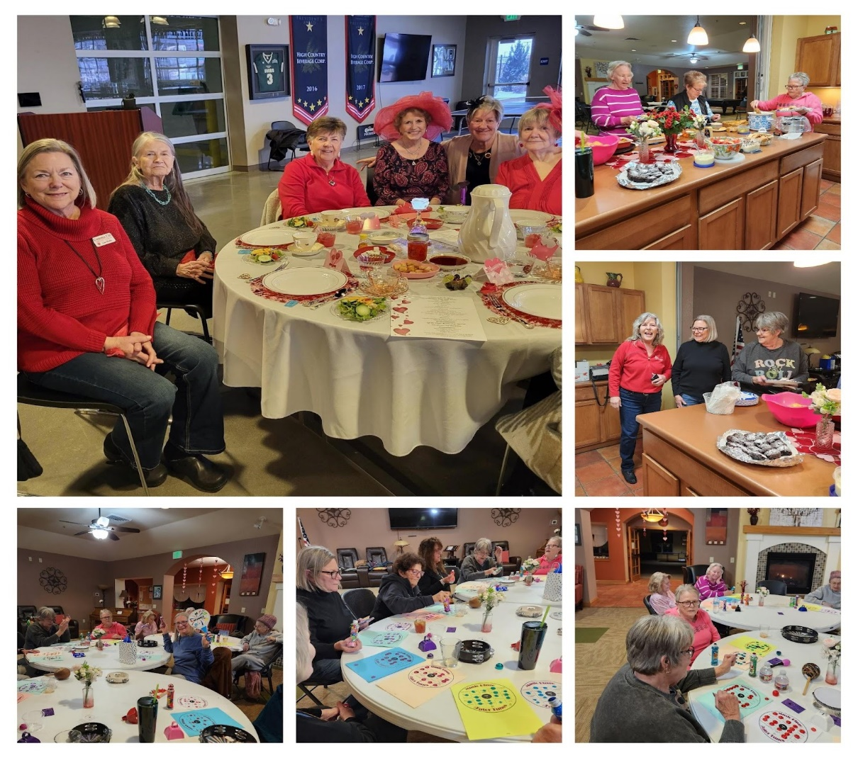

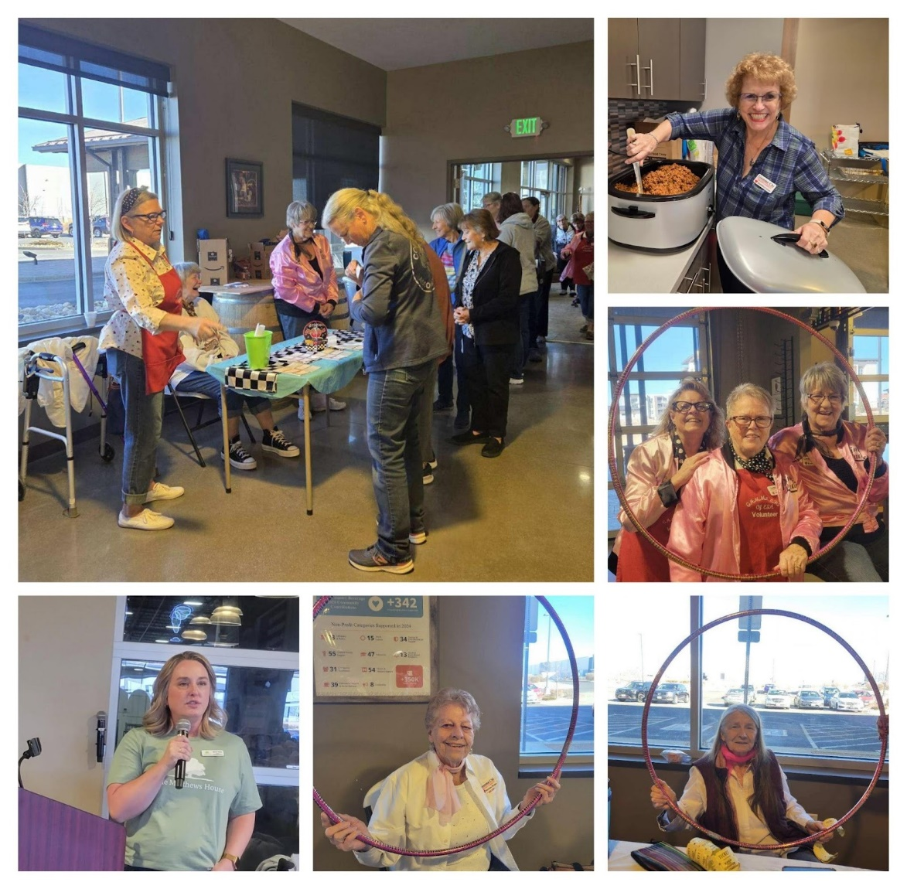

March started off with our annual bunco party with a rock n’ roll theme. 100 people showed up to play, laugh, eat, and just have a great time. We were able to raise over $2,000 for the Landing in Loveland.  During our March meeting we had Ron Albers share information about the Loveland Veteran Honor Monument. It is still in the planning and raising money stage, but they hope to start on it later this year. The Monument is being built in cooperation with the City of Loveland and Parks and Recreation Department. It will be a very beautiful and meaningful memorial.

Besides the usual volunteering we do each month, we are planning a Blood Drive on April 11th. The chapter is looking ahead to June and the Lake-to-Lake Triathlon, the Envision 5K in Evans, and the Wild West Relay in August. Of course, some of us will be at the State Convention in Lakewood.

See you soon. Happy Easter to our state sisters.

Pam

**Pi Sigma**

**Johnstown, CO**

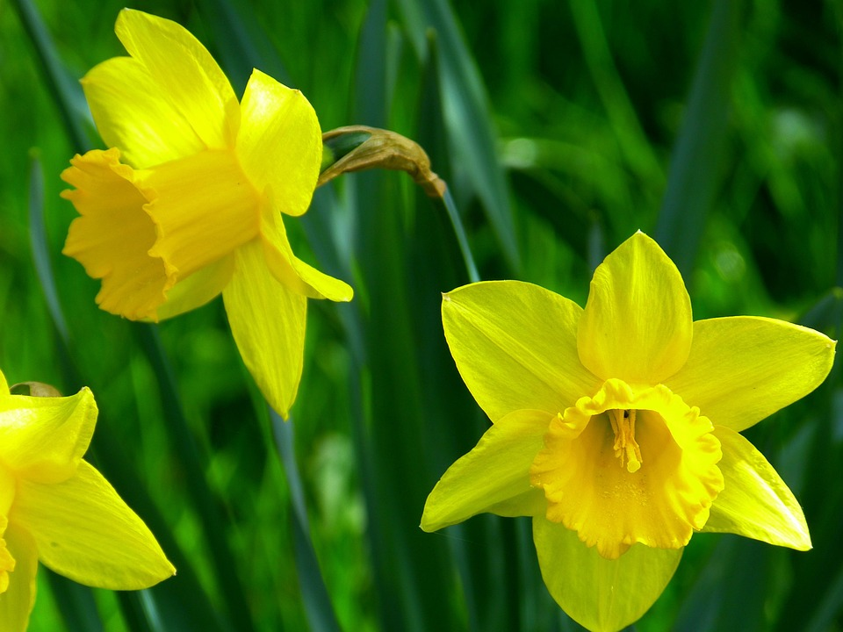

Hello ESA Colorado Friends and Welcome Spring 2025

Thank you to all who attended and helped Patty with the Valentine Tea last month. She is truly gifted with a passion to plan homemade catered menus and beautifully themed events. She’s already started planning next year’s event, so please keep a look out for updates from her.

Anyone else struggling with respiratory flu contagious crud? If so, prayers for healing. Tom and I spent the majority of January through February wearing masks trying not to infect others – both of our immunities were dismal at best. Very thankful we’re both feeling better and thank you for the texts and emails checking in on us.

Appreciate you all,

Love in ESA,

Susie Morris

[smilesatyou@gmail.com](mailto:smilesatyou@gmail.com)

970-217-9856

ESA Int’l Chapter Pi Sigma #5621

President

Johnstown, CO

**Sigma Rho**

**Loveland, CO**

**The Sisterhood of ESA**

When I was asked by a friend to come and check out her philanthropic service group Sigma Rho a chapter of ESA… I had no idea what any of that meant except for the fact that we would be helping people through service and raising money for St. Jude. Little did I know that by joining ESA I would gain a sisterhood, not only within my chapter but with other chapters in town and across the state of Colorado. As I learned more about this amazing service organization, I found out that we are not only in the United States, but we are International!

I begin my journey with ESA and Sigma Rho in 2017 when my dear friend Dixie had asked me to join. I had been to social events and met some of the ladies in my chapter. They seemed like they always had a lot of fun wherever they went, and I definitely wanted to be a part of that. I thrive on helping others, being around positivity and of course having FUN. When I was inducted in the golden glow of the candlelit room, I became a sister to an amazing group of women that will always have your back.

As I grew with my newfound sisters, my fondness for all of them grew too. So many people in life might not be able to experience something like this, boy are they missing out! We have a small but mighty group of 12, we have meetings, socials, and activities but something that comes with all of these are relationships. Our friendships have blossomed into so much more. We have gone through so much together, illness, job loss, surgeries, children, aging parents and even deaths. That is what is so awesome about have a sisterhood in ESA, we can lean on each other, share our experiences and no judgement. The wonderful part about having sisters in ESA is we are on this journey together and they are by your side for a hug, or to hold your hand.

I feel so blessed to have been given this opportunity to be a part of this special group. The closeness we have built up in our chapter has shown me that we can weather any storm if we do it together.

Here is a photo from our 2024 Bingo Event. Some of our friends are in this photo below but the Sigma Rho Sisters that are present are: Dixie Daly, Marilyn Johnson, Ginger Dodge, Debbie Davis, Chris Dostal, Deanna Sloat, Dawna Buchholtz, Emily Westphal.

Respectfully submitted by Deanna C Sloat

Sigma Rho #5014

Just a few highlights of Sigma Rho’s past year. We are a very busy group. Most of our members still work full time but still seem to find time to attend meetings and help when needed.

We started out by attending the Shopping Extravaganza which in turn supports AAYLC (Asian American Leadership Conference). Their mission is to help youth to rise above the obstacles before them and achieve their potential by promoting education, instilling self-confidence and developing leadership skills. Of course, we also love the shopping.

Our Social’s consisted of: attending the “Always, Patsy Cline” show at the Candlelight, painted wooden signs at Planks & Paint, had appetizers/drinks at the Sage Speakeasy and then watched the movie “Wicked”, Christmas social was held at Dixie’s, attended Dixie’s “Tickled Pink Beer Launch party at Grimm Brothers and others.

We pulled off a “Shock ‘N Claus” at the Epic Egg and presented our waitress with a gift of money at Christmas time.

Our Fundraiser’s consisted of our Annual “BLINGO” jewelry party, Barnes and Noble “Book Fair” and gift wrapping, serving at “Serve 6.8”, collecting food donations for veterans at Thanksgiving, collected Christmas gifts for the Berthoud HNS for their clients and donated/attended the Women Give and ATV Luncheons.

Our fundraising efforts raised over $7,700 including those listed above and Disaster Fund, ESA Foundation and St. Jude Children's Research Hospital. This isn’t counting donated goods.

As a Chapter, we are always here for each other; whether it’s a pat on the back, an atta girl, congrats or prayers for a family in need.

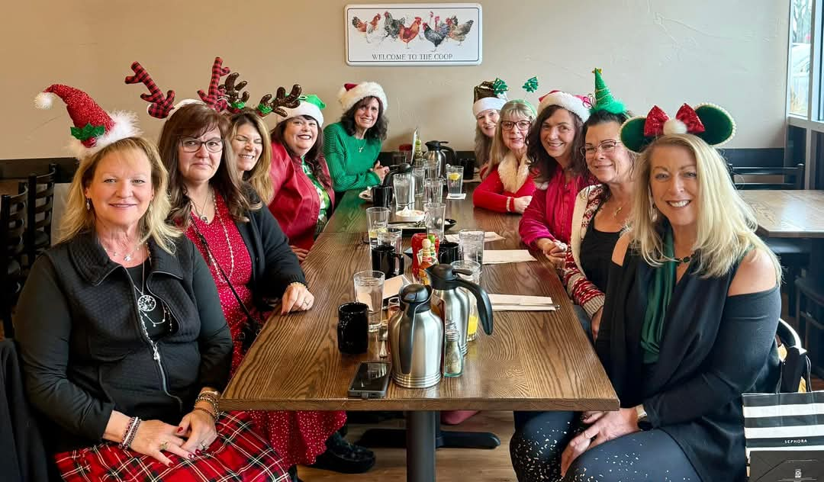

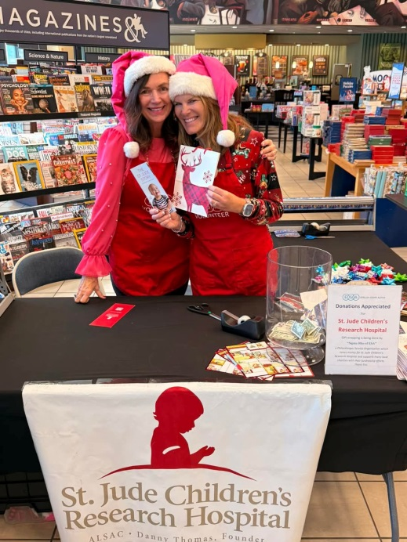

Here’s a few pics of our FUN times.

Chris Dostal, Sigma Rho

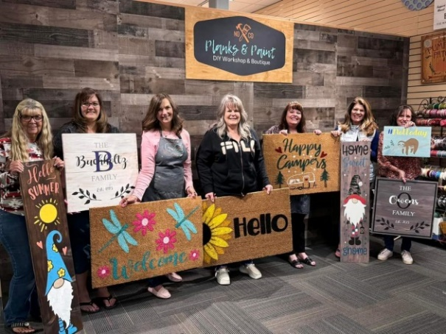

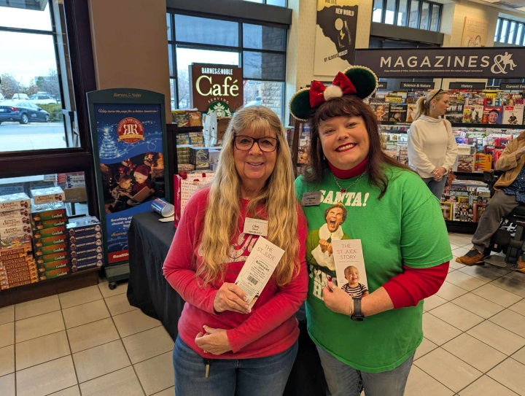

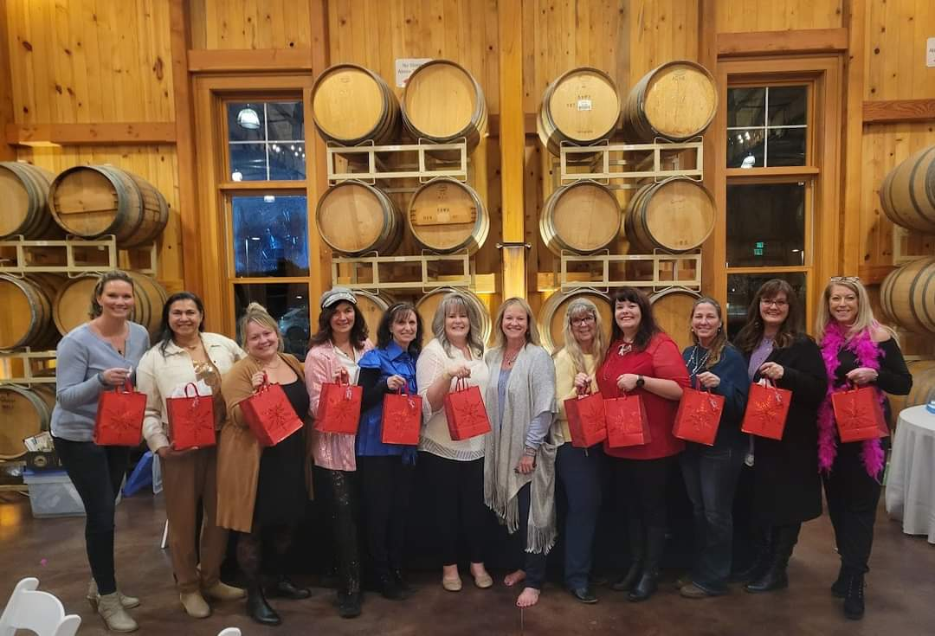

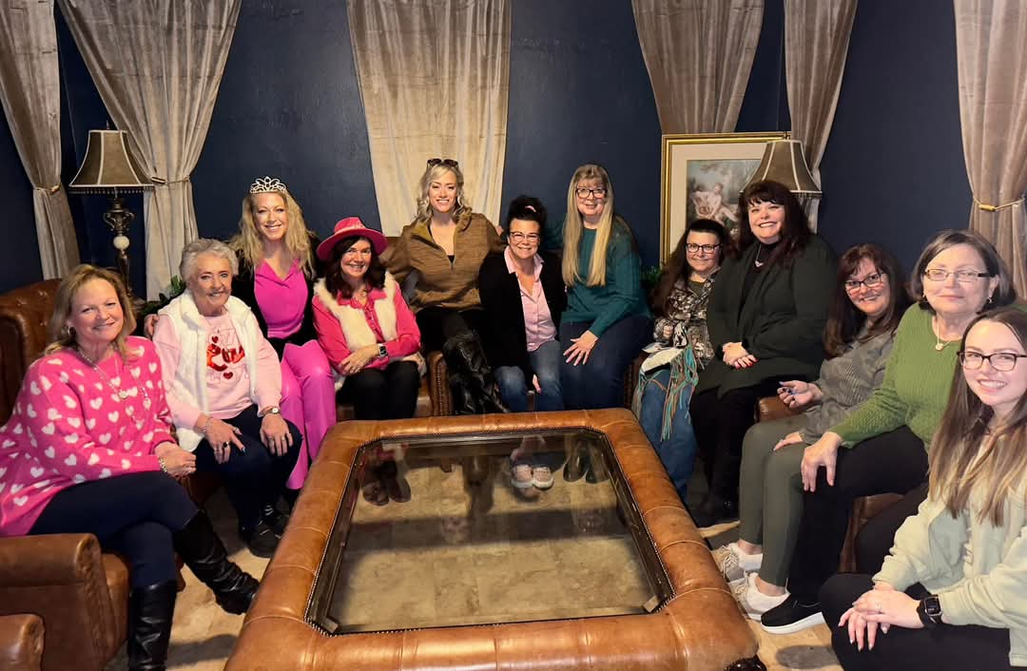

**Zeta Tau**

**Colorado Springs, CO**

Hi, Everyone -

Zeta Tau - Colorado Springs invites you to their Founder's Day Dinner on Thursday, May 1, 2025 4:30 p.m. at Rudy's Little Hideaway Restaurant, 945 S. 8th St., Colorado Springs, CO 80905.

Good food!  Good friends! Good times!  Please join us!

Please RSVP to Diane McNulty at 719-331-1301 or [dsmc624@hotmail.com](mailto:dsmc624@hotmail.com).

Always,

**

**Adi’s Page**

Adi has decided she wants to fundraise again this year for St. Jude Children’s Research Hospital.

Her goal for 2025 is $20,000.00. She is already scheduling cookie stands, bake sales, and she has also decided to have a Spaghetti Dinner to help her reach her goal. The flyer with all the information is attached.

This past weekend she had her first cookie stand of the year at our local home and garden show. We made over 500 bags of cookies, and she raised over $1,600.00. She also met up with the radio station and they told her that they will be backing her fundraising and will be helping her get the word out about all her upcoming events. They will also bring her into the radio station for an interview.

Adi has a Facebook and Instagram Page that follows all her fundraising. If you would like to follow her pages just search “ADI’S COOKIE STAND” on either Facebook or Instagram. I can keep Facebook more updated.

Yesterday Adi had a zoom meeting with Maddie from St. Jude and they are also going to help get the word out about her spaghetti dinner and she will also be sending items for the dinner.

At the dinner Adi wants to have a “Garden Wall” She is going to have paper on the tables shape like butterflies and anyone can write a note, a quote, or inspirational words to the kids at St. Jude and then hang it on the wall that looks like a garden. Maddie with St. Jude said she will make sure to get those notes to the kids at St. Jude.

Adi also has more fundraisers in the works you can find a list of all upcoming events on her social media!!

I can’t wait to see what she does this year! She is already signed up to walk in the St. Jude 5K walk in September in Denver. If anyone would like to join us. We would love that. Last year her and I were the only ones from Epsilon Sigma Alpha!

**Hi everyone!! This is Adi. I want to invite you to my Spaghetti Dinner Fundraiser for St. Jude. My mom has attached a flyer with all the information. I really hope you can make it!! A blue and white owl
**

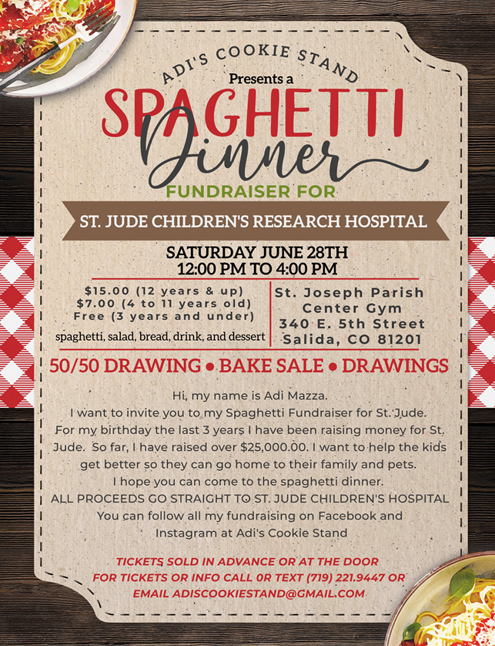

**State Convention**

