**Table**

**Of**

**Contents**

**General**

**Information**

“Do you know that our soul is composed of harmony?”

-Leonardo Da Vinci

**Colorado**

**State**

**Council**

“Music is freedom with a melody.” - Unknown Author

**Colorado**

**Chapters &**

**Area Councils**

“Medicine heals the body but music heals the soul.” - Unknown Author

**Colorado**

**Lamplighters**

“Behind every favorite song, there is an untold story.” -Unknown Author

**Rocky Mountain**

**Regional Council**

“Music Unwraps the heart, sings out the prayer, dances the Spirit and open the Soul.” -Kelly’s Treehouse

**International**

**Council**

“Sometimes Music is the only medicine the heart and soul needs.” -Unknown Author

**ESA**

**Headquarters**

“Music can be the universe.” -Lao Tzu

**CSC Bylaws and**

**Standing Rules**

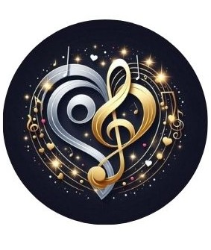

“Music is therapy. It is a communication far more powerful than words, far more immediate, far more efficient.” -Yahundi Menubin