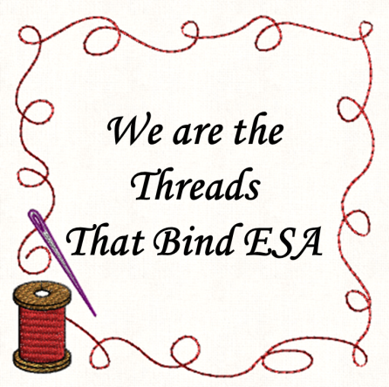

Colorado State Council President 2021 – 2022
Acceptance Speech
May 22, 2021

Good afternoon my ESA sisters.

My journey to this position started thirty years ago when Marlene Kopsa a 3rd grade teacher at Van Buren Elementary where I started my second career in teaching suggested I should join Gamma Chi which was part of ESA. So, it is fitting that my theme this year is “We are the threads that bind ESA’” What wonderful and strong threads they are as they have carried me on this journey and continue to intwine me in all facets of ESA. Thank you, Marlene.

The threads are strong and vibrant and have led me to meet all these sisters that make up the extraordinary world of ESA. Barb Hill after a long phone call, finally talked me into taking a position on her board. How grateful that those threads of friendship and leadership guided me to become involved on the state level. What is obvious on the journey is that from the beginning of ESA in 1929 those insightful women began extending those many threads not only in book groups, but service which became and still is the pinnacle of ESA. Those beautiful threads of various thickness and colors, lead us to branch out to hundreds of meaningful projects.

Through the years threads get knotted or broken, which changes some of our traditions. The biggest change years ago was getting a Webpage and learning to use it and realizing it works quite well. We are here today on Zoom, because of the last year and now we have new threads that have made us reach out to each other locally, within the state, and throughout the United States. This change also made knots in those threads, but we figured out how to go on and still provide service and time to be with each other. Whether we like it or not these threads are here to stay. They will continue to guide us on a little different path.

Phyllis shared during the Celebration of Life that we lose sisters, and those threads end but we also continue on adding new ones.

The most important threads and without them there would be no ESA, are the beautiful threads of friendship. We need the love, laughter, and togetherness that Friendship brings. We share those thoughts every time we say our Opening Ritual.

As I close, I want to thank a few other sisters and friends.

To my friends and family watching this today or here with me, thank you for joining the fun.

Kathy Garrison for helping me this year and being so supportive. We certainly had a lot of laughs along the way.

Vickie, I so enjoyed being on your board. You handled your term with humor and guided us to grow a better ESA garden.

To Canyon City for trying to plan State Convention and then letting it go.

To my dear Kathy Ellingson thank you so much for such a beautiful installation. Our friendship goes back to those days at Van Buren. I am so glad our threads guided us to each other. I know my Gamma Chi sisters played a part in this is special day and thank you very, very much. A special thank you to Annie for my banner and the officer banners. They are beautiful. You carried out my vision.

To all my sisters in Colorado and friends I have made in this wonderful organization, remember “We are the threads that bind ESA.” I look forward to seeing you in person in September.

Thank you.

