

President’s Message

Here we are standing looking at our plot of land, not sure where to start or what to plant. We access our land to find that it is great soil, just like ESA members. So as the rest of the world does not know what to think about their plot we know ours could not be any better. We have a great foundation. We can use our compost and fertilizer to keep our foundation strong. Ok what do we want to grow?

Let us plant some seeds for a strong border (Colorado State Board) to keep us protected from the wind.

What about planting some Easter lilies (Easter Seals)? It would be nice to see them grow and watch the people benefit from their beauty.

We need to leave room for a house or two on our big plot of land for St Jude Research Hospital.

We should plant some vegetables to feed Hope for Heroes.

We should save some seeds in case we have a Disaster and need to replant again.

As we plant we will need to keep track of our money to have room to grow, and our record keepers to keep us on track and let us know about our accomplishments.

So what do you want to grow? Do we need more gardeners? Thank you all for your years of servicing our garden and here is a ribbon cutting to another great year.

Hugs to all!

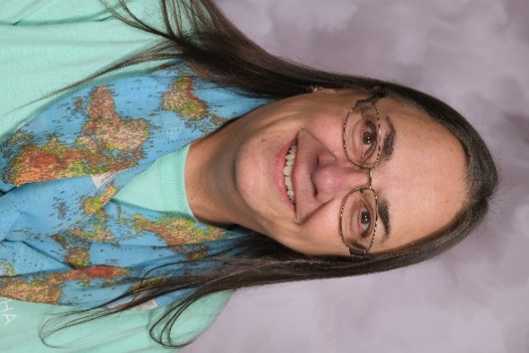Vickie Chavers-Bruso