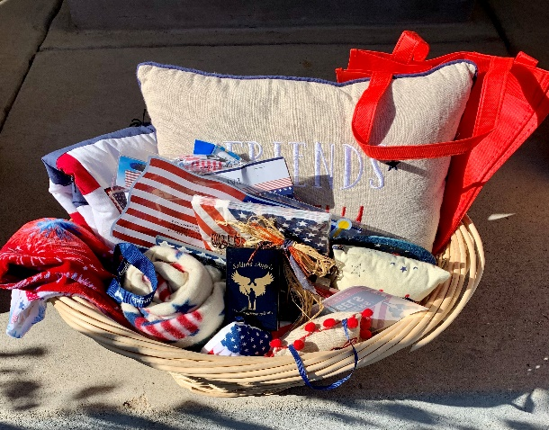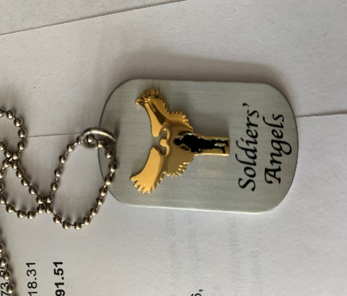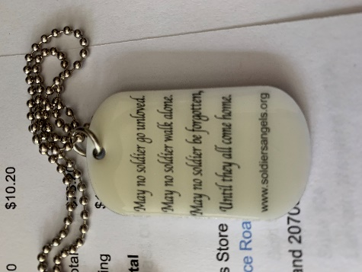

ESA
HOPE FOR HEROES
“Red, White & Blue” basket
Drawing Tickets:$1 each or 6 tickets for $5
Drawing @ CSC 2020 Convention
-Soldiers’ Angels bag, decal and boxed pin/coin set
-pillow, lap quilt, fleece lap blanket, hand towels, flag decals, decorations and more in a large wicker basket.

Soldiers’ Angels
“necklaces” dog tags/key chain for $10 each.

Please help support Colorado Veterans through ESA Hope for Heroes, by sending checks written out to Susie Morris and mail to:
Susie Morris
16815 Howlett Pl,
Mead, CO 80542

Thank you, God Bless the USA and LOVE in ESA,
Susie Morris, 2020-2021 ESA CSC Hope for Heroes – Chairperson

