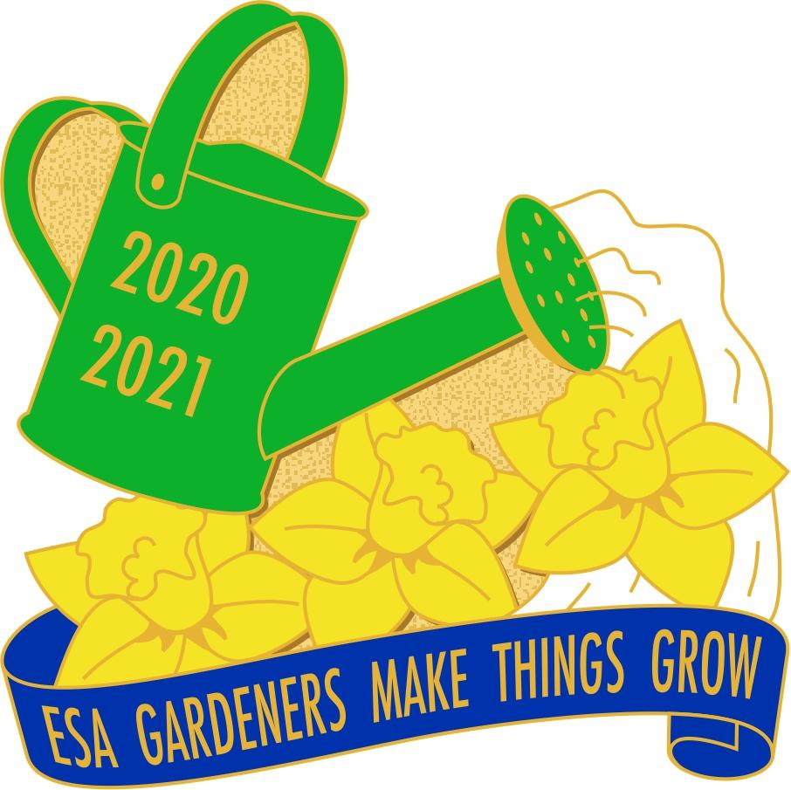

Colorado State Council President 2020- 2021
Acceptance Speech
August 22, 2020
It is only fitting that I begin my acceptance speech with words of thanks.
To Joyce Fuller for a beautiful Installation.
To Kathy Garrison and Joyce Fuller Co Chairs for a ground breaking Convention.
To Denver Epsilon Council for supporting me in this adventure.
To the Web team, Candie Patino, Kathy Ellingson, and Bonnie Gillmore for all the technical work.
This would not have been possible without everyone rolling up their sleeves, putting on their thinking caps and digging in.
My theme this year is “ESA Gardeners make things grow”. Just think, a short while ago we went from an in person convention to grow it into a virtual convention. So the seeds have been planted. Our soil is the best to nurture growth. Where do we go from here?
I am honored to become the Master Gardener. However, I warn you that when I plant seeds get impatient and plant more. Birds plant some and I end up with a jungle. Anyone need any oregano?
Even in gardening you need a since of humor the way I grow things. I remember having a neighbor over to look at my garden. I said look at my beautiful cucumber plants they have such pretty flowers. The leaves had not gotten big and as she looked at me in disbelief, she shook her head and said “those are nasturtiums”. I proceeded to tell her yes I did plant some flowers that are edible as well. The cucumbers never came up.
As we look forward to our harvest season we will need to work together to grow and plan the future crop.

