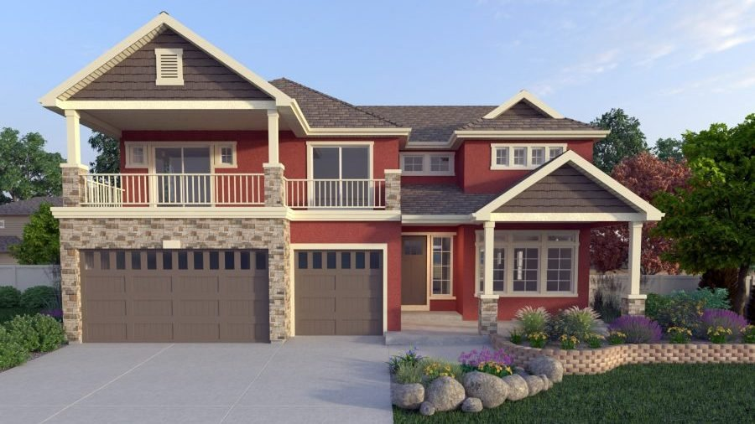

Winners of prizes in St. Jude Dream Home Giveaway
Tom Gibson of Aurora was drawn as the winner of the ninth annual St. Jude Dream Home Giveaway on October 23.
Every ticket helps St. Jude Children's Research Hospital and $1.45 million was raised.

About the Dream Home
The Enclave | 20891 Beekman Place | Denver, CO 80249
Built by Oakwood Homes |Estimated value of $775,000

Prizes
Open House Prize: $10,000 Furniture Row Shopping Spree- Jasmin Cuadrado- Aurora
Tickets On Sale Prize: $3,500 Visa Gift Card, courtesy of the Christie Family- Glendon Golden- Aurora
Early Bird Prize: 5-night stay at Riu Cancun resort, courtesy of Apple Vacations® -Mark Schwartz- Tennessee
Bonus Prize: 2019 Lincoln MKC, courtesy of Landmark Lincoln- Ed Miller- Denver
Secondary Prizes:
- $1,000 gift card at Coton Colors- Keith Pena- Loveland
- Artesso® Articulating Kitchen Faucet with SmartTouch® Technology, courtesy of Brizo®- Edward Gurnsey Jr.- Greeley
- $1,000 gift card at Shaw Floors®- Ann Guerin- Lone Tree
- 800 Series, 24″ Pocket Handle Bosch Dishwasher, featuring the innovative MyWay third rack, courtesy of BSH Home Appliances Corporation- Maria Cervantes- Denver
FOX31 & Colorado’s Own Channel 2 are proud to partners for the 2019 St. Jude Dream Home Giveaway, a community service project to support the St. Jude mission of finding cures and saving children.

