2019 Colorado Springs Dream Home Results
We received $940,000 for St Jude Hospital.
(We sold out the day before the drawing too.)

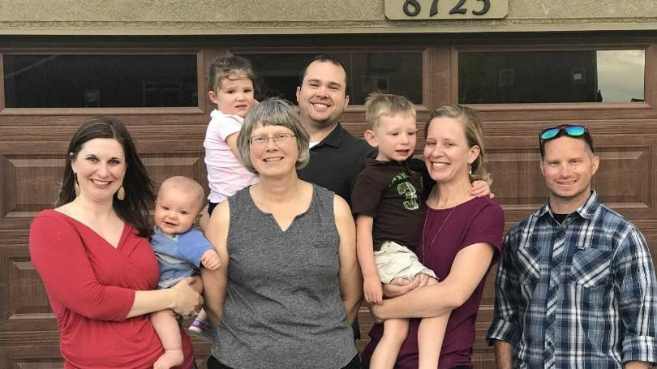

WINNER: Dream Home (valued at $525,000)
Laura Betts of Colorado Springs

Thank you to everyone who bought a ticket and participated! Every cent spent on a ticket goes towards St. Jude and their work towards eradicating childhood cancer.

WINNERS BELOW:
$10,000 furniture shopping spree (eligible if you toured the St. Jude Dream Home during Open House hours and entered at the home, no ticket purchase necessary)
Stacy Palos of Colorado Springs

$2,500 entertainment package
Kathye Pebley of Colorado Springs

$10,000 VISA gift card
Rosendo Jaime of Pueblo

Hot Spring Limelight Flash hot tub with cover
Susan McCormack of Colorado Springs

