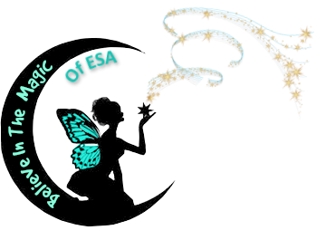

Believe In The Magic Of ESA
State Yearbook
2018 ~ 2019

Table of Contents

General Information
Website Information / Golden Lamp Schedule

Colorado ESA Council

Officers with Lamplighter Advisors and Chapter In-Service Assignments
Committees

Colorado ESA Chapters & Area Councils

Chapter Presidents and Treasurers
Area Council Presidents and Treasurers

State Council Past State Presidents

Lamplighter Officers
Lamplighter Addresses

Rocky Mountain Regional Council

Rocky Mountain Regional Officers

International Council & ESA Headquarters

Executive Board
IC Appointed Board (partial)
ESA Headquarters Personnel
Future IC Conventions
ESA Membership Corp

Past State Council Awards

Outstanding Chapter of the Year
Outstanding Woman of the Year
Pioneer Woman of the Year
Pledge of the Year

Available on the Colorado Website - www.esacolorado.org
CSC Officer Guidelines
ALL Updated Colorado State Forms
Complete Listing of Lamplighters 1947 - 2018
Complete Listing of All Past Colorado Awards
International Council Appointed Board
ESA Foundation Board of Directors

*Front folder pocket*

CSC CO Bylaws and Standing Rules
Colorado State Council Dues Form
IC Dues Form
*Back folder pocket*

2019 Colorado State Convention Registration Form
2019 Rocky Mountain Regional Registration Form
State Yearbook Change Form
President’s Special Charities

