COLORADO STATE COUNCIL
EPSILON SIGMA ALPHA
2019 – 2020 CANDIDATES

For the Office of President Loydette Knight
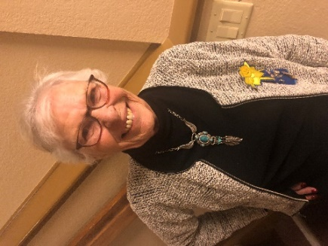
Loydette became a member in 1968 and is a member of ESA Foundation.
She was President of her previous chapter (5 times) and held all elected and appointed offices. She has served as Treasurer for her current chapter.
She served are Area Councils as Parliamentarian, Recording Secretary, Treasurer, Vice President and President.
Loydette has served on the State Council as Membership Chair, JR/SR St. Jude Coordinator, Treasurer, Recording Secretary, Vice President and President Elect.
She is a Life Active member and has earned her 5th Degree Pallas Athene. The has attended 31 State Conventions and 4 IC Conventions.
Her dues are paid and her chapter is in good standing.

____________________________________

For the Office of President – Elect Vickie Chavers-Bruso
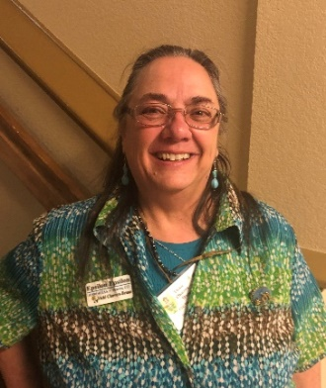
Vickie became a member in 1991 and is a member of ESA Foundation.
Vickie has served her chapter as President (4 times), Vice President, Recording Secretary, Corresponding Secretary, Treasurer, Parliamentarian and Chaplain. Vickie has served on the State Council as Parliamentarian, Treasurer, Vice President and all appointed offices with the exception of Foundation Councilor.
Vickie has her 1st Pearl and 4th Degree Pallas Athene. She has been chapter Woman of the Year (3 times), and her Area Council Woman of the Year twice. Vickie has attended many State Conventions and 1 IC Convention.
Her dues are paid and her chapter is in good standing.

__________________________________

For the Office of Vice President Pam McGee

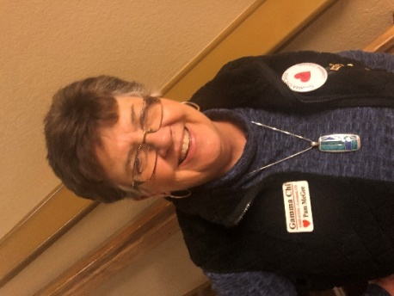
Pam became a member in 1991 and is a member of ESA Foundation.
Pam has served her chapter as President (3 time) and I have heard by the grapevine that Pam has served on the State Council at least once.
Pam has earned her 4th Degree Pallas Athene.
Her dues are paid and her chapter is in good standing.

____________________________________

For the Office of Corresponding Secretary JODY KARR
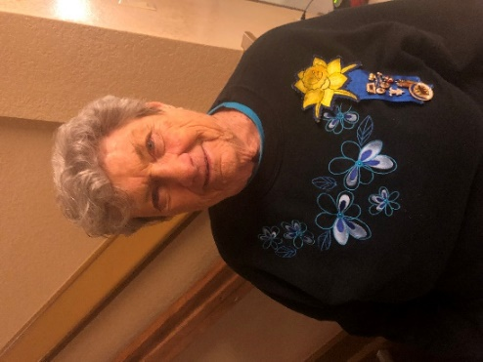
Jody became a member in 1986. She is a member of the ESA Foundation.
Jody has served her chapter as President (4 times) and has held all chapter offices. She has held all offices except corresponding Secretary in her Area Council.
Jody is a Colorado Past State President and had held all offices with the exception of Corresponding Secretary.
Jody is a Life Active Member and has her 1st Pear. She has been Woman of the Year in her chapter and Area Council. She has Attended 31 State Conventions and 28 IC conventions.
Her dues are paid and her chapter is in good standing.

_______________________________

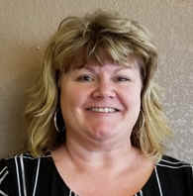
For the Office of Recording Secretary Susie Morris
Susie’s nomination qualifications will be read at state convention.

____________________________________

For the Office of Treasurer Karen Addison
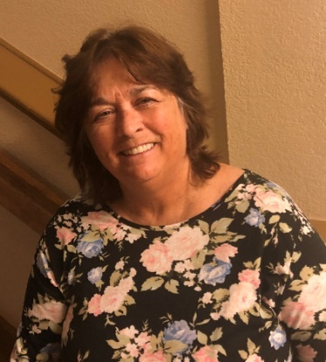
Karen became a member in 2013. She is a member of ESA Foundation. Chapter offices held by Karen are President and Recording Secretary. She has served on the Colo. State Council as Philanthropic Chair and Recording Secretary.
Karen has attended 5 State Conventions and 1 IC Convention.
Karen has Charted a new Chapter, Zeta Nu #5068 in Colorado Springs.
Her dues are paid and her chapter is in good standing.
According to the By Laws, Article 9, Section 4, new chapters are granted honorary member ship in the State Council for the term of their charter year.

_________________________________

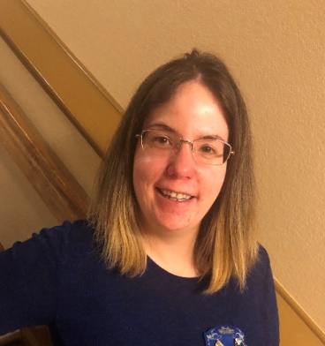
For the Office of Parliamentarian Chloe McClantock
Chloe became a member in 2009. She is a member of ESA Foundation.
Chloe has served her chapter as President (twice), Vice-President, Corresponding Secretary, Recording Secretary, Philanthropic Chair and 3 years as Co-Chair for her chapters Chocolate Party.
She has served her Area Council as Ways and Means, Philanthropic, Educational Chairs, JR & SR St. Jude Coordinator and as Treasurer.
She has been Woman of the year in her Chapter and Area Council. Chloe has eared her 1st Pearl and 4th Degree Pallas Athene. She has attended 21 State Conventions (11 as DESA/ELAN) and 3 IC Conventions.
Chloe has helped with the Denver and Colo. Springs Dream Homes and has become a Games Manager.
She has been a Girl Scout Councilor for 4 years.
Her dues are paid and her chapter is in good standing.
_______________________________

