Alpha Lambda Chili Supper
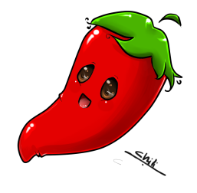
Please join Alpha Lambda for their annul Chili Supper. Lots of companionship, fun, food, door prizes and a grand prize drawing.
Chili Supper - $10.00
Proceeds go to: Local Charities, St. Jude and Children’s Hospital
Grand Prize drawing: tickets $1.00 each or 6 for $5.00
Crafts will be available for purchase (maybe).

When: Thursday; March 21, 2019
6:30 PM – 8: PM

Where: Evans Community Complex
1100 37 Street – Evans, CO 80620

RSVP: RuthMary Lyons
Rm80620@hotmail.com
970-405-0263

Ula Rae Adler
Ularae72@hotmail.com
970-330-4962 or 970-302-6572

