ESA Colorado State Council
Officer Candidates
2024-2025

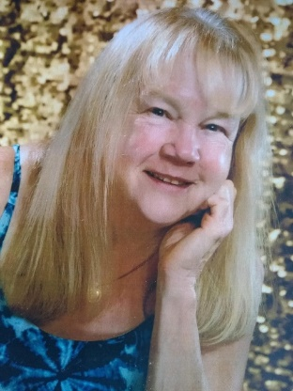 | Susan Bloss-President  - Member of Zeta Tau 2064 of Colorado Springs  - Member since 1991  - Attended 25+ State Conventions, 6 IC Conventions  - Has been Convention Co-Chair, Corresponding & Recording Secretary, and currently is President Elect  - Superpower is Organization
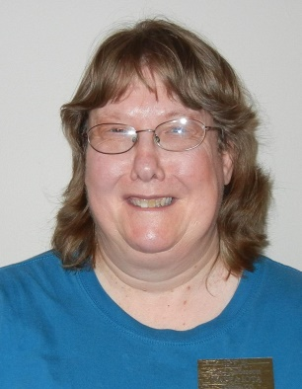 | Lori Anderson-Havelick-President Elect  - Member of Alpha Phi  - Member since 1984  - Attended 34 State Conventions, 17 IC Conventions  - Has held multiple State Offices to include Vice President, Recording Secretary, Treasurer, Parliamentarian, ESA Foundation Chair (10 years) and many appointed offices.  - Has been a Distinguished Athenian two times and is very active in promoting ESA in her free time and has supported St Jude through incredible personal fundraising.
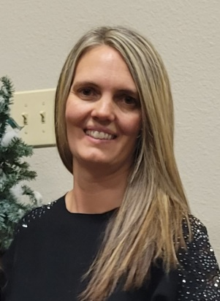 | Jenniffer Carlson-Mazza-Treasurer  - Member of Alpha Omicron 770  - Member since 2013  - Attended 2 State Conventions  - Has been the Golden Lamp Editor and Corresponding Secretary  - Along with her daughter Addie, has supported St Jude through phenomenal Fund raising.
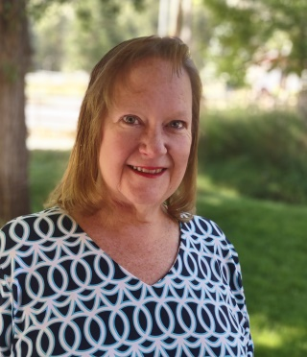 | Susan Winton-Secretary  - Member of Alpha Phi  - Member since 2021  - Attended 2 State Conventions , 2 IC Conventions  - Has been our ESA Foundation Chair for the past year  - Very enthusiastic and involved in ESA
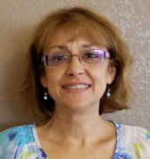 | Debbie Spear-Parliamentarian  - Member of Gamma Omega 4306  - Member since 1990  - Attended 9 State Conventions, 1 IC Convention  - Has held numerous State Offices to include Chaplain, Corresponding & Recording secretary, Parliamentarian, ESA Foundation Counselor, Treasurer, Hope for Heroes Chairman, & Scrapbook Chair.  - We are thrilled to have her back on our State Board
Dana Bell-Corresponding Secretary or Communications Chairman
- Member of Zeta Tau 2064
- Member since 1996
- Attended 20+ State Conventions, 5 IC Conventions
- Strong computer skills
- Very flexible with being Corresponding Secretary or Communication Chairman 😊

