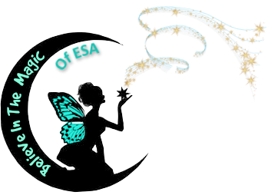

**Colorado Council**

**Epsilon Sigma Alpha**

**2018 ~ 2019**