2018 ~ 2019 Candidate Bios
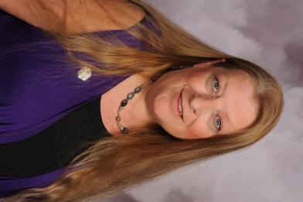
FOR THE OFFICE OF PRESIDENT:
Leslie Stevens, Kappa Iota #5442, Golden
Leslie joined ESA in 1984. She has held all Chapter Offices and committees. She is currently Chapter President, Philanthropic Chair and on several committees for the 2018 ~ 2019 Colorado State Convention.
Leslie is a member of Denver Alpha Council. She has been Yearbook Chairman for two years. She was also a member of Colorado West Council, Northwestern Area Council and Denver Epsilon Council holding the Office of Recording Secretary (CWC), Awards Chair (CWC &NWAC) and Co Convention Chair for the 1994 ~ 1995 Colorado State Convention in Glenwood Springs, CO. Leslie chaired several committees for Denver Epsilon Council.
Leslie has Chartered one Chapter with 5 members (Disbanded).
On the State Level, Leslie has been President - Elect, Vice President, Recording Secretary, Corresponding Secretary, Golden Lamp Editor 3 times, Jr. and Sr. Membership Director , Membership - Western Slope, Publicity Chair, Philanthropic Chair, Educational Director, Jr. and Sr. St. Jude Coordinator and 1994 Co Convention Chair.
Leslie has received the Distinguished Athenian Award twice, 1st and 2nd place, 3rd place for IC Newsletter her first year as Golden Lamp Editor, 1st place for The May E. Wells Award for Outstanding Educational Director and received 1st and 3rd place for her I.C. Assoc. Of the Arts entries in 2017.
Leslie has her 4th Degree of Pallas Athene, her First Pearl +1 and is a Life Active Member.
Leslie is a member of ESA Foundation.
Leslie has been to 28 State Conventions, 10 International Conventions, 3 Rocky Mountain Regional Roundups and 1 ESA Leadership Conference. For Rocky Mountain Regional Council, she designed and produced the “mini flags” that the multi States will use at IC Conventions.
Leslie’s dues are paid and her Chapter is in good standing.

FOR THE OFFICE OF PRESIDENT - ELECT:
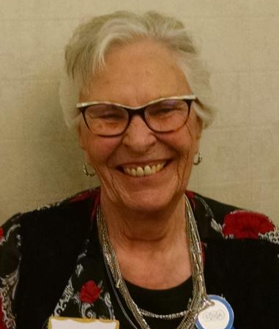
Loydette Knight, Zeta Rho #1774, Aurora
Loydette joined ESA in 1968. She has held all Chapter Offices multiple times.
She is a member of Denver Alpha Council and has held the offices of Parliamentarian, Treasurer, Vice President and is currently the President. She was also a member and President of Nothwestern Area Council.
On the State level, Loydette has served as Membership Director, Jr. And Sr. St. Jude Coordinator, Recording Secretary, Treasurer- twice and Vice President.
Loydette has received her 5th Degree of Pallas Athene, her First Pearl and is a Life Active Member.
Loydette has been Woman of the Year for her Chapter (Theta Zeta, Rangely) and was 1st runner up for State.
Loydette has attended 30 State Conventions, 3 International Conventions and 1 ESA Leadership Conference.
Her dues are paid and her Chapter is in good standing.
Loydette states, she has an eye for details with her career as a bookkeeper and Office Manager, as well as having been a Court Clerk and a Rental Manager.

FOR THE OFFICE OF TREASURER:
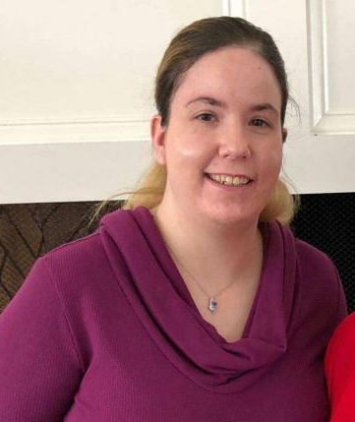
Chloe McClantoc, Chi Kappa, #5729, Denver
Chloe started ESA as a DESA/Elan and became a full member in 2009.
For her Chapter she has served as President, Corresponding Secretary, Recording Secretary, Publicity Chair, Educational Chair and Co Chair for their Chocolate Luncheon.

Chloe is a member of Denver Epsilon Council and has held the offices of Corresponding Secretary, Ways and Means Chair and Treasurer.
On the State level she has served as Publicity Chair - 2 years, Educational Director, Philanthropic Chair and St. Jude Jr. and Sr. Coordinator.
During her Sr. Year as St. Jude Coordinator, the State of Colorado received the St. Jude Pinnacle Award for raising $1 million in a single year for St. Jude and the Danny’s Dream Award for Colorado reaching the $11 million mark in donations to St. Jude. She also became a Games Manager for the Dream Homes.
Chloe was the Woman of the Year for her Chapter and Denver Epsilon Council in 2015.
She has received her 4th Degree of Pallas Athene and her First Pearl.
Chloe has attended 18 State Conventions and 3 International Conventions.
Chloe is a member of the ESA Foundation, her dues are paid and her Chapter is in good standing.

FOR THE OFFICE OF CORRESPONDING SECRETARY:

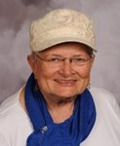
Nancy Cameron, Kappa Iota #5442, Golden
Nancy joined ESA in 1959 in Durango, CO.
She Chartered a Chapter in Brigham City, Utah, in 1964, before becoming a member of Epsilon Epsilon Chapter, in Denver where she remained for over 40 years. In 2004, she Co - Chartered Kappa Iota. She has held ALL offices and committees several times.

She is currently a member of Denver Alpha Council and has served as President, Treasurer and Parliamentarian, as well as several committee chairs. For Denver Epsilon Council, she served as President, Vice President, Recording Sec., Treasurer, and Parliamentarian. For the Durango ESA Council, she held the office of Recording Secretary.

At the State level, well what HASN’T she held. She served as State President in 1994 ~ 95, President Elect, Vice President, Parliamentarian, Treasurer, Chaplain, Jr. And Sr. St. Jude Coordinator, Philanthropic Chair, Educational Chair, Golden Lamp Editor, Foundation Councilor, Easter Seals Director, Publicity chair, State Convention Co Chair, I.C. Convention Committees 2x.

Nancy has her 5th Degree of Pallas Athene and is a Life Active Member. She is a member of Foundation.

Nancy has been Woman of the Year for her Chapter(s) several times, as well as for both Denver Councils. She has earned some very prestigious awards like The St. Jude/ALSAC Volunteer of the Year ESA Appreciation award, the 1st ESA Pioneering Woman Award, the Distinguished Athenian Award, and a slew of awards from St. Jude and ALSAC. She was the first Walkin’ the Dog Chair in Denver and continued in that position for 4 years, she chaired the very first Denver Radiothon in 1990 and continued in that position until 1998. She Co - Chaired the very first Denver Dream Home and continues as a Games Manager.

She has served as President, Vice President and Recording Secretary for RMRC and Co Chaired the Roundup 3 times.
On the International level, Nancy is currently an ADA for the I.C. President.
Nancy has attended 50 State Conventions, 25 International Conventions and 24
Her dues are paid and her Chapter is in good standing and she states “ I am a good gopher”!

FOR THE OFFICE OF PARLIAMENTARIAN:

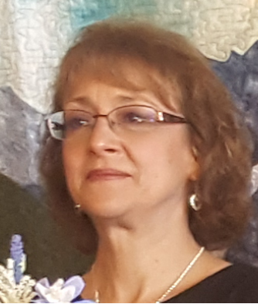
Debbie Spear, Gamma Omega #4306, Akron
Debbie joined ESA in 1990. For her Chapter she has served as President, Vice President, Recording Secretary and Treasurer.
She is a member of NE Council and has held the offices of President and Recording Secretary.
At the State level, Debbie has served as Corresponding Secretary, Chaplain and Recording Secretary.
Debbie has her 2nd Degree of Pallas Athene and her First Pearl.
She is a member of Foundation.
Debbie has attended 5 State Conventions and 1 International Convention.
Debbie states she has over 20 years secretarial experience, is familiar with Parliamentarian procedures, is task and detail oriented.
Her dues are paid and her Chapter is in good Standing.

FOR THE OFFICE OF RECORDING SECRETARY: (Your name here) ?

FOR THE OFFICE OF VICE PRESIDENT: (Your name here) ?

