International Council Future Conventions
July 18 – 22, 2018
Sheraton Grand Phoenix
Phoenix, Arizona
Hosted by Arizona and California
Registration: $250.00 Room Rate $139.00
Theme: “Sunshine and Celebrations”
Sherry Day, Chair; Rickie Brown, Co-Chair
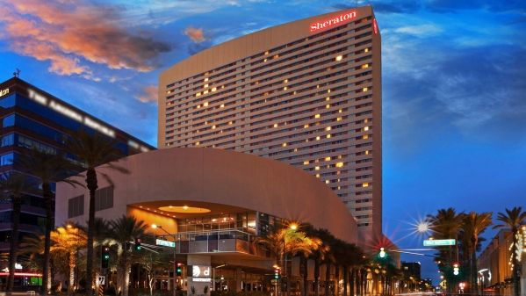

July 17 – 21, 2019
Sheraton Hotel
Memphis, Tennessee
Theme: “Merriment and Memories Memphis Style”
Registration $250 Room Rate $151.00
Hosted by Arkansas
Charlotte Garrett, Chair, Ann Southhall, Co-Chair