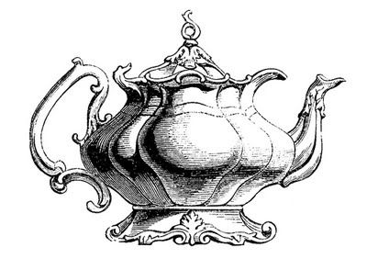
Nostalgic Holiday Tea
Join us at The Historic Manor House
For a day filled with Traditional Tea Fare
Holiday Cheer, Drawings, Homemade Baked Goods, and more!
December 16, 2017 (One week later than usual)
$37.00 per person
Tickets sold in advance (non-refundable)
Limited Seating – Visa and Mastercard accepted
Tickets purchased by November 15th will be entered into the “Early Bird” drawing for a Kindle Fire HD
Hosted by Epsilon Epsilon Chapter of Epsilon Sigma Alpha
Contact Kathy Garrison 303-791-6859
kgtdybear@comcast.net
WE HOPE YOU WILL JOIN US AT OUR EIGHTH ANNUAL HOLIDAY TEA

