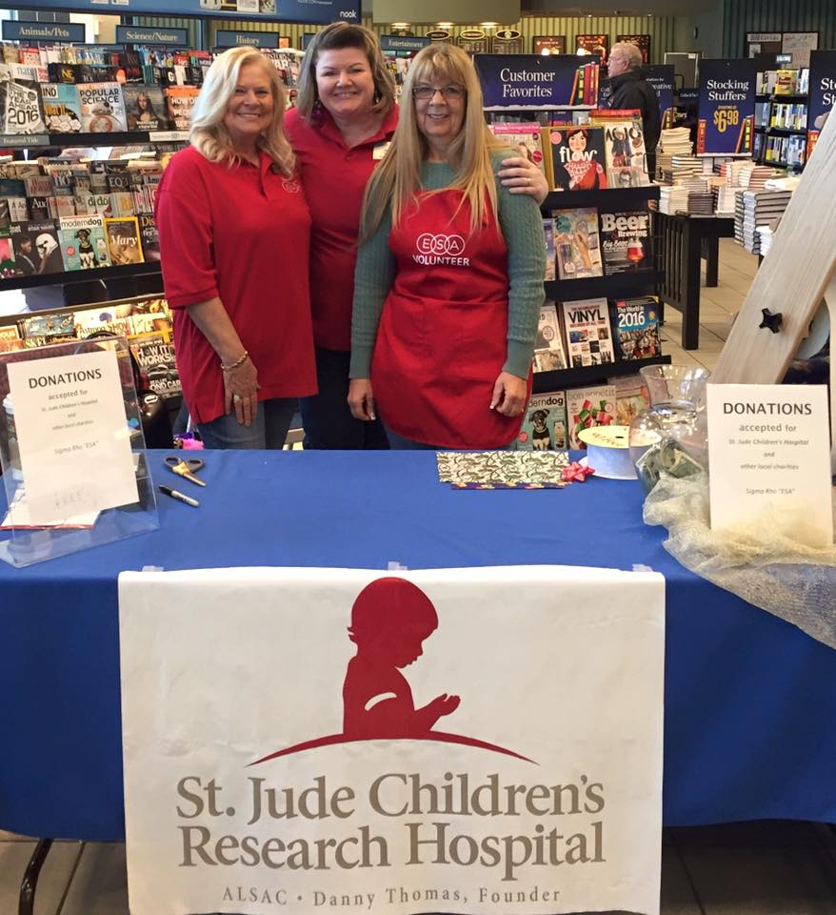
Monday, December 18th & Thursday December 21st from 11am – 8pm each day

Let Sigma Rho of ESA
wrap your Christmas gifts at:

Barnes & Noble
The Promenade Shops at Centerra
The Shops at Centerra
5835 Sky Pond Drive
Loveland, CO 80537
970-663-9473
100% donations go to St Jude

