The Colorado State Lamplighters . . . In 1959, the Lamplighters, an organization of Past Colorado State Presidents, was formed. Officers of the group are elected every two years. Membership consists of all past Colorado State Council Presidents and Past State Presidents from other states who are members of Colorado State Council.
NO. |  | NAME, Chapter City & Theme for Year | YEAR | INSTALLATION CITY & CONVENTION THEME
1 | 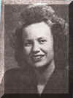 | Agnes Clark  Alpha Alpha, Denver | 1947-48 | Denver  "Hawaiian"
2 | 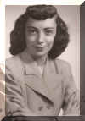 | Phyllis Rambat  Alpha Sigma, Arvada | 1948-49 | Estes Park  "ESA Roundup"
3 | 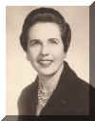 | Neta Sackman **  Alpha Delta, Pueblo | 1949-50 | Pueblo  "Luxury Liner"
4 | 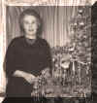 | Bernice Rogers **  Gamma Omicron, Colorado Springs | 1950-51 | LaJunta
5 | 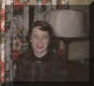 | Mary Abrams Kinkel **  Alpha Sigma, Arvada | 1951-52 | Fort Collins  "Rainbow"
6 | 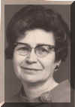 | Irene Fife **  Theta Lambda, Colorado Springs | 1952-53 | Denver  "Mardi Gras"
7 | 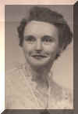 | Margie Thompson  Beta Theta, Fort Collins | 1953-54 | Colorado Springs  "South Sea Islands"
8 | 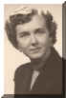 | Marilyn Weibe**  Alpha Alpha, Denver | 1954-55 | Grand Junction  "Treasure Seeking in the Grand Valley"
9 |  | Merrily Roberts | 1955-56 | Pueblo
10 | 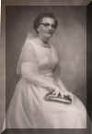 | Kay McLaughlin **  Delta Eta, Durango | 1956-57 | Estes Park
11 | 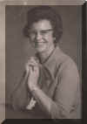 | Ardis Macy Blakley **  Epsilon Epsilon, Denver | 1957-58 | Durango
12 | 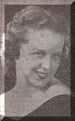 | Stella White  Alpha Upsilon Pueblo | 1958-59 | Fort Collins
13 | 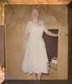 | Jennie Rose Reeves **  Alpha Phi, Golden  "Togetherness" | 1959-60 | Denver  "Hawaiian Holiday the E.S.A. Way"
14 | 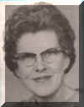 | Bernice Gates **  Beta Theta, Fort Collins | 1960-61 | Pueblo  "Les Girls"
15 | 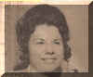 | Doralee Dickman  Gamma Delta, Meeker | 1961-62 | Grand Junction  "Kaiosoari State - Clasp with a Sister of E.S.A."
 |  | Mary Margaret Hooks **  Gamma Sigma, Lakeland, FL  "Happiness Through Sharing" | 1961-62 | Florida State President
16 | 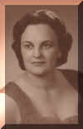 | Darlene Wallace **  Theta Zeta, Rangley  "Stairway to Happiness" | 1962-63 | Colorado Springs  "Faraway Places"
17 | 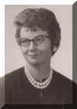 | Betty Jean (BJ) Christianson Marshall  Delta Lambda, Pueblo  "Count Your Blessings" | 1963-64 | Lamar  "Frontier Days in E.S.A."
18 | 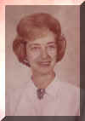 | Betty Jean Turetzky **  Alpha Gamma, Denver  "Strive for the Stars" | 1964-65 | Estes Park  "Four Seasons"
19 | 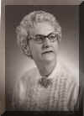 | Helen Corbin **  "Follow the Rainbow" | 1965-66 | Craig  "South of the Border"
20 | 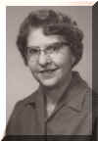 | Grace Wall **  Delta Eta, Durango  "Live Each Day with E.S.A." | 1966-67 | Denver  "Rainbows End"
21 | 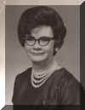 | Donna Jean Busmire **  Delta Theta, Denver  "Happiness in E.S.A." | 1967-68 | Pueblo  "Broadway Extravaganza"
 | 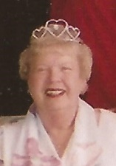 | Dorothy Roy**  Alpha Phi, Cedar Rapids, IA  "Pearls of Enthusiasm" | 1967-1968 | Iowa State President
22 | 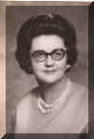 | Peggy Healy **  Zeta Tau, Colorado Springs  "Symphony in Blue & Gold" | 1968-69 | Cortez  "Four Corners Pow-Wow"
23 | 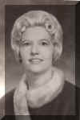 | Billie Jean Farnham  Beta Omicron, Monte Vista  "Open Hands – Open Heart" | 1969-70 | Craig  "E.S.A. Showboat of "69"
24 | 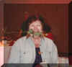 | Patricia Horan **  Alpha Alpha, Denver  "Impossible Dreams" | 1970-71 | Alamosa  "E.S.A. Train to Broadway in 1970"
25 |  | Mildred Cutler **  Alpha Zeta, Las Animas  "Doors of Friendship in E.S.A." | 1971-72 | Glenwood Springs  "Spa of the Rockies"
26 | 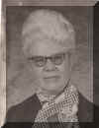 | Maxine Ong  Theta Zeta, Rangely  "Make a Pearl for E.S.A." | 1972-73 | Fort Collins  "Once In A World of Fantasies"
 | 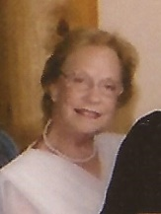 | Kathryn Kutch **  Alpha Nu, Merritt Island, FL  "Walk a Mile with Me" | 1972-73 | Florida State President
27 | 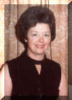 | Si Harkins **  Eta Beta, Denver  "Shadows of the Future" | 1973-74 | Grand Junction  "Gateway to Four Seasons"
 | 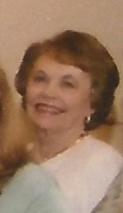 | Ruth Booton **  Beta Gamma, Albuquerque, NM  "Take Another Look" | 1973-74 | New Mexico State President
28 | 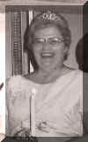 | Anne Slonaker **  Zeta Beta, Durango  "Three Golden Links" | 1974-75 | Colorado Springs  "E.S.A. – Gardens"
29 | 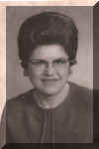 | Elda Mae Martin **  Beta Omicron, Monte Vista  "Dare to Be" | 1975-76 | Boulder  "Links of Gold"
30 | 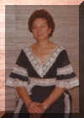 | Helen McSpadden **  Epsilon Epsilon, Denver  "E.S.A. - A Way of Life" | 1976-77 | Estes Park  "Spirit of "76"
31 |  | Pat Keller **  Delta Theta, Denver  "Free to Be You and Me" | 1977-78 | Denver  "A Royal Holiday in the Queen City"
 | 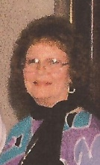 | Sue Johnston  Beta Alpha, Dubois, WY  "A Fortune in Friendship" and" Let Not the Flame Die" | 1977-78  1978-79 | Wyoming State President
32 | 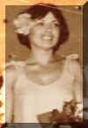 | Sandra Crosier  Alpha Nu, Akron  "Some See Stars" | 1978-79 | Grand Junction  "Junction Roundup - Western Style"
33 | 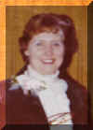 | Fran Emore **  Epsilon Omega, Dillon  "Follow Your Dreams" | 1979-80 | Lamar  "Holidaze in Lamar"
34 | 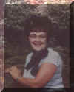 | Kay Westlake  Zeta Omicron, Cedaredge  "E.S.A. – A Bridge of Love" | 1980-81 | Pueblo  "When It’s Springtime in the Rockies"
35 | 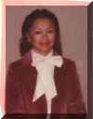 | Eileen Wright **  Eta Lamda, Cortez  "E.S.A. – A Bouquet of Flowers" | 1981-82 | Keystone  "Roses in the Snow"
36 | 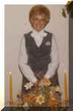 | Terry Eakle  Zeta Eta, Glenwood Springs  "E.S.A. – A Gift of Wings" | 1982-83 | Fort Morgan  "In the Mood with E.S.A."
37 | 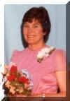 | Gertie Chapin  Beta Epsilon, Ft. Morgan  "E.S.A. – A Highway to Friendship" | 1983-84 | Denver  "Reflections"
38 | 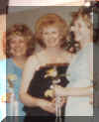 | Neeoma Coston **  Delta Theta, Denver  "Step to the Music You Hear" | 1984-85 | Steamboat Springs  "Steamboat’s a Comin’"
39 | 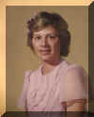 | Diane Collins  Gamma Chi, Loveland  "E.S.A. – The Song in My Heart" | 1985-86 | Estes Park  "The Sounds of Music"
40 | 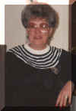 | Judie Tate **  Zeta Rho, Aurora  "Come with Me to Care-A-Lot" | 1986-87 | Craig  "E.S.A. Country Jamboree"
41 | 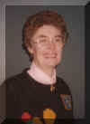 | Nancy Negomir **  Theta Eta, Denver  "E.S.A. – The Greatest Show on Earth" | 1987-88 | Alamosa  "Caring and Sharing"
42 | 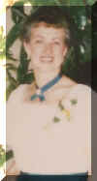 | Mary Alice Covelli  Beta Epsilon, Fort Morgan  "The Wonder of it All" | 1988-89 | Grand Junction  "Under the Big Top"
43 | 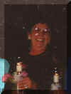 | Jean Kump **  Theta Zeta, Rangely  "E.S.A. – A Way to Grow" | 1989-90 | Denver  "In the Glitter of Memory Lane"
44 | 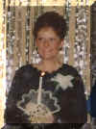 | Cindy Powers  Beta Epsilon, Ft. Morgan  "We’ve Come a Long Way Ladies" | 1990-91 | Fort Collins  "Fantastic Voyage"
 |  | Betty Walterscheid  Beta Eta, Moab,UT  "ESA Rises in the West" | 1990-91 | Utah State President
45 | 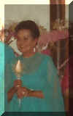 | Connie Ernest **  Zeta Rho, Denver  "The Gift of Love" | 1991-92 | Pueblo  "Discover Pueblo"
46 | 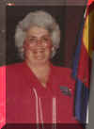 | Karen Smith **  Alpha Eta, Denver  "Among the Young at Heart" | 1992-93 | Greeley  "Holidays on the Plains"
47 | 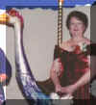 | Nancy Cameron  Epsilon Epsilon, Denver  "You Are the Music of ESA" | 1993-94 | Denver  "Follow the Yellow  Brick Road"
48 | 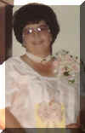 | Linda Pittsenbargar **  Theta Zeta, Rangely  "Legacy of Love" | 1994-95 | Glenwood Springs  "Dancin’ on the Mountain Tops"
49 | 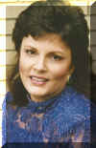 | Candie Patino  Beta Xi, Berthoud  "E.S.A. – Our Wings to Rainbows" | 1995-96 | Grand Junction  "Butterflies are Free"
50 | 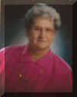 | Doris Sutherland **  Beta Tau, Grand Junction  "Dream Weavers of E.S.A." | 1996-97 | Fort Collins  "A Dreamer’s Holiday"
51 |  | Pat Peters  Gamma Kappa, Westminster  "E.S.A. – A Parade of Friendship" | 1997-98 | Delta  "Delta Queen"
52 | 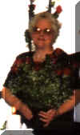 | Phyllis Vrbas **  Chi Kappa, Denver  "Remember the Past, But Reach for the Future" | 1998-99 | Breckenridge  "E.S.A. - You Light up Our Lives" "
53 | 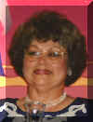 | Pat Bernhardt  Gamma Chi, Loveland  "E.S.A. – Love Is the Bridge Of the Centuries" | 1999-2000 | Cortez  "Southwestern Dreams"
54 | 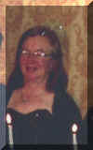 | Eileen Stanley  Zeta Eta, Glenwood Springs  "E.S.A. – Soaring to Greater Heights In The New Millennium" | 2000-2001 | Colorado Springs  "Peak into the Future"
55 | 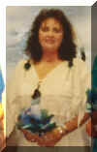 | Bobbi Hawkinson  Gamma Omega, Akron  "Dances With Wind & ESA" | 2001-2002 | Fort Morgan  "E.S.A. Country Fair"
56 | 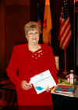 | Jody Karr  Zeta Rho, Aurora  "ESA: A Class Act" | 2002-2003 | Grand Junction  "Discover the Ancient Magic"
57 | 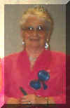 | Millie Foley  Eta Beta, Arvada  "ESA, Where Spirits Soar" | 2003-2004 | Denver  "Hats Off to ESA"
58 | 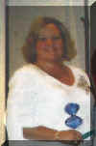 | Alice Robinson  Zeta Tau, Colorado Springs  "Celebrate Yourself, Celebrate Your Spirit, Leave a Legacy" | 2004-2005 | Estes Park  "A Class Reunion"
59 | 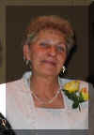 | Barbara Hill **  Pi Lambda, Buena Vista  "ESA Winds of Time Bring Change, Dreams Can Come True" | 2005-2006 | Keystone  "Reflections of the Past"
60 | 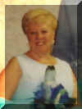 | Joyce Fuller  Theta Eta, Denver  "The Hidden Gems of ESA" | 2006-2007 | Denver  "Dreams Do Come True"
61 | 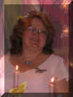 | Patty Ehrlick  Sigma Rho, Loveland  "Childhood Dreams on Butterfly Wings - ESA and You can make them come True! | 2007-2008 | Denver  "The Colors of ESA"
 | 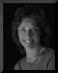 | Margaret Ames  Alpha Zeta #2710  Anchorage, Alaska  "Soaring to New Heights" | 2007-2008 | Alaska State President
62 | 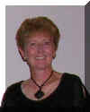 | Sandy Alexander  Kappa Iota, Golden  "Shining Stars of Hope" | 2008-2009 | Colorado Springs  "Seasons in the Sun"
63 | 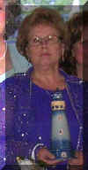 | Shirley Telinde  Zeta Rho, Aurora  "ESA - A Guiding Light for Our Future" | 2009-2010 | Loveland  "On Broadway with ESA"
64 | 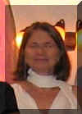 | Bonnie Gillmore  Gamma Chi, Loveland  "Catching the Dreams of ESA" | 2010-2011 | Canon City  "ESA - The Sister Act"
65 | 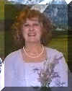 | Cathy Westlake  Zeta Omicron, Cedaredge  "Mountains that Inspire Deeds of Love: | 2011-2012 | Denver,  "The Wonderland of Blue and Gold"
66 | 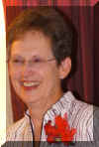 | Mary Humphrey  Beta Alpha, Aurora  "Believe" | 2012-2013 | Montrose  "Carnival in Venice"
67 |  | Joan Snyder  Kappa Iota, Golden  "ESA . . . Real Women - Real Harmony" | 2013-2014 | Salida  "Country Living in the Heart of the Rockies"
68 | 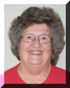 | Rita Martin  Chi Kappa, Denver  “ESA – What a Wonderful World” | 2014-2015 | Fort Morgan  “Reminisce”
69 | 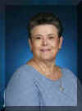 | Vicki Martinez  Zeta Rho, Aurora  “ESAS – Flying High on Eagles Wings” | 2015-2016 | Canon City  “Rhythms on the Arkansas”

