ESA
Colorado State Council
2017-2018
Candidates

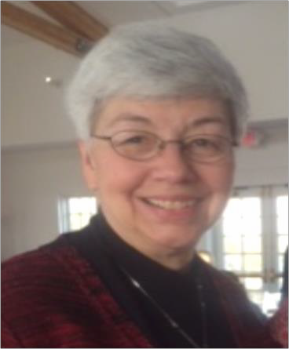

For the Office of President Kathy Garrison
Kathy joined ESA in 1992 and is a member of Epsilon Epsilon #1896 Denver.
Kathy has been her chapters President 5 times, Vice President 4 times, Parliamentarian 5 times, Recording Secretary 2 times, Treasurer 4 times, Scrapbook Chair 3 times, Publicity 5 times, Educational Director 11 years, Philanthropic Chair 4 times, Ways and Means, and Christmas Tea Chairman 7 times, Founders Day Chairman 2 times, and Jonquil Girl.

Kathy has served on Epsilon Council as President 2 times, Vice President 2 times, past President 2 times, Parliamentarian 2 times, Philanthropic Chair, Historian 2 times, Yearbook 3 times, and Founders Day Chair 2 times, Recording Secretary, Corresponding Secretary.
Kathy has served on the state council as President Elect, Vice President, ESA Foundation Counselor, Education/Workshop Director, receiving first place for Educationals, Distinguished Athenian award, placed in the top ten at IC 3 times, awarded second place May E. Wells Award for Outstanding State Educational Director 2014, Chaplain, Recording Secretary, Parliamentarian, Minutes Review Committee, 2005 Convention Co-Chair, Games Manager 4 years, first Dream Home office and record keeping.
Kathy has her 5th Degree Pallas Athene and her First Pearl and is a Life Active Member. She is a member of Foundation.
Kathy has been Woman of the Year for her chapter 3 times, council twice and third runner up for state 2014.
Kathy has attended 17 state conventions and 2 international conventions.

Kathy worked in trust and estate for eleven years, established client relationships retained over many years, worked with attorney regarding estate issues. She believes in building lasting relationships with our sisters to ensure that ESA continues to offer our sisters a place to grow and develop their talents.

Kathy experienced many of the offices in state and has acquired knowledge of how the state council performs.
Kathy’s dues are paid and she is in good standing with her chapter, state and IC.

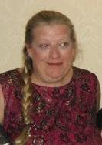
For the Office of President Elect Leslie Stevens
Leslie joined ESA in 1984 and is a member of Kappa Iota #5442 Golden.

Leslie has held all chapter offices, and committees. She is currently Publicity Chair, Chaplain and Educational Chair for Kappa Iota.
Leslie is a member of Denver Alpha Council.

On the state level Leslie has been Vice President, Recording Secretary, Corresponding Secretary, Golden Lamp Editor 3 years, Membership Jr and Sr, Membership - Western Slope, Publicity, Philanthropic, Educational Director, Jr. and Sr. St Jude Coordinator, and 1994 Convention Co-Chair.
Leslie has received the Distinguished Athenian award, 3rd place for IC Newsletter – first year as Golden Lamp Editor, received the May E. Wells Award for Education Director, 1st Place and has chartered one chapter with 5 members.
Leslie has her 4th Degree Pallas Athene and her First Pearl +1 and is a Life Active Member. She is a member of Foundation.
Leslie has been to 27 state conventions and 9 international conventions. Leslie’s dues are paid and she is in good standing with her chapter, state and IC.

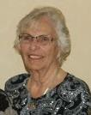
For the Office of Vice President Loydette Knight
Loydette joined ESA in 1968 and is a member of Zeta Rho #1774 Aurora. Loydette has held all chapter offices multiple times.
She is a member of Denver Alpha Council and has held the offices of Parliamentarian, Treasurer, Vice President and was the President of Northwest Area Council. Loydette has served on the state council as Membership Director, Jr. and Sr. St Jude Coordinator, Recording Secretary and Treasurer.
Loydette has received her 5th Degree Pallas Athene and her First Pearl and is a Life Active Member. Loydette has been Women of the year for her chapter and was 1st runner up for state women of the year. Loydette has attended 29 state conventions and 2 international conventions.
Loydette has a keen attention to detail with her career as a bookkeeper in charge of Accounts Payable, Receivable, Payroll as well as being a Court Clerk, rental manager and office manager.

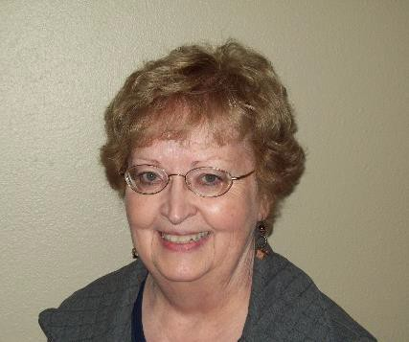
For the Office of Treasurer Anita Miller
Anita is a member of Alpha Omicron, #770, Salida. She pledged ESA in 1998. She has served all elected and appointed offices in her chapter at least twice. Her Chapter does not belong to an area Council.

On the State level, Anita has held the elected offices of Recording Secretary, Parliamentarian. Anita has held the appointed offices of Chaplain, Membership West, Jr. and Sr. Easter Seals, Golden Lamp Editor for 2 years and was Co-Chairman for State Convention.
Anita has done bookkeeping for 20 years and has been Treasurer for her chapter 2 times.

Anita has earned her Fourth Degree Pallas Athene. She has attended 16 State Conventions. Her dues are paid and her Chapter is in good standing.

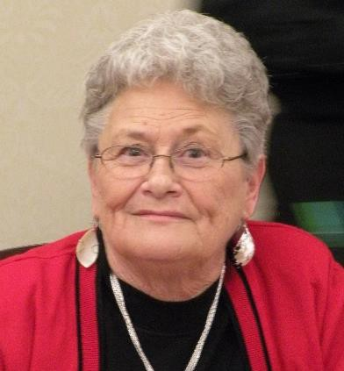
For the Office of Corresponding Secretary JoAnn Singley
JoAnn pledged ESA in 1977 and is a member of Epsilon Epsilon #1896, Denver.
JoAnn has been President of her Chapter 4 years, Recording Secretary 3 years, Corresponding Secretary 2 years, Treasurer 4 - 2 year terms,
Parliamentarian 3 years, Awards 15 years, Philanthropic 8 years and Ways and Means.

JoAnn is a member of Denver Epsilon Council and is currently serving for 2 years as President. She has also held the offices of Vice President 2 years, Corresponding Secretary, Recording Secretary, Treasurer, Parliamentarian, and served as Chairman of every committee at least twice.
On the state level JoAnn has been Jr. and Sr. ESA Foundation, Corresponding Secretary, Treasurer, Parliamentarian, Teller 3 times, Scrapbook Judge 4 times.
JoAnn has received her 5th degree Pallas Athene and her First Pearl and is a Life Active Member. JoAnn has been Woman of the year for her chapter 3 times and her council 3 times and state in 2016. JoAnn has been to 37 state conventions and 7 international conventions.
JoAnn’s dues are paid and she is in good standing with her chapter, state and IC. She is also a member of Foundation.

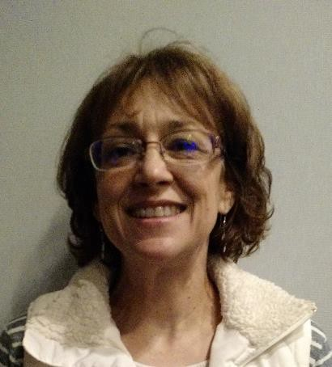
For the Office of Recording Secretary Deb Spear
Deb pledged ESA in 1990 and is a member of Gamma Omega #4306 Akron.
Deb has been President of her chapter and served as Vice President, Recording Secretary and Treasurer.
Deb is a member of Northeastern Area Council and has served as Recording Secretary and is currently serving as President.
On the state level Deb has been Corresponding Secretary and Chaplain. Deb has her 2nd Degree Pallas Athene and First Pearl.
Deb has been to 4 state conventions and 1 international convention.

Deb has 20+ years of secretarial experience, excellent proofreading and grammar skills, is task oriented, and reliable.

Deb’s dues are paid and she is in good standing with her chapter, state and IC.

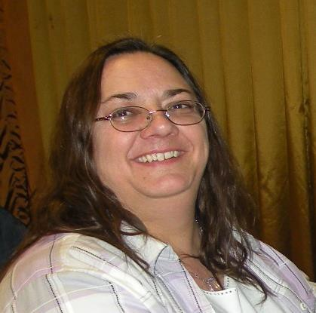
For the Office of Parliamentarian Vickie Chavers-Bruso
Vickie joined ESA in 1991 and is a member of Epsilon Epsilon #1896 Denver.
Vickie is currently serving as Vice President of her chapter. She has held the offices of President 3 times, Vice President 4 times, Treasurer 4 years, Corresponding Secretary 2 years, and Parliamentarian.

Vickie is a member of Denver Epsilon Council and has held the offices of President, Vice President, Treasurer 4 years, Corresponding Secretary 2 years and Parliamentarian.
On the state level, Vickie has held the offices of Treasurer, Jr. and Sr. Circle of Life, Jr. and Sr. Easter Seals, Education Director, Philanthropic, Publicity, Collegiate, Finance committee, Audit committee, and Games Manager. Vickie has just accepted Co-Chair of the Denver Dream Home and will be handling reporting.
Vickie has been Woman of the Year twice for her Chapter and her Council. Vickie has attended 23 state conventions and 1 international convention. Vickie has received her 4th Degree Pallas Athene and First Pearl.

Vickie’s dues are paid and she is in good standing with her chapter, state and IC. She is also a member of the Foundation.

