2014-2015
IC Presidential Focus Project: 72-Hour Emergency Packs
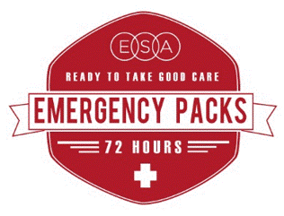

Emergencies and natural disasters strike without warning, and having a simple “emergency pack’ ready to grab at a moment’s notice can make all the difference in the first 72 hours, which is often how long it takes first responders to arrive with help in a disaster situation. IC President Vickie Farris chose 72-hour emergency packs as her presidential focus project this year and invites all ESA members to participate in making ourselves and communities safer.
“I chose this focus project because there is peace and reassurance in knowing that if we prepare ourselves for emergencies, when they happen they don’t feel so much like emergencies. After witnessing several hurricanes and other natural disasters this decade, I have a strong belief that being prepared for emergencies is vital. When we are prepared, it gives us more opportunity to serve and care for our neighbors and friends.”
Ways YOU Can Participate:
- Have everyone in your chapter make a pack together
- Create packs to share with single moms, elderly neighbors, or first responders in your community
- Host a “Pack Party” or sponsor a community-awareness event about emergency preparedness
Get everything you need in the member center toolkits.

